Draft Tempe South

Local Area Traffic Management Strategy
Glossary of Treatments

Edge linemarking
Edge linemaring is the delineation of lanes on the roadway including the parking lane and the trafficable lane. These work by visually narrowing the roadway, which help reduce vehicle speeds, and minimise inconvenience for local residents.
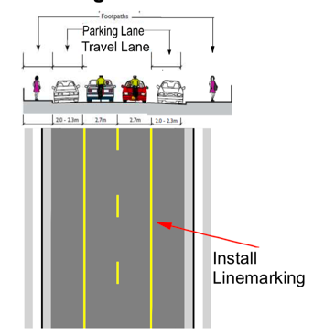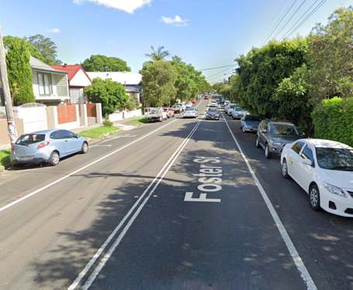
Speed Cushions
A speed cushion is a speed reduction device in the form of a raised curved profile often installed as a set and installed at a height of 75mm. Cyclists, emergency vehicles and buses are unaffected by speed cushions. These work by reducing speed and discouraging traffic. Whilst some may associate noise issues, recently constructed asphalt type speed cushions are generally quieter than the older design made from recycled rubber.
Kerb blister/Kerb extension
A kerb blister or kerb extension involves widening of the verge or footpath and used to narrow the roadway to reduce speeds, prevent parking, and improve visibility near intersections. This also provides an opportunity for landscaping.
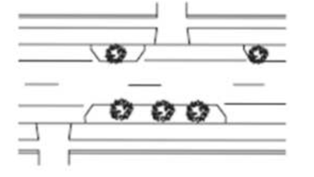
Contrasting Pavement
A contrasting pavement is a coloured treatment on the road surface and can be installed in a specific colour or patterns such as brick or honeycomb styles to help lower vehicle speeds. They are normally installed at-grade without a raised surface. Whilst they are not intended to be a crossing facility for pedestrians, they are designed to calm traffic for traffic entering into a local street.
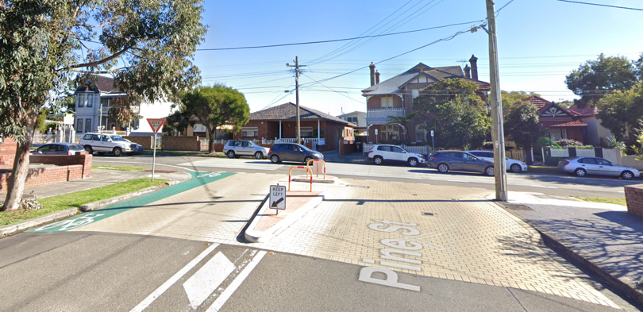
Shared Zone
A shared zone gives priority to pedestrians and has a speed limit of 10km/h. The roadway features a textured road surface to differentiate from a typical road environment, entry and exit signage, and speed cushions to help maintain low speeds. On-street parking is permitted in marked bays.
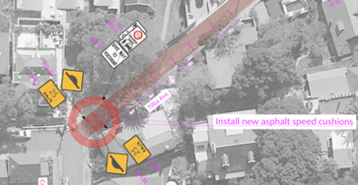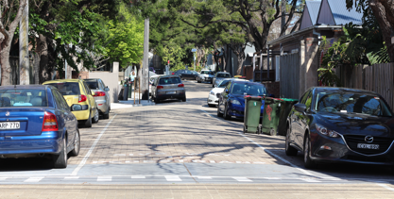
Median island

A median island is a speed reduction device used to narrow the roadway. The median island proposed in Smith Avenue will be 50mm in height designed to be mountable by trucks. 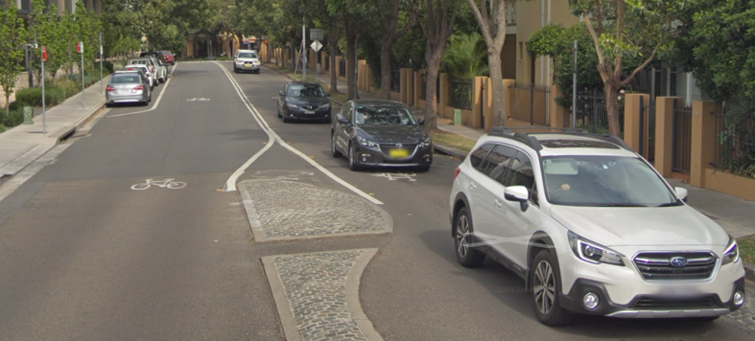
Flat-top raised hump/Raised thresholds

These are speed reduction devices having a flat top profile and typically installed at a 100mm height. These have contrasting surfaces or an inverted ‘piano keys’ linemarking, supplemented with warning signage. Parking is permitted on a speed hump, provided that there is sufficient space for passing vehicles.

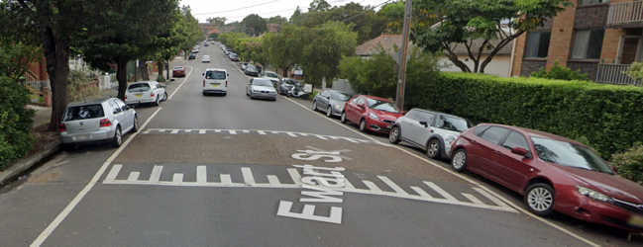

Glossary of terms

Sight distance
Refers to the length of unobstructed view from a driver/rider/pedestrian.
Reported crashes
Are crashes reported by the NSW Police, NSW Health, SIRA, and icare. Further information can be found on https://roadsafety.transport.nsw.gov.au/statistics/index.html
Local road
Are public roads under the care and management of local government. These exclude arterial roads such as Princess Highway.
Landscaping
Are areas where shrubs and planting (low height) are used to beautify a public area
Delineation
Refers to vehicle placement, speed and direction of a vehicle.
Bike logos
A bike logo is installed on bicycle routes, which remind road users of presence of a bicycle rider mixing with general traffic. Bicycle warning signs are also installed on approaches from side streets and directional signs are also installed to provide connectivity to other areas.

On-ramp/Off-ramp
Ramps provide smooth transition for wheeled devices (prams, wheelchairs, and bikes) from a footpath or a shared path to a road pavement at crossing points.
Verge/Nature strip
Refers to the grassed or landscaped area between the paved footpath and the kerb.
Indented Parking Spaces
Indented parking spaces are areas designed within the road and nature strip areas for parking of vehicles. These are typically designed with a 6m length.
Drainage Pit/Stormwater Pit
A drainage pit is an inlet allowing for the flow of runoff water, typically rainwater and connected to the network of pipes, channels and creeks.

