Monday, 6 September 2021

<First last name>
<Address 1>
<Address 2>
<Suburb NSW 1234>

Dear community member,

Have Your Say
Draft Leichhardt West precinct parking study
In November 2020, the community shared key concerns and challenges with parking in the Leichhardt West precinct. This information has been combined with data and ongoing correspondence with the community to develop a draft Leichhardt West precinct Parking Strategy.
The Leichhardt West study area is bounded by Parramatta Road, Elswick Street, Darley Road and the Inner West Light Rail. This is illustrated on the map below.

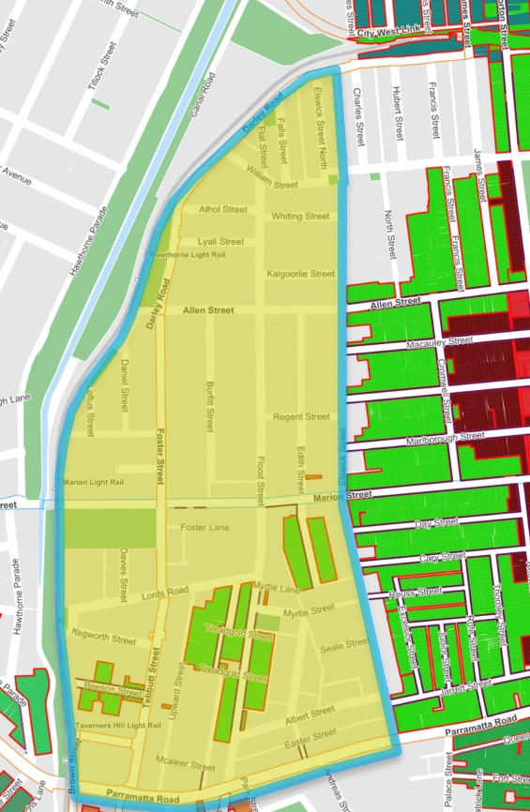
What is proposed?
The draft presents 12 proposals and aims to:
- Ensure the supply of parking permits does not exceed the total capacity
- Replace redundant, faded and damaged signage
- Monitor commuter parking near light rail stops during peak times
- Advocate for mitigating the impact of new developments as part of the Inner West DCP

Read the draft parking strategy
Due to lockdown, our service centres are closed and hardcopies cannot be made available for inspection. There are two ways you can inspect the draft Leichhardt West Parking Study during public exhibition:
- Download a copy from yoursay.innerwest.nsw.gov.au
- Contact me to request a paper copy posted to your address

Have your say
Let us know your views on the proposed study:
- Online at: yoursay.innerwest.nsw.gov.au
- By mail: addressed to Inner West Council, PO Box 14, Petersham, 2049. Please mark your feedback with reference – Leichhardt West Precinct Parking Study
- Call a FREE Interpreter or the National Relay Service, Monday to Friday between 9am-4pm and provide our phone number 02 9392 5561.
  - Free Interpreter call TIS National on 131 450
  - Voice relay call 1300 555 727
  - TTY call 133 677
  - SMS relay call 0423 677 767
Final day for comments is Friday, 15 October 2021.
Enquires
Contact me on 9392 5561 or email jason.scoufis@innerwest.nsw.gov.au.
Yours sincerely,

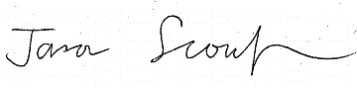

Jason Scoufis | Traffic & Parking Planner

