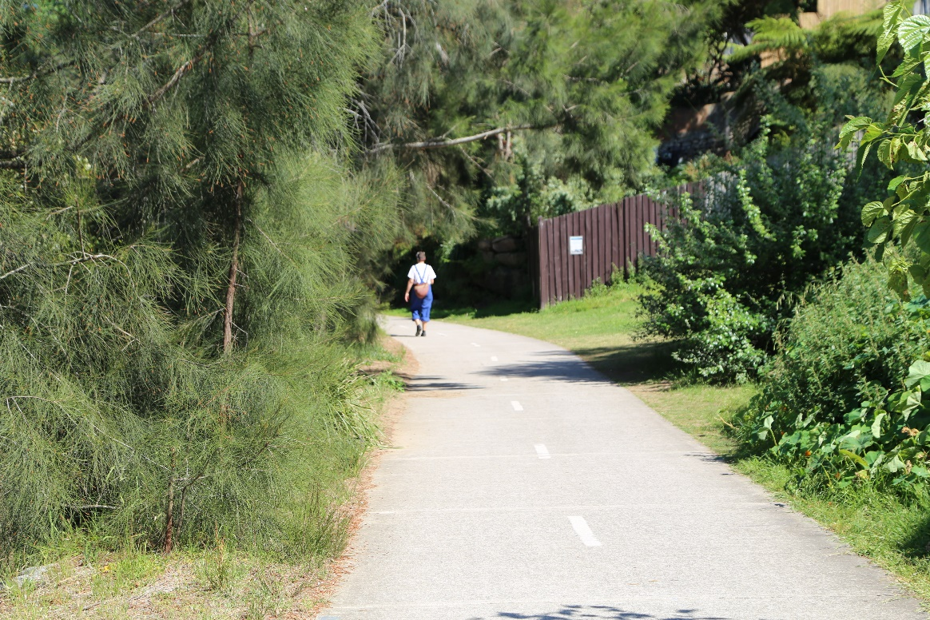

Recreation Strategy

Engagement outcomes report

Contents

Summary 3
Background 3
Engagement Methods 3
Promotion 3
Engagement outcomes 4
Who did we hear from? 4
What did they say? 6
Comments received from sporting groups: 7
Officer comments in response to public exhibition 9

Summary

Community engagement for the Inner West Council Recreation Strategy was carried out via the online engagement platform Your Say Inner West (YSIW) from 31 August to 29 September 2020.
The YSIW project page received 277 visits. Of those visitors, 31 left feedback. They were prompted to express their thoughts on the Recreation Strategy and offer additional suggestions. The majority of those leaving feedback were residents (15), closely followed by community/sporting groups (12).
There was overwhelming support for the Recreation Strategy with only 3 respondents saying they didn’t support it.
The strategy was downloaded 145 times.

Background

Council engaged the Inner West community for input into its proposed Recreation strategy. This strategy is informed by Healthier Inner West (a previous recreation needs study endorsed by Council in 2018).
A key objective of the Recreation strategy is to tackle the problems associated with inactivity. Its focus is on partnerships with schools, investment in recreation infrastructure and planning community friendly public spaces. The strategy includes measurable outcomes that will help track Council's progress and report back to the community.

Engagement Methods

The main method of engagement was online via the Your Say Inner West page. Additional engagement options included email and mail.

Promotion
The engagement was promoted through an Announcement on the Your Say Inner West home page. All local sporting clubs and key sporting partners were also notified of the engagement process and encouraged to provide feedback on the draft recreation Strategy.

Engagement outcomes

Who did we hear from?
Residents were the main group of respondents however Sporting/Community groups were a significant group providing very detailed responses.
Groups that responded include:
- AFL NSW/ACT
- APIA Leichhardt Tigers Football Club
- Ashfield Bowling Club
- Balmain & District Football Club (via email)
- Balmain Rowing Club
- Balmain South Sydney Cricket Club
- Camperdown Tennis Club
- Gymnastics NSW
- Newtown Swans
- Petersham Rugby Union Football Club
- Tennis NSW (Metro South)

Which of the following best describes your relationship to Inner West?

What did they say?
The Recreation Strategy was downloaded 145 times with the vast majority of respondents supporting it.

Do you support the draft Recreation strategy?

Main themes of the feedback were (in no particular order):
- Future-proofing – ensuring more public spaces such as playing fields are available in the future to meet the needs of the growing population
- General maintenance and upkeep of existing recreation facilities – toilets, safe footpaths, broken fixtures and fittings, lighting, safety etc
- Allowing equitable access to fields and facilities for groups other than big sporting clubs
- Climate change – water collection and storage in parks, more native plants, coastal inundation and water damage (areas such as rowing clubs and Dawn Fraser pools).
- Companion animals – clear and detailed signage relating to dog on/off leash areas, allowing pets on public transport, education programs for pet owners, more open accessible dog parks
- Active streetscapes – more focus on walking and pathways, safe walkways, comprehensive bike map
- Passive recreation – ensuring requirements for informal activity and passive recreation are included
- Waterfront recreation activities – need more focus

Community/sporting groups
All sporting groups that responded discussed their support for the strategy as well as highlighting their own club’s links to the strategic aims. The main focus was:
- Overall support for the need to increase open spaces available for sport and recreation in the future.
- Asking for continued support from Inner West Council in maintaining and upgrading facilities.
- Looking for opportunities to work together with Council on achieving aims of inclusivity.

Comments received from sporting groups:
AFL NSW/ACT
- Supports the focus on increasing amount of open space available for sports and recreation.
- Safe and clean facilities important – public change rooms and toilets, car park and pedestrian access.
- Supports ‘share our space’ opportunities.
- Strongly supports resurfacing of natural turf with new technology-driven alternatives
APIA Leichhardt Tigers Football Club
- More open space to support growing club membership particularly among girls and women
- Improved facilities with synthetic turf
- Wanting a broader cross-section of the community to participate in football
Ashfield Bowling Club
- Looking for opportunities to work with IWC to deliver inclusive community events such as family and senior citizen days.
- Outdoor coffee area on club grounds.
- Changing grass to synthetic grass (water-saving benefits, can access all year round)
- Car park for access to less mobile members and visitors.
- Better lighting
Balmain Districts Football Club
- Advocating for a synthetic football field at Rozelle Parkland, and supportive of further synthetic fields in the IW LGA
- Child safe requirements to be mindful of being realistic for volunteer organisations
- Sporting ground rationalisation to be based on participation trends
- Recognition of Clubs already active in the diversity and inclusion space
- Water harvesting, improved lighting, and other improvements to increase sporting ground capacity and sustainability
- Improved supporting amenities

Balmain Rowing Club (BRC)
- Strategy scope should include waterfront aquatic facilities and clubs.
- Inundation - Rising sea levels and impact on maintenance bills of places such as Balmain Rowing Club & Dawn Fraser Baths. BRC looking for funding support to address these issues.
- Strategy should include importance of access to water for people with disabilities.
Balmain South Sydney Cricket Club
- They would like a cricket pitch and practice nets.
Camperdown Tennis Club
- Wanting greater flexibility in leasing arrangements to allow for facility improvements.
- Looking to share its space with other community groups.
Gymnastics NSW
- Supportive of a new indoor facility including gymnastics in the IW LGA
Newtown Swans
- Limited availability of grounds is an impediment to Club growth
- Local clubs should be involved in strategic decision making affecting their future
- Supportive of Clubs sharing grounds, facilities and other resources to get best community outcomes
- Strongly support diversity in sport and recreation and increasing participation and social cohesion
- Advocate for a indoor sports training facility (separate to an indoor sports centre)
Petersham Rugby Union Football Club
- Facilities improvements including playing surface and cricket pitch (during rugby season), rugby pitch grass, scoreboard, more toilets, lighting, rotunda.
- Greater communication and advice about ground closures
- Main facility block – demolition of stand gives spectators nowhere to sit and makes it hard for spectators to see.
- Looking for investment in a new re-vamped facility with club rooms
Tennis NSW
- Looking to form a partnership with Council re: its Tennis Restart engagement initiative to research the current ‘state of play’ for tennis in the Inner West LGA.

Officer comments in response to public exhibition

Council officers have reviewed all the submissions received along with the feedback and outcomes of the community engagement process. The draft recreation strategy has been updated to respond to these changes and amended to ensure that the strategy reflects the community and stakeholder feedback.
Specific re-working of the document was undertaken in consultation with the Parks Capital Works, Strategic Planning and Property Services teams.
Emphasis was placed on:
- Accessing deficiencies in the provision of open space and developing ways to acquire and create new open space;
- Inclusion of future master planning for Leichhardt Oval; and
- Development of a ten-year rolling renovation plan for sporting grounds to address and manage current and future use.

