Dear <name>,

HAVE YOUR SAY
Improving safety and calming traffic in Rozelle North

Council is developing a Local Area Traffic Management (LATM) Plan to manage traffic and improve walking and cycling in Rozelle North. This area is bounded by the waterfront, Young Street, Darling Street and Victoria Road. - see a map overleaf.

The plan will:

- Increase road safety for pedestrians, cyclists and motorists;
- Calm traffic and improve access for pedestrians and cyclists; and
- Manage changing traffic needs over the next ten years.

Have your say

Local knowledge of walking, cycling and driving in your neighbourhood is invaluable to this work. You are invited to share information and experiences by completing an online survey at yoursayinnerwest.nsw.gov.au

The last day to complete the survey is Monday 9 March 2020.

Who should fill in the survey?
We would like to hear from schools, residents, business owners and workers. The experiences of pedestrians, cyclists, motorists and other road users are all welcomed.

What happens next?
Your survey answers, along with a review of traffic volumes, vehicle speeds, heavy vehicle use and crash statistics, will be used to develop a draft Local Area Traffic Management Plan for Rozelle North.
Testing options drop-in session
Before finalising the draft Rozelle North LATM Plan, we will be hosting a drop-in session on Wednesday 8 April 2020 from 4:30 – 7pm at the Hannaford Centre, Rozelle. At the drop-in session we’ll show you some options for the Rozelle North LATM Plan and gather feedback before finalising the draft Plan.
For those who are unable to make it to the drop-in session, we will have the options and ability to provide feedback on yoursayinnerwest.nsw.gov.au.
Everyone who provides feedback in the initial study will be sent an update when this is open.

Public exhibition
The draft Plan will be placed on public exhibition for community feedback before it is considered by elected Council. Once the Plan is adopted by Council, a schedule for implementing it will be developed.
Keep up to date with the project at yoursay.innerwest.nsw.gov.au
Further information
If you need a printed copy of the survey mailed to you or if you have any queries about this study please contact Sunny Jo, Traffic Management Planner, on 9392 5965 or email sunny.jo@innerwest.nsw.gov.au.

Yours sincerely
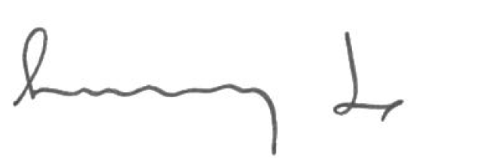

Sunny Jo
Traffic Management Planner

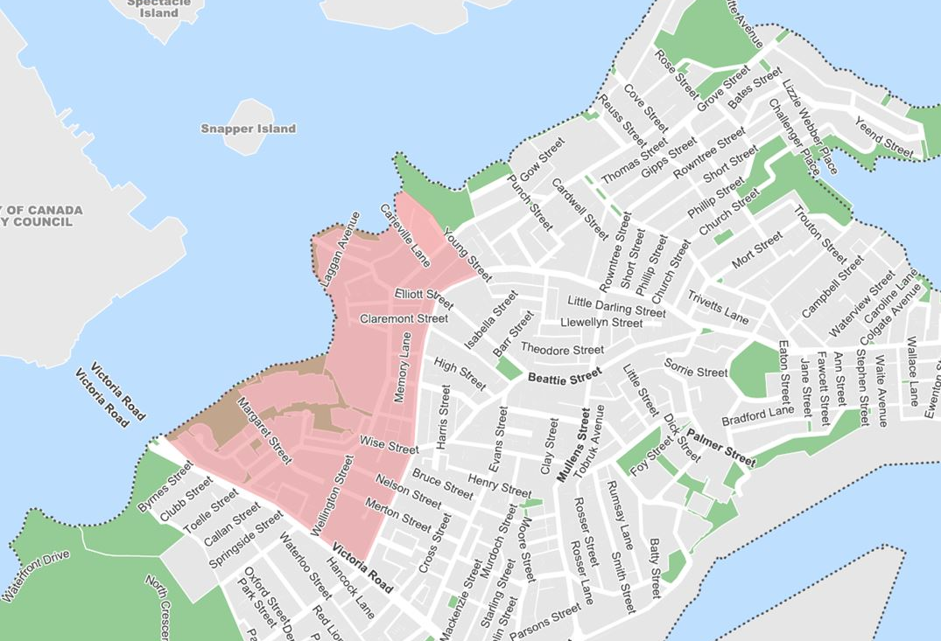
Map – Rozelle North precinct study area

