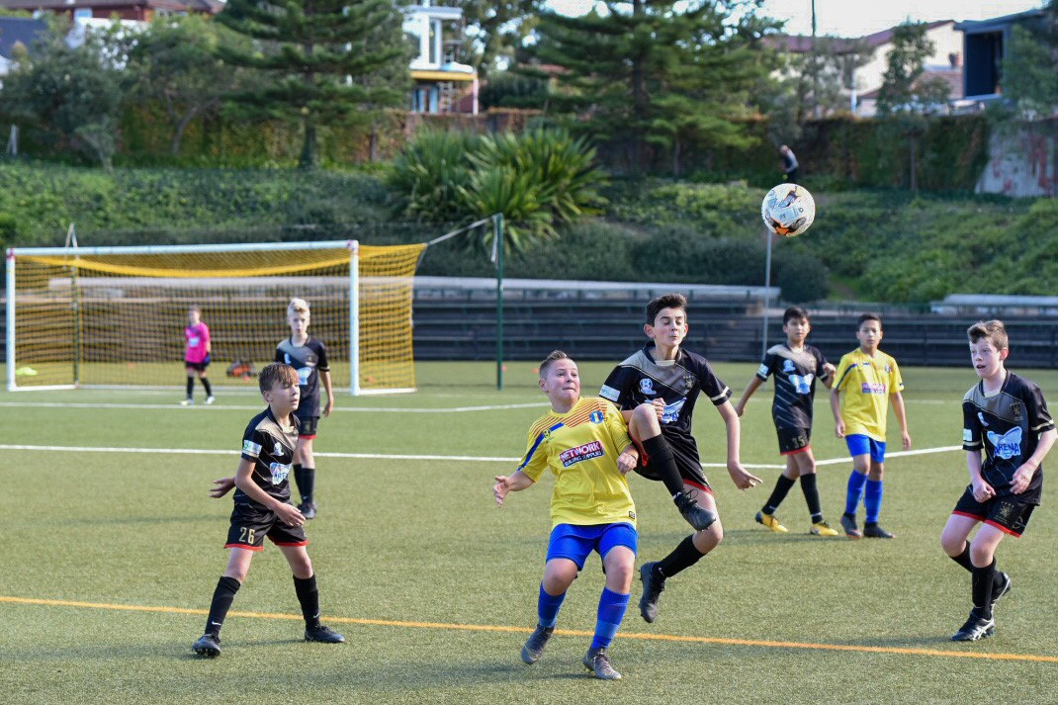

Stage three - engagement on the
amendments to the Revised Operational Plan with local residents

Engagement outcomes report

Contents
Summary 3
Background 4
Engagement Methods 5
Promotion 5
Engagement outcomes 5
Who did we hear from? 5
What did they say? 7

Summary
The engagement purpose was to publicly exhibit amendments to the Revised Operational Plan based on the elected Council feedback as per Council resolution, seek further feedback from local residents living around Arlington Reserve.
The engagement period was 8 March to 31 March 2021. People could provide feedback through an online form at Your Say Inner West Council’s engagement platform. Some feedback was also received via email to the General Manager.
A total of 449 people visited the project page, 286 spend time on the page interacting with the information and 147 of those downloaded the Revised Operational Plan. One hundred and fifty-nine people provided feedback via the online survey, of those 58 were residents living in streets surrounding Arlington Reserve.
The online form consisted of four questions.
Q1 - Do you support the amendments to the Arlington Reserve Operational Plan?
- Yes – 42 (27%)
- No – 77 (49%)
- Don’t know/Unsure – 38 (24%)
Q2 - Current hours of use for schools Monday to Friday are 9am-3.30pm. Do you want the hours to?
- Increase – 28 (17%)
- Stay the same – 129 (79%)
- Decrease – 7 (4%)
Q3 - Current hours of us for sports clubs Monday to Friday are 4-9pm. (These hours are mostly for training. Clubs are allowed one game a month on a weeknight) Do you want the hours to?
- Increase - 58 (36%)
- Stay the same – 79 (48%)
- Decrease – 26 (16%)
Q4 - Current weekend hours of use are 9am-9pm for sports club games. Do you want the hours to?
- Increase – 36 (22%)
- Stay the same – 99 (61%)
- Decrease – 28 (17%)

Background

The original Operational Plan for the Arlington Reserve, developed by former Marrickville Council, required revision as it no longer met community needs. In Feb 2020 (10/2-8/3) Inner west Council sought community feedback to develop a revised Operational Plan that aimed to balance the uses of the Reserve. Based on community feedback and other information a revised draft Operational Plan for Arlington Reserve was developed and placed on public exhibition in July 2020 (27/7-24/8).
Following the public exhibition Council's officers finalised the draft Revised Operational Plan based on feedback received and on 13 October 2020 the draft was considered by Council.
The elected Council decided to defer its decision and requested further consultation with local residents on amendments to the Revised Operational Plan.
For more information about the Council decision view item two in the meeting minutes.

Engagement Methods
Feedback was sought via an online survey on Your Say Inner West

Promotion
The project was promoted through:
- Social media
- Direct email to those who provided feedback on stage two engagement on Your Say Inner West.
- Posters at Arlington Reserve

Engagement outcomes

Who did we hear from?
Suburb - see next page

What did they say?

Question 1. Do you support the amendments to the Arlington Reserve Operational Plan?

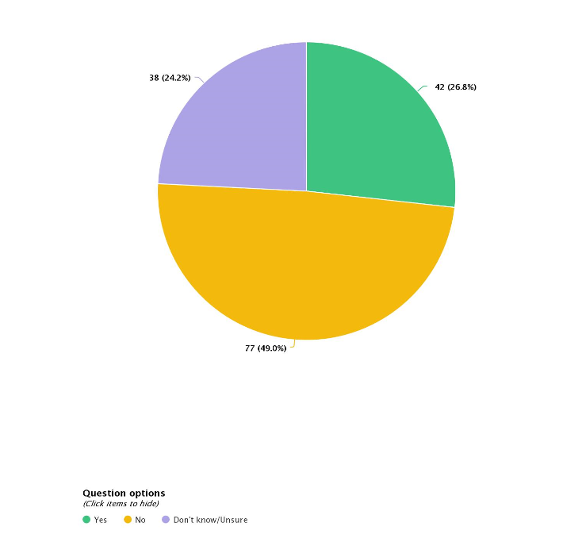
- Yes – 42 (27%)
- No – 77 (49%)
- Don’t know/Unsure – 38 (24%)

How did the residents respond compared with the wider community?

- Not sure / Don’t know - Residents 13 Community 25
- No - Residents 24 Community 53
- Yes - Residents 20 Community 22
Comments on the amendments to the Operational Plan
The common themes are summarised below.
- The plan is fair and balanced and considers the needs of all users
- Support for the committee structure including residents
- Including a scientific definition of noise levels based on NSW Environmental Legislation
- Set clear service levels for dealing with complaints
- Set up clear and transparent resolution process
- Council be more active in its role to encourage female participation
- Introduce heavy penalties for breach of the plan and the rules
- Committee meetings should occur monthly
- Question 2. Current hours of use for schools Monday to Friday are 9am-3.30pm. Do you want the hours to?
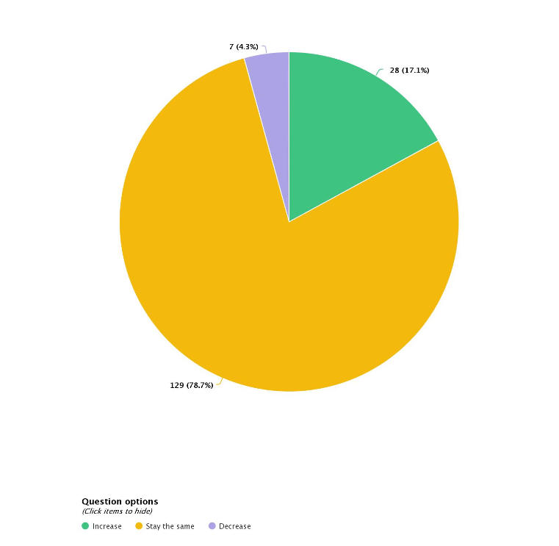
- Increase – 28 (17%)
- Stay the same – 129 (79%)
- Decrease – 7 (4%)

How did the residents respond compared with the wider community?

- Decrease - Residents 6 Community 25
- Stay the same - Residents 44 Community 53
- Increase - Residents 8 Community 22

Question 3. Current hours of use for sports clubs Monday to Friday are 4-9.00pm. These hours are mostly for training. Clubs are allowed one game a month on a weeknight. Do you want the hours to?
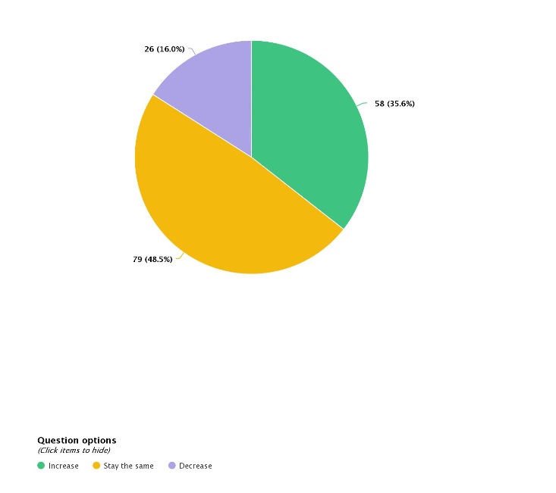
- Increase - 58 (36%)
- Stay the same – 79 (48%)
- Decrease – 26 (16%)

How did the residents respond compared with the wider community?

- Decrease - Residents 26 Community 0
- Stay the same - Residents 22 Community 53
- Increase - Residents 10 Community 48

Question 4. Current weekend hours of use are 9am-9pm for sports club games. Do you want the hours to?

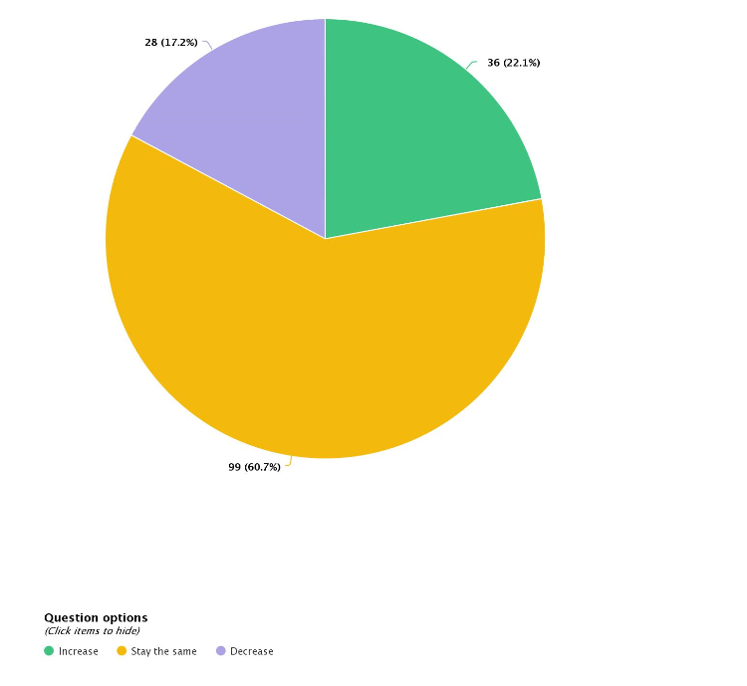
- Increase – 36 (22%)
- Stay the same – 99 (61%)
- Decrease – 28 (17%)

How did the residents respond compared with the wider community?

- Decrease – Residents 27 Community 1
- Stay the same - Residents 22 Community 77
- Increase – Residents 9 Community 27

Comments on days/hours of use
The common themes are summarised below.
Comments in support of the existing hours of use by sporting clubs
- Reduction in hours of use would be detrimental to local sports clubs and the community.
- Sporting clubs use should be prioritised because the community benefits from participating in organised sports. Reducing the hours of use will impact this participation. Increasing the opportunities for our children to participate in sports helps to reduce their device use, improves their behaviour, physical and mental health, and keeps them off the streets and out of trouble.
- The historical significance of Arlington reserve as a sporting facility and its superiority in comparison to other fields.
- Council must use the facility for its intended purpose as a high-quality playing field
- Football community is an important part of the community at large.
- Local residents discussed the enjoyment of living near the reserve and the joy of hearing the activities on the field.
- Support for the existing hours and against any reduction.
- Reduction in hours would severely impact local sports clubs and the health of the community.
- Community sport should be prioritised as it contributed to the health, fitness, and wellbeing of our community – especially for children.
- Current hours benefit the local business.
- Children need space to train and play.
- Community needs require protection against the private needs.
- The Arlington Reserve has been a sporting ground since the 1930’s which must be protected and used to maximum capacity and is a superior ground compared to other fields.
- Prioritise access to local clubs.
- The beauty and enjoyment of the game. Recognition of the football community being important part of the local community.
- Local residents discussed the enjoyment of living near the reserve, attending games and the joy of the activities on the field.

Comments in support of reducing the hours of use by sporting clubs
- Reduction in hours will improve quality of life and physical and mental wellbeing.
- Residents experiences such as: noise levels impacting on everyday activities such as being able to open windows, watching tv, traffic congestion safety issues with illegal stopping and parking, light pollution, rubbish on the streets, foul language.
- Lack of respect from players and spectators towards residents.
- Clubs did not abide by the guidelines outlined in the plan.

Other suggestions
- Supporting equitable participation in football and other sports.
- Provide more synthetic all-weather facilities.
- Equity of access provisions too weak Council must play active role to ensure access
- Change parking conditions to favour residents and enforce this on the weekend
- Provide more synthetic all-weather facilities
- Ensure signage is up specifying acceptable behaviour
- Fix the facilities at the reserve

Residents feedback on the days/hours of use by sporting clubs
- Reduction in hours will improve the quality of life and physical and mental wellbeing.
- A number of comments described residents experiences such as: noise levels impacting on everyday activities such as being unable to open windows, traffic congestion safety issues with illegal stopping and parking, rubbish on the streets, foul language.
- Residents must have direct say in allocating usage and paths to complaint resolution.
- Lack of respect from players and spectators towards residents.
- Access the to the reserve on the weekend
- Clubs not abiding by the guidelines outlined in the plan, including the code of conduct for player and spectators, public transport use.

Feedback received through other channels
- Three emails were received providing feedback. The feedback in those emails has been incorporated in the above comments.

Officer comments in response to public exhibition
- Stage 3 engagement focussed on reviewing hours of use
- There was overwhelming support for school hours of use to stay the same or increase. Recommendation to Council is for school hour use remain the same.
- Resident response to hours of use for weekday training and weekend games was divided – slightly more than 50% wanted hours to stay the same or increase, slightly less than 50% wanted a decrease. Based on this feedback recommendation to Council is the revised Operational Plan decreases Sunday hours of use with games restricted to once a fortnight during winter season and no Sunday use from October-February.
- Based on feedback recommendation to Council is to adopt the revised Operational Plan that includes the establishment of the Arlington Recreational Reserve Operation Committee with representatives from residents and seasonal sporting hirers who meet regularly to address areas of concern.

