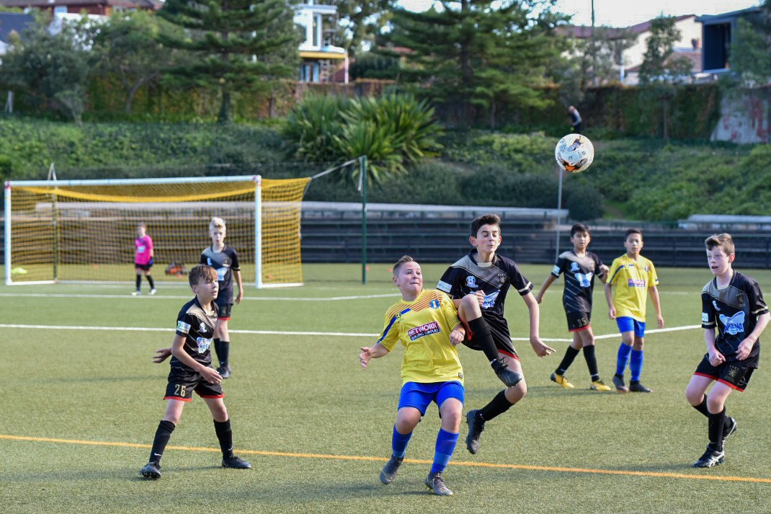

Engagement outcomes report

Arlington Reserve Operational Plan

Contents
Summary 3
Background 3
Engagement Methods 3
Promotion 3
Engagement outcomes 4
Responding to the community’s concerns 5

Summary

In early 2020 Council undertook an initial engagement for the development of Operational Plan for Arlington Reserve. Stage One - the initial engagement occurred between 10 February and 8 March 2020. Community views were sought through an online survey on Your Say Inner West on the issues experienced by residents, individuals and clubs using the facility. Some of the topics covered in the survey were traffic, noise, litter, hours of use and player and spectator conduct. Over 300 people visited the project page on 68 people completed the survey.
Additionally, a stakeholder meeting with seasonal hirers was held during the engagement period. Some of the issues discussed in the meeting included the creation of the Arlington Reserve Committee, community expectations regarding noise levels and light pollution as well as limited parking.
The feedback from the initial engagement informed the development of the draft Operational plan. Stage Two - public exhibition of the Operational plan took place between 27 July and 24 August 2020. There were 800 visits to the project page, 160 downloads of the draft document and 91 people provided feedback via the online survey on Your Say Inner West, other feedback was also received through email.
The draft Operational Plan provides a clear direction in assisting to improve relationships between local residents and sporting users. The plan specifically addresses areas of concern including compliance with hours of use, compliance with traffic and parking restrictions, managing noise levels and ensuring cleanliness of the reserve.

Background

The development of the new Operational Plan was prompted by residents’ complaints about the many issues they faced when the Arlington Reserve was used for training and sporting events.

Engagement Methods

Stage one – initial engagement
- Feedback was sought via an online survey on Your Say Inner West
- Stakeholders meeting
Stage two – public exhibition of draft Operational Plan
- Feedback on the draft plan sought via an online survey on Your Say Inner West

Promotion
Stage one – initial engagement
Stage one - the project was promoted through:
- Social media
- Direct email
- Onsite posters
- Council Column – Inner West Courier 25 February 2020
- Letters to residents living in the surrounds of Arlington Reserve
- Email to clubs using the Reserve
Stage two – public exhibition of the draft Operational plan
- Social media
- Council website
- Onsite posters
- Direct email to all stakeholders
- Letters to residents notifying them of the public exhibition on the draft plan
- Email to all those who provided feedback in stage one

Engagement outcomes – stage one
During the engagement period there were 371 visitors the project page and 70 submissions.
What is your relationship to the Arlington Reserve?
Most people who answered this question selected multiple options showing multilayer relationships to the reserve.
- Thirty-two people who said they either lived nearby or bordering the reserve also use the reserve for walking for leisure, relaxing and enjoying the green space, walking their dog.
- Fourteen people said they either lived nearby or bordering the reserve and did not use the reserve in any other way.
- Twenty-three people said they used the reserve in various ways but did not live near the reserve.

How do you get to the Arlington Reserve?
- Forty-five people answered they either walk, cycle or catch public transport to get to the reserve
- Ten people said they use a variety of ways to get to the reserve including driving, cycling, public transport
- Ten people answered drive only

Which suburb do you live?
Most people said they lived in Dulwich Hill (40) other suburbs were Marrickville (3), Stanmore (3) and Summer Hill (2) other suburbs included Ashfield (1), Tempe (1), Lilyfield (1), Kensington (1).

What did they say?
Online via yoursay.innerwest.nsw.gov.au
We asked people to give us feedback on specific aspects related to the management of the reserve. Most people commented on multiple aspects. Top three aspects were:

  - Hours of use (28) – main theme excessive use of the facility by clubs.
  - Compliance with traffic and car parking restrictions (26) – main themes illegally parked vehicles and lack of enforcement of parking breaches.
  - Public access to Arlington Reserve – (20) main theme more public access and afterhours access.
Other topics that were selected by more than 15 participants were:
  - Lighting - 17
  - Litter - 17
  - Noise - 16
  - Player and spectator conduct - 16

- Stage One
A meeting with seasonal hirers 26 February 2020
Several issues were discussed including:
  - Arlington Reserve Committee – create a committee to improve communications and relationships with local residents
  - The timeline for the resurfacing of the grounds with synthetic turf and new line markings
  - Managing community expectations regarding noise levels during training and games
  - Parking issues experienced by both seasonal users and the residents
  - Access by schools - hours of access
  - Floodlights issues which are within Council’s remit to resolve
  - Public holidays use

- Other responses from individuals

Stage two

Residential Concerns
  - Player and audience behaviour and language at the oval needs to be improved.
  - Excessive noise is problematic to the amenity of residents.
  - Lighting is considered extreme
  - Parking is problematic on weekends.
Individual Sporting User Concerns
  - Support continuation of sporting activities at the park .
  - Request reconsideration of 9:10pm lights out position. This raises serious safety concerns with parents who may be running late to pick up children.
  - Mid week games should be permissible
  - Dulwich Hill FC and Stanmore FC have been long term users of the ground and their use should be permitted to continue.
  - Lack of clarity over usage hours -this needs to be clarified eg does the 41 hours a week apply to school use as well

- Petitions
No Petitions were received.

Engagement outcomes – stage two
We asked people about their relationship to the Arlington Reserve. Participants responses:
  - 43 resident living near the reserve
  - 25 members of a club using the oval
  - 21 regular users
  - 11 visitors
  - 3 other
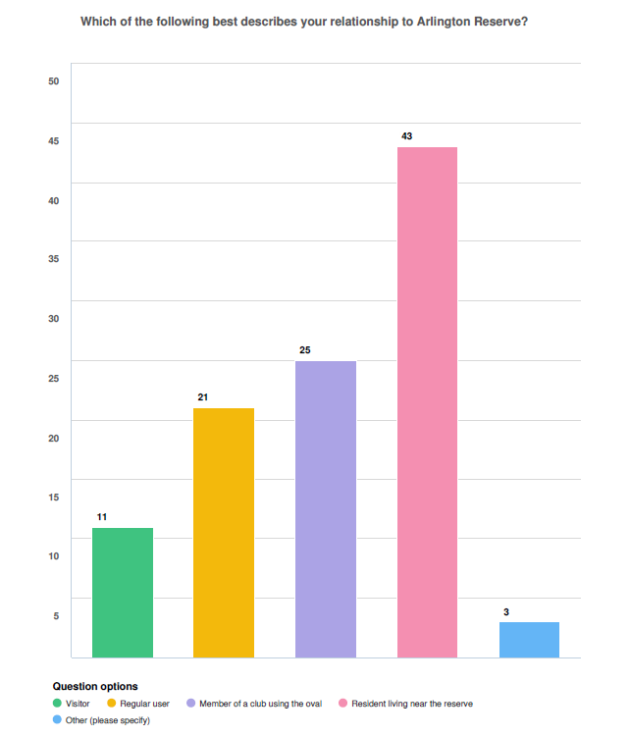

We asked in which suburb they lived. Top five responses:

  - Dulwich Hill 45
  - Other 11
  - Summer Hill 5
  - Annandale, Ashbury and Stanmore 3
  - Lewisham and Hurlstone Park 2
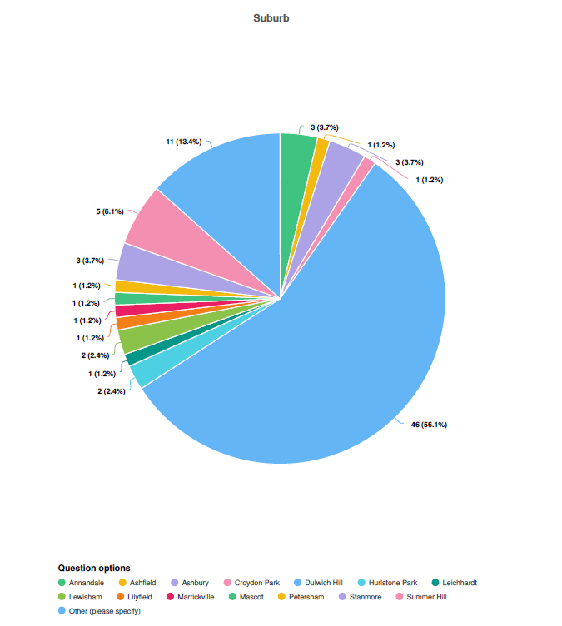

Do you support the draft Arlington Reserve Operational Plan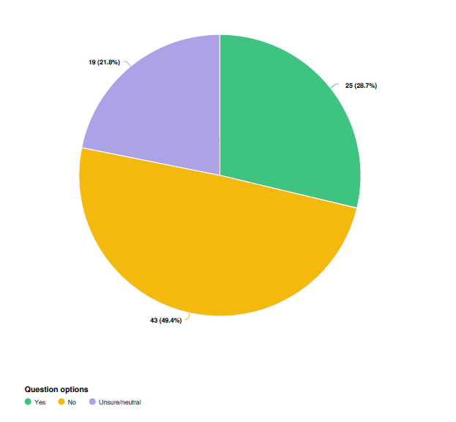

Responding to the community’s concerns

Community concern
The sporting club community indicated their concern about removing mid-week games from the roster as well as the change in lights out time from 9.20 to 9.10.
Officer’s response
The cut off time for lighting has now been recommended for 9:20pm

Community concern
Local community indicated concern with the level of access by the clubs (up to 41 hours a week). Comments related to reducing hours of access further to reduce issues related to parking, noise and the use of floodlights.
Officer’s response
Arlington Recreation Reserve sporting ground and grandstand was built in 1932 and has been in use as a sporting ground since this time. Council has an acute shortage of sporting grounds and the hours of use prescribed to sporting user groups is considered acceptable and balanced with residential needs.

Community concern
The structure of the Arlington Reserve Operation Committee. Particularly, the representation of residents on the committee, suggestions on who should be on the committee, as well as its vague terms.
Officer’s response
Council will develop a robust criteria around residential participation on the Arlington Reserve Operational Committee.

Community concern
Lack of enforcement mechanisms for breach of the Operational Plan and the Players and Spectators code of conduct.
Officer’s response
Council officers have revised the criteria around enforcement in the Operational Plan as well as provided evidence based mechanisms to guide decision making on non-compliance with the operational plan.

Community concern
Lack of clarity regarding community access particularly clarifying whether the community can access the Arlington Reserve before 9am.
Officer’s response
Access before 9am is permissible. Access on game days can be restricted by the sporting users if approved prior by Council.

Community concern
Diversity and inclusion particularly working with Aboriginal and Torres Strait Islander groups and / or Culturally and Linguistically diverse groups to provide opportunities to access the grounds to run sports clinics. Provide access to clubs that have girls and women’s teams.
Officer’s response
Council officers have revised the Operational Plan in this respect.

Community concern
Lack of servicing of the area including emptying rubbish bins frequently, monitoring noise levels, improving signage and the need for security guards to monitor and enforce the rules.
Officer’s response
These issues are resource operational and will be addressed separately to the Operational Management Plan for allocated use of the sporting ground.

