HAVE YOUR SAY
A practical plan to balance sporting use of Arlington Reserve with local amenity
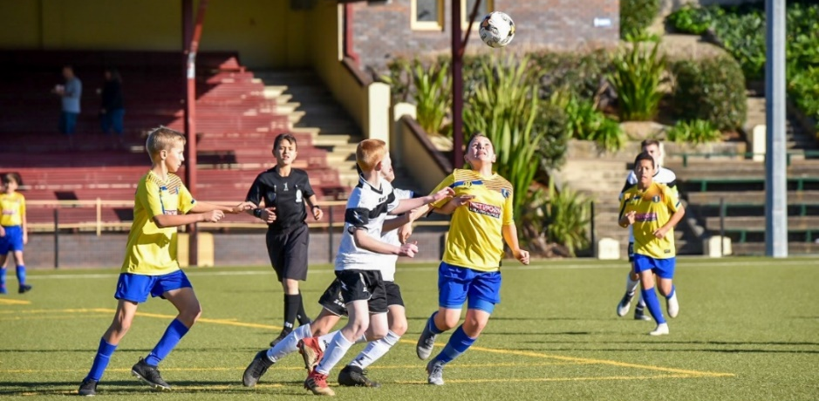

Image courtesy of Nick Hyde, Dulwich Hill FC
Dear Community member
We are renewing the Arlington Reserve Operational Plan and want to understand issues faced by local residents and sporting users as we develop a new plan for 2020.
What is an Operational Management Plan?
The Operational Plan is a practical plan in which we outline what we can do to improve overall management of the space in partnership with regular and casual users.
The Plan covers hours of use and allocation, compliance with traffic and car parking restrictions, minimisation of traffic generation, public access, hirer’s community liaison contact, noise, code of conduct and litter. The plan also includes a declaration section where users must sign to confirm their agreement with the terms.
Have your say
To develop this plan, we need to understand the issues you experience associated with the use of the space.
We invite you to tell us what you know by filling out our feedback form at yoursayinnerwest.nsw.gov.au
The last day to provide comments is Sunday 8 March 2020. All feedback will be considered in the development of the Arlington Operational Management Plan which will be publicly exhibited later in the year before going to the elected Council for adoption.
Enquiries
Please contact Aaron Callaghan, Parks and Recreation Planning Manager
P: 9392 5634 E: aaron.callaghan@innerwest.nsw.gov.au

Kind regards,
Simon Duck
Sports and Recreation Group Manager

