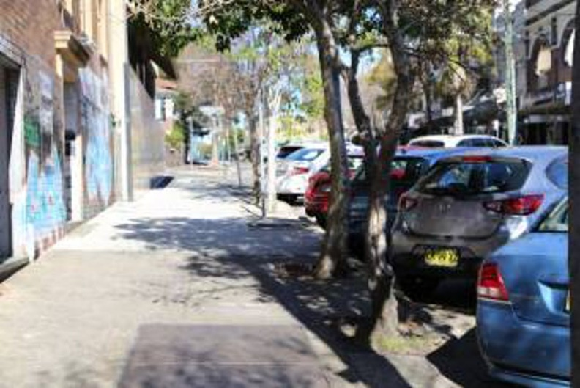

Balmain East Parking Study

Engagement outcomes report

Contents
Summary 3
Background 3
Stage 1 – Initial community insights 4
Overview 4
Engagement Methods 4
Promotion 4
Who did we hear from? 4
What did they say? 5
Stage 2 – Public Exhibition of the draft Balmain East Parking Study 7
Overview 7
Engagement Methods 7
Promotion 7
Who did we hear from? 7
What did they say? 9
Officer comments in response to public exhibition 10

Summary
This Engagement Outcomes Report outlines the feedback received during two stages of community engagement: the initial survey with the community and public exhibition of the draft Balmain East Precinct Parking Study.
The initial survey was conducted from February to March 2020. Overall, 369 people participated. Of these 83% lived in Balmain East, with other responses from neighbouring areas. Responses indicated 70% of the respondents have trouble finding parking daily in their area, and that the most difficult time to find parking near residences is evening/night.
This information was used to inform the draft study, which was placed on Public Exhibition in late October 2020. The community could provide feedback from 22 October 2020 until 20 November 2020. A total of 1,408 letters were mailed out with a colour map of the draft proposals, inviting recipients to provide comments online and via separate email and paper submissions.
Overall, 117 people provided feedback on the draft Balmain East Parking Study. The Your Say Inner West page had 512 visits and 89 submissions. A further 28 submissions were received via email, customer service enquiry, and post.
The feedback can be summarised into the following themes:
- The lack of parking enforcement in Balmain East
- General desire for the resident permit scheme (RPS) to be extended to areas currently not covered
- Disagreement with current RPS permit eligibility
- Mixed opinions about the pricing for second permits
- Further clarification requested regarding parking hierarchy and visitor permits.
Area specific feedback includes:
- Concern with the impact of Fernwick Restaurant
- Opposition to providing RPS spaces in the Gallimore Avenue carpark
- Requests to include Datchett Street residents as part of the proposed Darling Street RPS
- Increasing the supply of RPS spaces.
Officer comments to these key themes can be found on pages 9-10.

Background
The Balmain East Precinct Parking Study reviews how parking is managed and investigates opportunities for improvement. The review combines community sentiment and technical studies, including:
- Current parking management: Supply and demand of parking, distribution of residential and commercial parking including long-stay and short stay parking.
- A review of current parking strategies and policies, including permit allocation in the Resident Parking Scheme.

Stage 1 – Initial community insights

Overview
The initial survey was conducted from February to March 2020 with 390 participants. Of these 83% lived in Balmain East. 70% indicated that they had trouble finding parking daily in their area, and that evenings/nights are the most chosen timeframe for issues finding parking near their residence.

Engagement Methods
The community could provide feedback online via Your Say Inner West or request a paper copy of the questionnaire. Paper responses could be submitted via email or post.

Promotion
The opportunity to participate was promoted via:
- Council’s social media
- Your Say Inner West E-news and homepage
- Letters to residents and businesses
- Council website

Who did we hear from?
- Overall, 97% of respondents living in the Balmain East postcode area. Other responses came from neighbouring suburbs
- Most participants (79%) were received from people living in a house
- Less than half, 42% are usually able to park less than 100 metres away from their place of residence
- 49% have access to off-street parking at their residence while 28% of whom have more than one off-street parking space

What did they say?
The questionnaire asked participants about their views on different aspects of parking management in Balmain East, especially concerning ways to manage residential parking and commuter parking. The results and commentary are provided below.
Residential parking management
The sentiment between making changes and maintaining the status quo was close. Overall, 104 respondents believe paid Resident Parking Permits should only be allocated to residents of existing dwellings without any off-street parking.
In comparison, 99 respondents want to keep the system the same. This total is made up of 49 who want to keep the existing system of free residential parking permits and 50 who want to keep the existing system of free permits supported by better enforcement of time limits.
Figure 1: Respondents’ views toward addressing residential parking management
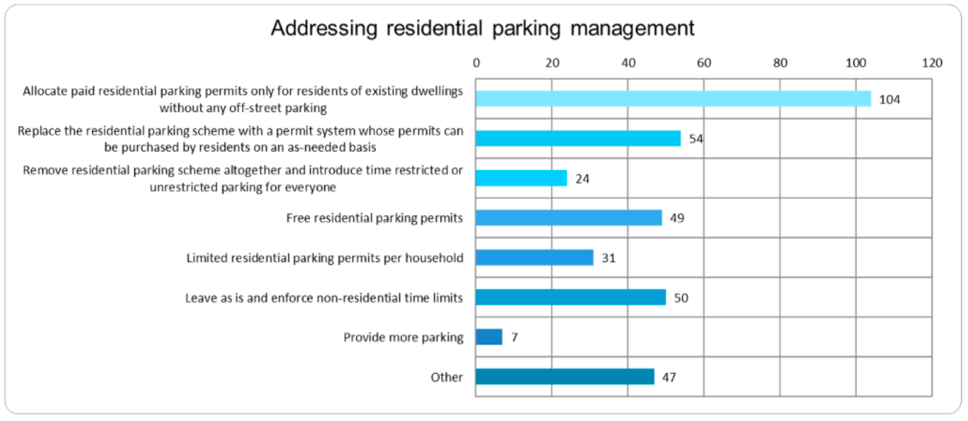
Managing commuter parking
The most popular mechanism supported by respondents is to deter commuter parking via weekday business hour time restrictions, which is how the existing BE resident parking scheme operates.

Figure 2: Respondents’ views toward addressing commuter parking
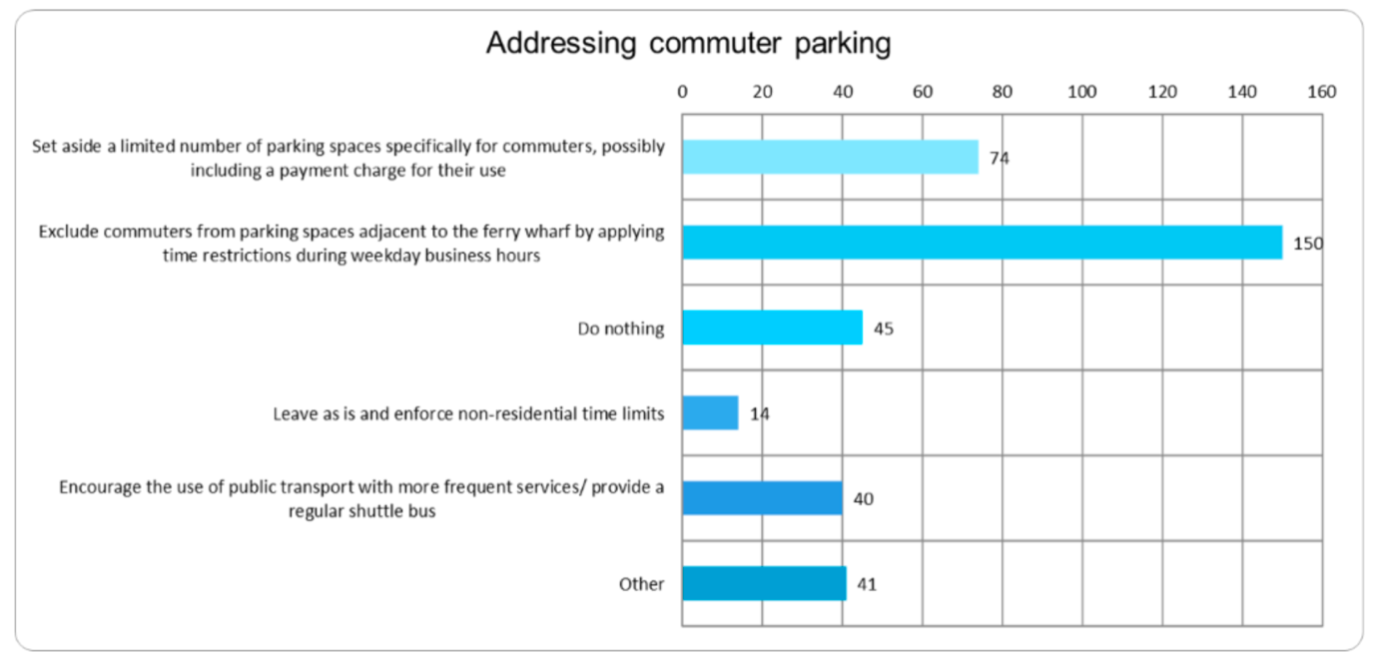

Stage 2 – Public Exhibition of the draft Balmain East Parking Study

Overview

The information from stage one was combined with technical studies to inform the draft study. Public exhibition commenced on 22 October 2020, ending 20 November 2020. The project page had 512 visits and 89 responses received. A further 28 responses were received via email, customer service enquiry, and post.

Engagement Methods
During public exhibition, the community could provide feedback via:
- An online feedback form on Your Say Inner West
- Via email
- Via post

Promotion
The engagement was promoted via:
- Letters mailed to 1,408 addresses, including residents and businesses, with a colour map of the draft proposals
- An email to participants of the initial engagement in February 2020
- Your Say Inner West E-News
- Council Website

Who did we hear from?
Those who provided feedback were mainly residents from Balmain East, with smaller groups of business operators, visitors and others. The data below reflects responses made via the feedback form on Your Say Inner West.

Figure 3: Graph showing responses to ‘Which of the following best describes you in relation to Balmain East?’
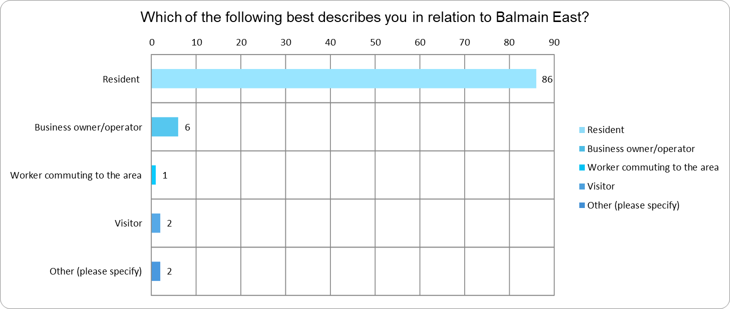
Figure 4: Graph showing responses to ‘suburb’.
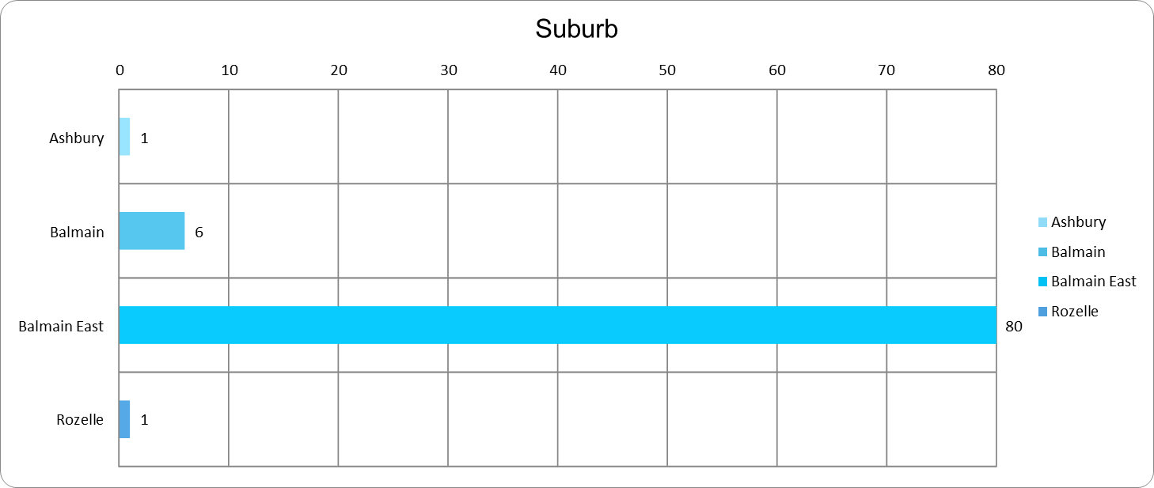

What did they say?
In total 89 responses were received via Your Say Inner West. Overall, most respondents (58 people) do not support the draft Balmain East Parking Study. Of the remaining respondents, 24 were unsure/neutral and 6 supported it.
There were 28 responses received via e-mail or mail, which did not definitely state their support or opposition and therefore have not been quantified as mentioned above.
Based on all responses provided, the main themes in the comments are summarised below:
Area-wide issues:
- Enforcement of existing parking restrictions is not up to standard. Multiple anecdotes of cars parked in ‘no stopping’ zones or staying long after the posted restriction. General community view that if enforcement was improved, many of Balmain East’s parking issues would be resolved.
- General desire from residents in non-RPS streets to be included in the RPS.
- Disagreement with the restriction on the number of permits available per household, especially the allowance for only one permit for households without on-site parking. Those that held this view frequently suggested that permits should be issued according to a household’s number of bedrooms.
- Mixed opinions on the introduction of pricing for second permits. Some residents completely oppose, while others conditionally support it depending on the price of the second permit
- Need to clarify the proposed parking hierarchy (found on pages 30-33 of the final report)
- Need to clarify policy for issuing of visitor permits in the future.
Locally-specific issues:
- Extension of trading hours at the Fenwick Restaurant impacts resident parking on nearby streets
- Opposition to proposed residential permit parking at the Gallimore Avenue carpark (Item 11)
- Expand RPS to Datchett Street as part of Item No. 2, particularly as many residents are ageing and cannot walk 500+ metres to the nearest unrestricted parking
- Increase the supply of RPS spaces on the eastern end of Clifton Street and the northern end of Gallimore Avenue so that spaces are more easily accessible to Clifton Lane residents by foot.

Officer comments in response to public exhibition

Staff have provided responses provided to main themes raised during public exhibition.
Area-wide issues | Response
Frequent comment that enforcement of existing parking restrictions is not up to standard. Multiple anecdotes of cars parked in ‘no stopping’ zones or staying long after the posted restriction. General community view that if enforcement was improved, many of Balmain East’s parking issues would be resolved. | Inner West Council’s Parking Services proactively patrols timed parking restrictions across the whole Inner West Council Local Government Area (LGA). Within Parking & Ranger Services there is a specialist Parking Analysis team, who monitor trends within parking throughout the LGA. They continually re-assessing parking patrol areas to determine the optimum allocation of resources.  If illegal parking, unrelated to timed parking, is reported Parking Services will attend to those complaints as soon as resources are available.
General desire from residents in non-RPS streets to be included in the RPS. | Staff will include properties on Datchett Street, Little Nicholson Street and Union Street in the RPS. These streets will be subject to the same Zone A restrictions as recommended in the study.
Frequent disagreement with the restriction on the number of permits available per household, especially the allowance for only one permit for households without on-site parking. Common alternative suggested that permits should be issued according to a household’s number of bedrooms. | The current policy of using off-street parking provisions and the number of vehicles is based on the permit guidelines outlined by the State Government, which is consistent with other Councils in NSW.
Mixed opinions on the introduction of pricing for second permits. Many residents completely oppose, while others conditionally support it depending on the price of the second permit. | References to pricing for a second permit have been removed from the final document.  Zone A does not allow a second permit.
Consistent comment that clarity should be provided on the proposed parking hierarchy. | Further information on the parking hierarchy is provided in p30-33 of the final report. It is anticipated that Council will include an overarching parking hierarchy in future policies, context or location dependant, which will align with existing Council policies.
Further clarity wanted on the issuing of visitor permits in the future. | In Zone A, dwellings that are eligible for a resident permit will receive up to 30 one day visitor permits per year.

Locally-specific issues | Draft response
Recurring comment that extension of trading hours at the Fenwick Restaurant impacts resident parking on nearby streets. | Nearby streets with RPS parking have a 2P restriction for non-permit holders. It is recommended that Council undertakes better enforcement of this area to ensure the 2P restriction is adhered to.
Opposition to proposed residential permit parking at the Gallimore Avenue carpark (Item 11) | Staff recommend that this remains unchanged because it will increase the supply of parking. The area is experiencing high demand from the current oversupply of resident permits relative to the number of spaces available.  Converting this car park to RPS parking will help manage the existing parking demand, and support residents in Clifton Lane when they are added to the RPS scheme. The 2P restriction enables visitors to park for short periods of time, improving turn over.
Frequent proposal to expand RPS to Datchett Street as part of Item No. 2, particularly as many residents are ageing and cannot walk 500+ metres to the nearest unrestricted parking. | Refer to area-wide recommendation above on Datchett Street and other streets.
Clifton Lane – Increasing the supply of RPS spaces on the eastern end of Clifton Street and the northern end of Gallimore Avenue so that such spaces are more easily accessible to Clifton Lane residents by foot. | The study has been amended to change the wording of the street affected to Clifton Street and Gallimore Avenue as this has created confusion for local residents. Council will mark new RPS spaces as requested on Clifton Street and Gallimore Avenue to provide better accessibility to Clifton Lane.

