22 October 2020
SJ:CED:34135412

<First last name>
<Address 1>
<Address 2>
<Suburb NSW 1234>

Dear Resident/owner
Have Your Say – making parking fairer in Balmain East
Following community feedback in February 2020 Council has developed a draft Parking Strategy to address key parking concerns and challenges in Balmain East. This study area is in the Balmain/Balydarru Ward and is bounded by the waterfront between Simmons Point, Peacock Point, Cooper Street and Jubilee Place. See the map of the area on page four.

How was the draft strategy prepared?
The strategy has been developed using information from:
- Feedback from the community via Your Say Inner West. The community was notified via a letter distributed to 1,500 residents
- Ongoing correspondence from the community about parking issues in the area
- Parking data collected in February 2020

What’s in the draft plan?
The plan includes short and long term strategies to better manage parking in the Balmain East area. The table below lists the intended actions and the streets impacted.
Short term strategies (0-5 years)
Item no. | Description | Streets affected | Priority
1 | Inclusion of additional properties in Clifton Lane to Residential Permit Scheme (RPS). These properties will be limited to One Balmain East (BE) permit only. | Simmons Street | High
2 | 2P 8am-10pm Permit Holders  Excepted area BE RPS expansion  in Darling Street between Duke  Street and The Avenue (this new  section will be limited to 1 BE permit and 1 visitor permit per property). Existing Bus Zone, Mobility Impaired Space and No Parking zones will remain. | Darling Street (between Duke Street and The Avenue) | High

Item no. | Description | Streets affected | Priority
3 | Reduction of 6m length No Parking zone in east side of Galimore Avenue, 30m north of Darling Street. | Galimore Avenue | High
4 | Parking management in Jubilee  Place. Angle parking opposite  Police Marine Area Command to be time limited 4P 8am-6pm Mon-Fri, subject to NSW Police Marine Area Command dedicating Jubilee Place  to Council as a public road. | Jubilee Place | High
5 | Work with carshare operators to  introduce additional fixed car share spaces in Balmain East. | N/A | Medium
6 | Development of parking hierarchy. | All streets within Balmain East | Low
7 | Replacement of redundant, faded, damaged signs. | Streets identified in the signage audit within study area. | Medium
Long term strategies (5+ years)
8 | 1P or 2P 8am-6pm Mon-Fri, 8am-  1pm Sat (no permit exceptions), 2P 6pm-10pm Mon-Fri Permit Holders Excepted area BE. Existing Bus Zones, Motorbike parking and Mobility Impaired spaces will remain. | Darling Street | High
9 | Changes to boat trailer parking  management consistent with other  areas within Inner West Local Government Area. | Streets with historical boat trailer issues. | Low
10 | Introduction of permit pricing on second residential permit. | All streets with RPS in Balmain East. | Low
11 | Introduce residential permit parking  in Gallimore Avenue carpark  (corner of Brett Avenue and  Galimore Avenue) | Galimore Avenue | Low
12 | Transition to permit zone type A  within Balmain East (Household  without any on-site parking spaces,  is eligible for one parking permit,  transferrable up to three nominated  vehicles registered to that address.  Households with one or more  spaces are not eligible for permits). | All streets with RPS in Balmain East | Low

Have your say
Let us know your views on the proposed study:
- Online at: yoursay.innerwest.nsw.gov.au
- By mail: addressed to Inner West Council, PO Box 14, Petersham, 2049. Please mark your feedback with reference - Balmain East Parking Study 34108693.

Last day to provide feedback is Friday 20 November 2020.

Do you want to know more?
For more information about this project visit yoursay.innerwest.nsw.gov.au.

Enquires
Contact me on 9392 5965 or email sunny.jo@innerwest.nsw.gov.au.

Sincerely,
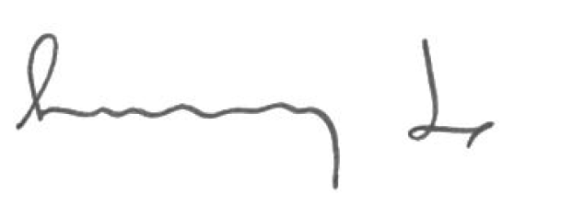

Sunny Jo
Traffic and Parking Planner

