Engagement Outcomes Report (Public Exhibition)

Creative Inner West:

Cultural Strategy 2021 - 2025

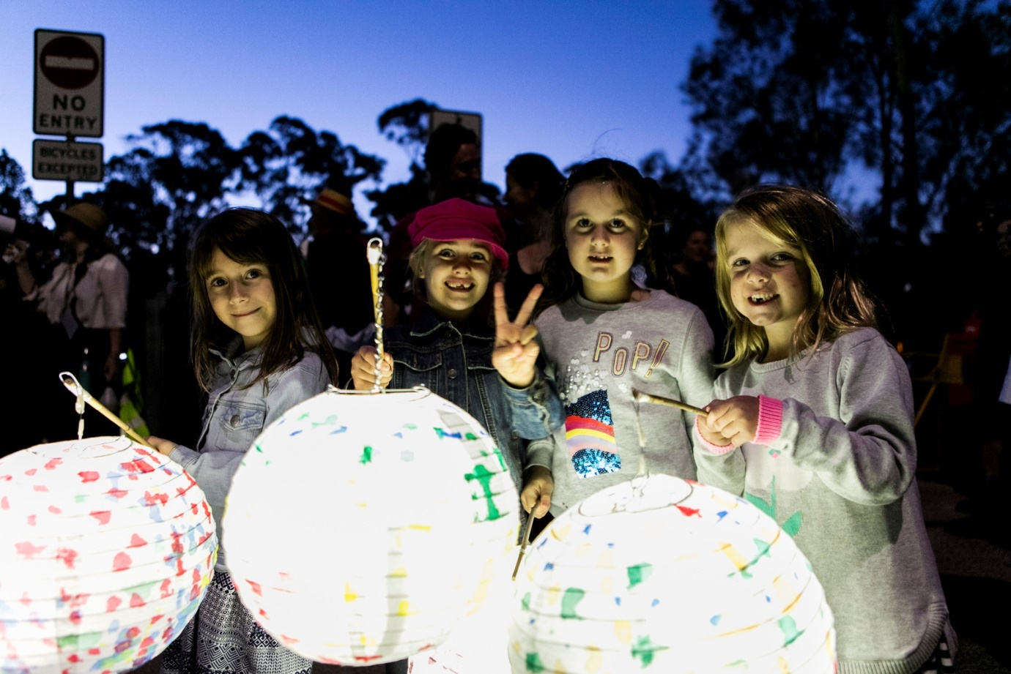
Picture: EDGE Greenway 2019

Contents
Summary 3
Background 3
Engagement Methods 3
Promotion 4
Engagement outcomes 5
Officer comments 6

Summary

The Creative Inner West: Cultural Strategy responds to the views and aspirations of our community drawing on conversations among community representatives, organisations, creatives and Council. This includes Aboriginal and Torres Strait Islander peoples and organisations, culturally diverse groups and networks, a broad range of creative industries, and people from different age groups and abilities.
Community feedback was supplemented by in-depth interviews and research with cultural production spaces and venues; and a social media campaign and online survey captured people’s ideas about Inner West culture.
More than 500 artists, makers, creatives, musicians, performers, creative entrepreneurs, community members and organisational leaders participated in the development of the strategy.
The Creative Inner West: Cultural Strategy sets out a vision, priorities and actions for Council and community partners to respond to the community’s needs and aspirations.
Engagement phases were as follows:
- Background research and engagement (2018)
- Creative Spaces research and engagement (2017 – 2019)
- Broad Cultural Strategy engagement (in person and online) (2019 - 2020)
- COVID impacts research (April – August 2020)
- Local democracy groups and internal workshopping (2020 – 2021)
- Public exhibition (August - September 2021)

Background

Following Council’s 2017 Creative Communities Notice of Motion, which included a Council commitment to local creativity and culture, Council undertook:
- Research into the local creative economy (2018)
- Research into local creative spaces, including:
- Planning Cultural Creation and Production in the Inner West LGA: A case study needs analysis (Western Sydney University, 2018)
- Creative Spaces and Venues Discussion Paper (Leftbank and JOC, 2019)
Council’s Executive endorsed the launch of the two Creative Spaces research papers in November 2019 and initiated the development of a local Creative Industries Economy Strategy. This was then developed into the scope for Creative Inner West: Cultural Strategy. Extensive research and engagement was carried out to develop the Draft Creative Inner West: Cultural Strategy.
On 8 June 2021 (C0621 Item 2) Council endorsed the Draft Creative Inner West: Cultural Strategy and Action Plan 2021 – 2025 for public exhibition.
This Report details the engagement and outcomes of public exhibition (Phase 6).

Engagement Methods
  - Meeting with Local Democracy Groups: Arts and Cultural Committee; Aboriginal and Torres Strait Islander Committee; Access Committee; Multicultural Advisory Committee
  - Meeting with Council Working Groups: Youth; LGBTIQ
  - Your Say Inner West survey
  - Email and phone conversations
  - Social media engagement (likes, comments etc)
  - Summary of Draft Strategy and invitation to comment translated into 5 community languages

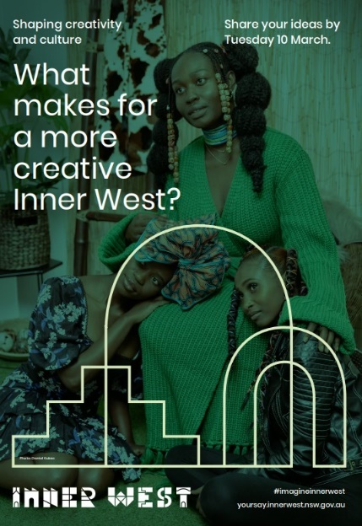
Promotion
  - Flyer in letterbox requesting feedback during Public Exhibition
  - Social media campaign
  - Living Arts e-newsletter (1500+)

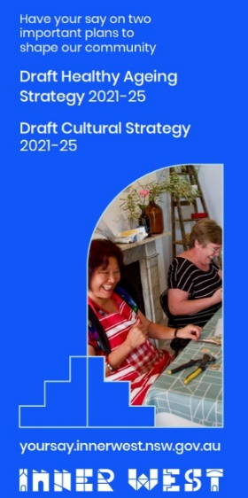
Engagement outcomes

Public Exhibition
There were 60 responses through Your Say Inner West. Of these:
- 80% of respondents support Creative Inner West: Cultural Strategy
- 17% of respondents support Creative Inner West: Cultural Strategy with changes
- 3% of respondents do not support Creative Inner West: Cultural Strategy

- Each of the 5 Focus Areas also had above 80% moderate, strong or complete support
- The definition of culture also had above 80% support for use without changes.
- Of YSIW respondent, 7% were Aboriginal or Torres Strait Islander, 7% identified as having a disability and 20% spoke a language other than English at home.
- 55% of respondents were residents, 3% were business owners, 15% were makers/creators, and 2% were visitors

Additional feedback was received from:
- 13 direct emails, including one submission from an organisation
- 1 phone call
- Council’s Aboriginal and Torres Strait Islander Committee
- Council’s Arts and Cultural Advisory Committee
- Council’s Multicultural Advisory Committee
- Council’s Access Committee
- Council’s Youth Working Group
- Council’s LGBTIQ Working Group
- Social media/ Facebook: 83 likes/ loves, 17 comments, 6 shares

Officer comments in response to public exhibition

Theme | Change to Strategy: | Change to Action Plan:
24 hour economy | Focus Area 3: Added Special Entertainment Precinct Pilot | Added Special Entertainment Precinct (3.4.4)
Aboriginal culture | Focus Area 1: Added “on country”, strengthened Aboriginal justice | Added Intellectual Property Framework (1.1.2); Aboriginal Naming Policy (1.1.3); Gadigal Wangal Wayfinding (1.3.2); early childhood (1.3.3); Teaching on Country (1.3)
Activating neighbourhoods | Focus Area 3: Added mainstreet activations | Added Mainstreet activation (3.3.7). Also considered as part of Inner West Fest, EDGE and Outdoor Dining Guidelines/ Public Activation Strategy
Affordable housing |  | Changed to "including" Affordable Housing Review to broaden opportunities (4.3.3)
Career pathways and learning |  | Strengthened careers and education (5.3.3)
Children and Young people | Focus area 2 and 5: Commitment to children and young people strengthened | Added Let's Play Strategy (5.1.4), strengthened careers and education (5.3.3)
Council creative spaces |  | Added evaluation of Artists in Residence program and Chrissie Cotter Gallery (4.4.2). Timeframe brought forward
Cultural exchange | Focus Area 2: Cultural intersection and exchange strengthened
Viability/ fair payment of artists and venues | Focus Area 3: viability of artists and venues added
Inclusive of everyone (not only supporting specific groups) | Focus Area 2: Renamed to Culture is for everyone, to focus on inclusion, diversity and unity. | Changed actions to focus on inclusion, exchange and bringing people together (2.1.1 - 2.2.5).
LGBTIQ | Focus Area 2: Included LGBTIQ arts | Added celebrating LGBTIQ in public places (2.2.4)
Partnerships |  | Added Aboriginal partnerships (1.2.1), creative partnerships (5.1.5)
People living with a Disability | Focus Area 2: Strengthened inclusion. Use words "People With a Disability", description in appendix | Strengthened inclusion (2.1.1, 2.1.2, 2.2.3)
Street Art |  | Added support street art (3.3.6)
Sustainability/ Nature | Focus Area 5: Strengthened sustainability, connection to nature. | Strengthened sustainability and connection to nature (5.1 - 5.1.3)
Technology | Focus Areas 3 and 5: Technological change and opportunities added
Wellbeing | Focus Area 5: Added connection between creativity and wellbeing | Connection between creativity and wellbeing added to Priority (5.1, 5.1.1)
Wording and clarity | All Areas: Minor wording changes throughout Strategy | Minor wording changes throughout Strategy and Action plan as necessary

