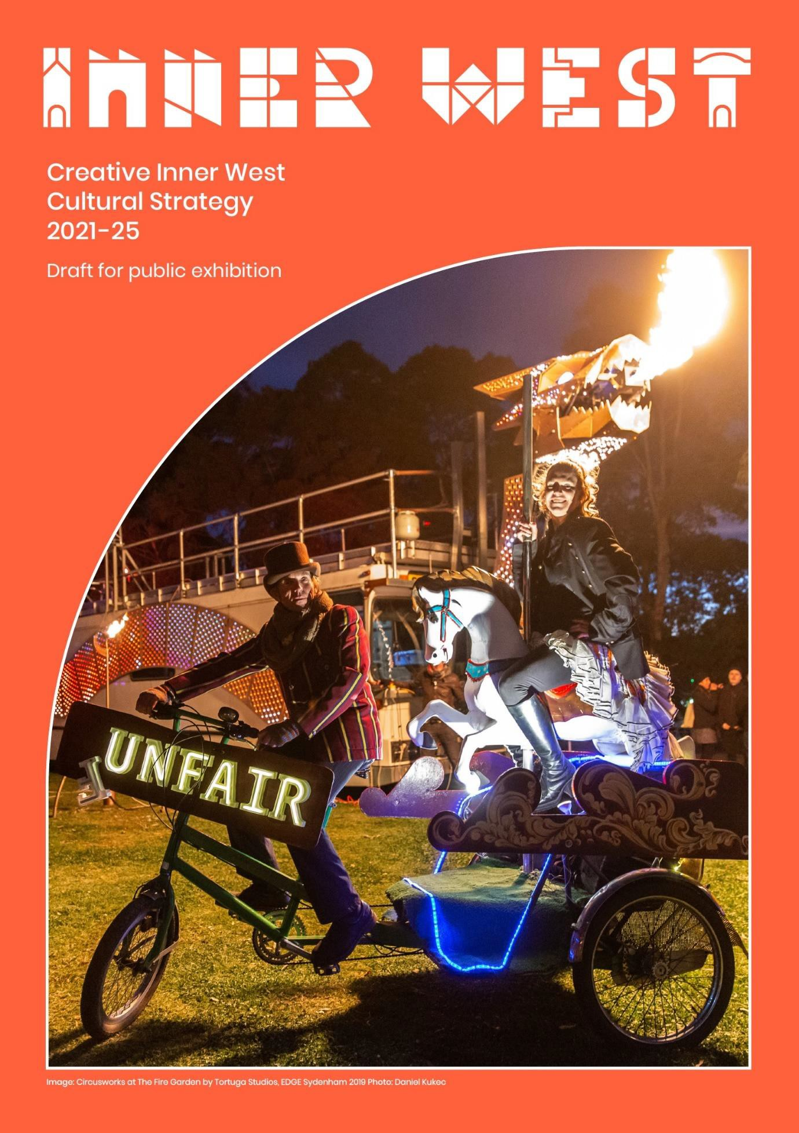

Contents
Creative Inner West: A cultural strategy for the Inner West 4
How do we define culture? 5
Profile of the Inner West creative sector 6
How was Creative Inner West developed? 6
A vision for culture and creativity in the Inner West 6
Council’s role 7
Strategic focus 8
Focus areas 8
- Aboriginal and Torres Strait Islander cultures at the centre 8
- Diversity enriches us and makes us stronger 9
- Love Inner West, day and night 10
- Culture’s role in our growing places 10
- Imagining our future together 11
Strategy implementation and measuring outcomes 12
What has been delivered to date? 16
Resourcing 17

Aboriginal and Torres Strait Islander Statement

Inner West Council acknowledges the Gadigal and Wangal peoples of the Eora Nation, who are the traditional custodians of the lands in which the Inner West local government area is situated.
We celebrate the survival of Aboriginal and Torres Strait Islander cultures, heritage, beliefs and their relationship with the land and water. We acknowledge the continuing importance of this relationship to Aboriginal and Torres Strait Islander peoples living today, despite the devastating impacts of European invasion. We express our sorrow for past injustices and support the rights of Aboriginal and Torres Strait Islanders to self determination.
Inner West Council understands our responsibilities and role in working with the Aboriginal community to promote cultural heritage and history, address areas of disadvantage, and protect and preserve the environment as well as sites of significance to Aboriginal peoples. In doing so, we acknowledge that Aboriginal cultures continue to strengthen and enrich our community.
Today, diverse groups of Aboriginal and Torres Strait Islander peoples live and work across Inner West. We admire the resilience displayed in their significant achievements and in making immense contributions to both Council and the broader community.
Inner West Council is committed to embedding the values and perspectives of the Aboriginal and Torres Strait Islander communities to ensure we learn from the mistakes of our past and forge a positive future of long-lasting value built on mutual respect, equality and opportunity.

Creative Inner West: A cultural strategy for the Inner West

Executive summary

Culture and creativity are essential for healthy, thriving communities.

As Australia’s cultural production hotspot,^{i} the Inner West is celebrated for its dynamic and diverse creative sector, and the significant cultural contribution it makes locally, nationally and internationally.
Like its contemporaries across the world, the Inner West’s creative community was among the first and hardest hit by the impacts of the COVID-19 pandemic delivering unprecedented challenges for the sector.
Inner West Council is committed to working with our local creative sector to support its recovery and promote strong growth well into the future.
The Creative Inner West: Cultural Strategy 2021 – 2025 has been shaped through consultation and engagement with the creative sector and the broader community, as well as a review of international leading practice approaches.
Supported by a comprehensive Action Plan, the strategy is designed to be delivered in collaboration with the community across five key areas:
- Aboriginal and Torres Strait Islander cultures at the centre
- diversity enriches us and makes us stronger
- love Inner West, day and night
- culture’s role in our growing places
- imagining our future together.

Introduction

The Inner West is a critical contributor to Sydney’s creative ecosystem.

Our local creative sector is recognised nationally and internationally for leading independent making and creating, and for seeding creative productions of regional and national significance.
Inner West Council acknowledges that this is a critical time for local arts and culture. In addition to the significant impact of the pandemic on the sector, increasing living costs, finding affordable living and production spaces are an ongoing challenge.
Council recognises the importance of its role in collaborating with the community to support the continued contribution of arts and culture to our social and economic life, and to promote culture as a vehicle for equity, community leadership, and social and environmental change.

This four-year strategy provides a framework for Council’s vision and commitment to preserving and growing culture and creativity in the Inner West.

How do we define culture?

Culture means different things to different people. In the Inner West, the community’s understanding of culture is influenced by its strong heritage of cultural diversity and practicing artists.
For the purposes of Creative Inner West: Cultural Strategy, Council uses the following definition:

Culture is: the way we live and express ourselves in the world, including making, sharing and participating in creativity and drawing on our customs, stories, heritage and beliefs.

Artists, cultural groups, residents, visitors and businesses all help to create our distinctive cultural life. Culture can also inspire new ways of thinking and living in a changing world.
Additional definitions used in Creative Inner West: Cultural Strategy are provided in the glossary on page 14.

Profile of the Inner West creative sector

The Inner West is a national leader in urban creativity and culture.

Creative and cultural industries contribute $1.4 billion each year to the local economy and employ 6,500 people.^{ii}, one in 10 local residents work in the creative and cultural sector, and over half of these are cultural producers, making the Inner West Australia’s cultural production capital.^{iii}
The area is the base for long-established artists and cultural groups who have made their home here for generations, and much of the creative activity in the Inner West has thrived because our community were pioneers of multiculturalism and artist run initiatives.
We embrace difference and experimentation, and the everchanging expressions of culture. Residents, businesses and visitors are drawn to our cultural diversity across food, street life, local artisan products, community groups and campaigns and some of Australia’s most impressive street art.
The Inner West is home to over 60 live music and performance venues, including the renowned Enmore Theatre, more than 100 artist studios, a wealth of grassroots arts and cultural organisations (including Australia’ largest community centre, The Addison Road Centre) and Boomalli, one of Australia’s first urban Aboriginal artist co-operatives.
Culture and creativity are truly woven through our local community, economy and sense of place.

How was Creative Inner West developed?

The Creative Inner West: Cultural Strategy responds to the views and aspirations of our community drawing on conversations among community representatives, organisations, creatives and Council. This includes Aboriginal and Torres Strait Islander peoples and organisations, culturally diverse groups and networks, a broad range of creative industries, and people from different age groups and abilities.
Community feedback was supplemented by in-depth interviews and research with cultural production spaces and venues; and a social media campaign and online survey captured people’s ideas about Inner West culture.
More than 500 artists, makers, creatives, musicians, performers, creative entrepreneurs, community members and organisational leaders participated in the development of the strategy.
The Creative Inner West: Cultural Strategy sets out a vision, priorities and actions for Council and community partners to respond to the community’s needs and aspirations.

A vision for culture and creativity in the Inner West

The Creative Inner West: Cultural Strategy aims to embed culture at the heart of the Inner West, now and for future generations. It strives to grow the Inner West as the creative engine of Sydney, as a destination and a leader in cultural equity.

Based on feedback, the Inner West community shares a vision that promotes: Greater diversity:
- Aboriginal and Torres Strait Islander arts and culture have a central role in our places and creative life
- Cultural diversity is supported and celebrated, and emerging cultures are nurtured Community values:
- Arts and culture promote our values of equity, inclusion and environmental sustainability
- Our culture maintains its grassroots, independent character A creative life:
- Urban places provide abundant opportunities to access creativity and culture at all stages of life
- Creative spaces, town halls, schools and libraries are hubs of creative activity A sense of place and a strong economy:
- Our streets and shopfronts are home to buzzing arts and culture, day and night
- Culture is embedded into local places, including arts and culture in public spaces and Council facilities
- We are a hub for Sydney’s cultural production and small to medium arts sector
- We nurture local homegrown artists, organisations, products and events, including young and emerging creatives
Leadership:

- Council is committed to sustaining culture and creative industries as an invaluable part of our social and economic fabric
- Our creatives and diverse cultures provide leadership for a sustainable future Better planning:
- Culture and creativity have an important role in Council decision-making and planning

Council’s role

The Community Strategic Plan (CSP) Our Inner West 2036 guides Council to achieve the outcomes that the Inner West community has identified as priorities. The CSP belongs to the community and is facilitated by Council on their behalf. The CSP aims to:
- inform our strategic decision-making that will shape our future community, economy and environment
- protect and enhance the community’s values and heritage
- pave the way for the future through proactive planning for the impacts of change
- strive for inclusivity, sustainability, resilience, accountability and innovation.
Within this context, Council has identified key responsibilities that support the Creative Inner West Cultural Strategy:

Custodian: Caring for our Aboriginal and Torres Strait Islander history and culture, as well as the layers of migrant heritage, emerging cultural practices and creative places
Leader: Cultivating a vision for people and places to respond to local and global issues, and produce innovative content and products
Collaborator: Connecting communities, businesses and all levels of government to work together in partnership for a creative life
Commissioner: Funding and commissioning creative works and projects, seeding new ideas and providing support to the small to medium cultural sector
Producer: Co-designing projects, artworks and infrastructure with our creative and cultural communities

Enabler: Empowering creatives and organisations to develop professional capacities, projects, creative spaces and events
Advocate: Promoting the vital importance of local cultural and creative practitioners, organisations and venues to our social and economic life, and to Greater Sydney

Strategic focus

The following themes emerged from community conversations and research into national and international best practice. The Creative Inner West: Cultural Strategy will focus on five areas:
  - Aboriginal and Torres Strait Islander cultures at the centre
  - diversity enriches us and makes us stronger
  - love inner west, day and night
  - culture’s role in our growing places
  - imagining our future together

Following are further details of each area including the initiatives to realise Creative Inner West’s vision. Actions are detailed in the Creative Inner West Action Plan.

Focus areas

Aboriginal and Torres Strait Islander cultures at the centre

Aboriginal and Torres Strait Islander cultures have central importance; local cultural leadership and expressions are nurtured.
The Australia Council for the Arts has stated that supporting First Nations arts and culture is perhaps the single greatest contribution we make to our national and global identity^{iv}. The Creative Inner West: Cultural Strategy provides an opportunity for Council and our community to promote justice and systemic change for Aboriginal peoples, and to support local Aboriginal arts and culture.
The Inner West is home to more than 2,000 Aboriginal and Torres Strait Islander peoples, the long standing Boomalli Aboriginal Artists Co-operative and some of Australia’s most successful Aboriginal artists.

Our local Aboriginal community wants public cultural programs and artworks to be led by Aboriginal peoples and organisations, and for public art and placemaking to tell the truth about our national history. By providing more leadership opportunities for Aboriginal artists and cultural leaders, Council can support broader opportunities and employment in the creative and cultural Industries.
Local places are a rich opportunity to share culture and learn from each other, and there is a desire within local Aboriginal communities and non-Aboriginal communities to connect with local Aboriginal culture through mapping and understanding local places. The community believes this can be achieved through cultural exchange, including language and digital storytelling, and particularly with Aboriginal Elders.

Initiatives:

- Create connections to Aboriginal history and culture through Aboriginal-led public art, performance and placemaking
- Demonstrate justice and equity for Aboriginal peoples through local arts and culture
- Support local sharing of Aboriginal culture through place-based learning and exchange
- Create leadership and employment opportunities for Aboriginal organisations, artists, curators and cultural leaders

For the purposes of Creative Inner West, when the word Aboriginal is used, it refers to Aboriginal and Torres Strait Islander peoples of the Inner West.

Diversity enriches us and makes us stronger

Diversity makes our lives richer and our communities stronger; we commit to cultural diversity, equity and inclusion.
The Inner West community includes 52,000 people who speak a language other than English at home^{v}.

We celebrate diversity in all forms, and the diversity of local culture is key to our identity and strength.. Diversity feeds our cultural life and a significant proportion of our local artists and cultural organisations are from diverse cultural backgrounds, are older people, , are living with a disability, and / or identify across a range of genders and sexual orientations.
Our cultural life is made richer by young creatives, emerging cultures and new ideas. Local culture is also closely linked with our community values. We host homegrown grassroots organisations that lead community campaigns on significant issues such as racism and gender discrimination.
Nurturing local inclusion and diversity requires breaking down physical, social and economic barriers to participation, sharing culture to create mutual understanding, and nurturing talented creatives and cultural producers through to further employment and leadership positions. Increased access to creative opportunities for diverse communities and people with a disability are a focus. Diverse community groups can help to provide leadership on creating a truly inclusive cultural life and how to get there.
Initiatives:
- Work with people from diverse backgrounds to support equity, belonging and representationCelebrate and share diversity in the Inner West

Love Inner West, day and night

The Inner West is a buzzing cultural hub by day and night; local creatives thrive at the heart of our economy and identity.

The small to medium creative sector, including independent creatives, community galleries, venues, production spaces and artist run initiatives, are the foundations of culture in the Inner West. These are the places where our local artists and performers take risks, nurture their talent, and build their audiences and content. The amount of new work generated in the small to medium sector far surpasses that of our major cultural institutions making it fundamental to Australia’s cultural landscape. ^{vi}

With the move by audiences to more intimate, local experiences as a result of COVID, the Inner West has an opportunity to promote our thriving small to medium creative sector to local audiences and as a destination for Greater Sydney and beyond. This includes spotlighting the Inner West as the heart of Sydney’s live music scene. Focussing cultural programming in precincts and neighbourhoods based makes the most of the creative energy and activity that already exists in the community. Examples of neighbourhood based cultural programming include tours, artist activations and public artworks across a range of artforms.

Council acknowledges that creative venues and activities are often faced with a range of regulatory barriers and is committed to improving regulatory conditions for creative activities and the nighttime economy. This includes developing pathways for creative activations in shopfronts, warehouses and public spaces, and extending opening hours for suitable businesses.

This strategy is an opportunity to renew how Council works with the local sector, including access to funding, employment opportunities, advocacy, professional networks and supportive regulatory conditions.
Initiatives:
- Support and showcase the Inner West as a leading hub of independent arts and cultural producers
- Stimulate the creative economy by simplifying regulatory conditions and providing planning support
- Enliven precincts and neighbourhoods with cultural programming and activations
- Support the Inner West 24 hour economy
- Build capacity of the local sector, including networking, training and advocacy

“In nearly all modern post-industrial economies, ‘cultural occupations’ and creative industries are growing as a share of total jobs and are making greater contributions of value to local and national economies. Creative and cultural activity is recognised as a driver of job creation, employment, entrepreneurship and productivity, and contributes positively to both design led industries and to place- making and management.”^{vii}

Culture’s role in our growing placesPlaces with soul; arts and culture enlivens our public spaces and cultural infrastructure sustains our creative city.
Urban infrastructure planning is often framed around meeting the community’s health, housing, education and transport needs. At times, cultural infrastructure is not an equal part of the equation. As our places densify, culture can support social connection, a creative life and ensure the Inner West still feels like home. Cultural infrastructure includes public art, creative spaces, affordable housing for artists and cultural enlivenment opportunities accessible by all members of the community. Embedding culture and placemaking into parks, open spaces and Council facilities are an important opportunity for the future of our community.
Inner West Council has identified creative spaces as a priority for local cultural sustainability. This is supported by the Council of Capital City Lord Mayors 2021-2024 Strategic Plan, which identifies cultural infrastructure as a top priority. The Inner West’s industrial buildings for cultural production have become an essential part of independent making and creating, supplying major creative productions of regional and national significance, and providing an essential small to medium layer for Sydney’s creative ecosystem.
Council recognises its important role to support the supply of affordable cultural production spaces, including protecting industrial employment lands from re-zoning and optimising and expanding Council- owned creative spaces.
Music and performance venues and artist run initiatives have also historically thrived in Inner West industrial areas and on our main streets. Relevant policies that support the operational needs of creative activity need to be developed to strike a balance with other needs, such as residential encroachment or changing community expectations.

Initiatives:
- Ensure public art and cultural activation are integrated into public spaces and parks in the Inner West to support discovery and belonging
- Planning policies support creativity and culture, including the supply and affordability of cultural production spaces
- Create ongoing opportunities to provide creative spaces, creative employment and affordable housing for artists through development policies and partnerships
- Consolidate and expand Council-owned creative spaces and optimise the community cultural benefit provided, including town halls
- Implement planning approaches that protect local creative precincts and activities and balance these with other local needs

- Imagining our future together

Artists and cultural leaders help us imagine the future; working with Council and community on change and adaptation.
COVID19, the 2020 bushfire season and the 2021 floods highlight that new ways of thinking and living are urgently needed. Arts and culture shine a spotlight on local and global issues and have a key role in generating new ideas. Creative Inner West: Cultural Strategy will incubate ideas through local community discussions, creative labs and activations, including utilising new technologies and connecting with natural places. This will provide leadership on local responses to the climate emergency and social issues, such as justice for Aboriginal peoples, gender equity and healthy ageing.
Children and young people have an important part to play in helping to create a future that is rich in ideas and fit for future generations. The strategy supports creative opportunities for children and young people and provides connections and pathways into local public life and decision-making processes.
The creative sector also leads the way in co-design and inclusion in planning and implementation of services and infrastructure.
More broadly, Council will develop and implement an evaluation system and work closely with groups such as Council’s Arts and Culture Advisory Committee to ensure its programs and approaches are meeting all of the community’s needs.

Initiatives:
- Facilitate creative initiatives that support reimagining our future
- Enable the creative and cultural sector to have an increased role in place planning and local decision- making processes
- Promote new cultural leaders and voices

Strategy implementation and measuring outcomes

Implementation of the Creative Inner West: Cultural Strategy 2021 – 2025 will be overseen by a range of Inner West Council teams and community partners.
Council will evaluate the impact and success of the strategy through clearly defined measures, which are detailed in the strategy’s Action Plan.

Glossary

Definitions below are those developed by Inner West Council based upon sector research and existing industry definitions.
Creative and cultural industries: the definition used is based upon the research of David Throsby and UNESCO. It includes literature, music, performing art, visual arts, films, museums, galleries, photography, libraries, advertising, architecture, design, fashion, heritage services, publishing and print media, television and radio, sound recording, computer games.
Cultural production: the making of cultural products, including craftspeople, music and theatre production and visual artists. It generally involves direct-to-consumer products and services, including developing, testing and creating. Cultural production often occurs in flexible warehouse spaces.
Creative services: commercial business-to-business services, including advertising, marketing, architecture, design and software and digital content development. These are often technology-based and desk-based and are found more typically in office and retail spaces.
Cultural presentation: the performing and exhibiting of culture, usually taking place in venues, such as music and performance venues, community spaces, galleries and libraries.
Cultural infrastructure: spaces where people come together to create, share and enjoy arts and culture, including theatres, galleries, museums, libraries, archives, community halls, cinemas, public art and outdoor events spaces. It can also include infrastructural support for artists including affordable housing.
Creative spaces: are creative spaces and venues for the purpose of making, producing and presenting culture, for professional and community-based creativity as well as mixed use spaces that house creative uses.
Creative enterprise: cultural and creative organisations or initiatives whose aims and projects have a community or social benefit. The governance structure of a cultural enterprise may be for-profit, but the activities of the venture must demonstrate community benefit.
Placemaking: communities participating in the shaping and reimagining of public spaces. Placemaking capitalises on a local community's assets, inspiration, and potential, with the intention of creating public spaces that promote people's health, happiness, and well-being.
Agenda 21: Agenda 21 for Culture was approved by the Committee on Culture of the World United Cities and Local Governments (UCLG). The Agenda describes that Culture and Cultural Strategies should have central importance in local governance, and that in turn, local culture should have a significant role in national culture. Cultural Strategies are a key means for supporting the aims of Agenda 21, such as embedding culture’s role in human rights, spiritual and emotional health, economy, social inclusion and the conditions for peace.

Appendix

Inner West Council’s Integrated Planning and Reporting Framework

Under the NSW Local Government Act 1993, Councils are required to develop a hierarchy of plans known as the Integrated Planning and Reporting (IPR) Framework. This framework assists councils to deliver their community’s vision through long, medium and short-term plans.

The purpose of the framework is to formalise strategic and resource planning across NSW councils and to ensure long-term planning is based on community engagement leading to a more sustainable local government sector.

The Inner West Community Strategic Plan (CSP), Our Inner West 2036, identifies the community’s vision for the future, its long-term goals, and strategies to get there. It also outlines how Council will measure progress towards the vision.

There is increasing recognition governments need to move beyond recognising only social, economic and environmental sustainability, to acknowledging culture as the fourth pillar of sustainability.^{viii}

Culture and creativity feature significantly in the Inner West Community Strategic Plan (CSP), Our Inner West 2036 and the Local Strategic Planning Statement, Our Place Inner West (LSPS). Creative Inner West supports the delivery of the CSP and LSPS by addressing a number of priorities in these plans:

  - Creative communities and a strong economy
  - Unique, liveable, networked neighbourhoods
  - Caring, happy, healthy communities
  - Progressive local leadership
  - An ecologically sustainable Inner West

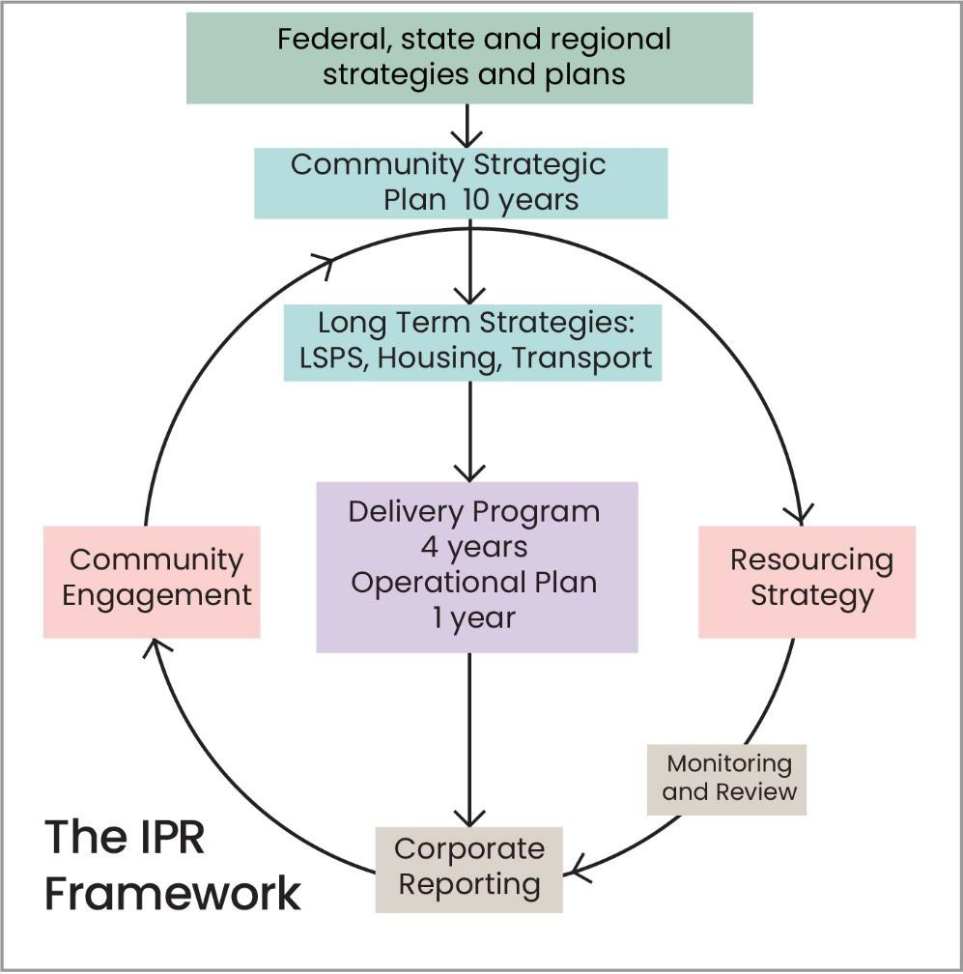

Inner West regional and state context

The Inner West is impacted by city wide, state and federal planning frameworks, and fits within a number of broader plans that guide our development and priorities. Some of these include the Greater Sydney Commission Eastern District Plan (A vision to 2056;, The 24 Hour Economy Strategy 2020; Global NSW; and NSW Cultural Infrastructure Plan 2025. Key elements for the Creative Inner West: Cultural Strategy 2021 – 2025 are:
- the preservation of industrial land for cultural production (Greater Sydney Commission Eastern District Plan 2056)
- support of 24 hour cultural activity (24 Hour Economy Strategy, Global Sydney 2020)
- the importance of cultural infrastructure in urban development (NSW Cultural Infrastructure Plan 2025)
There are major state renewal initiatives underway in the Inner West, including Parramatta Road Urban Renewal, Whites Bay Urban Renewal Precinct, WestConnex, GreenWay Missing Links and the Sydenham to Bankstown Metro, all of which bring challenges and opportunities to our community.
Culture is also a major driver underpinning the hospitality and tourism industries and are embedded in a range of federal and state strategies to support sectors such as tourism, technology and innovation.

What has been delivered to date?
Council is already investing significantly in arts and cultural provision, programs and strategic support. Key highlights include:

  - Project with Mirvac to deliver the $45 million Marrickville Library and partnership with West Connex and other funding bodies for $4.5 million upgrade of Haberfield Library
  - Partnerships with Sydney Biennale, Roads and Maritime Services, Marrickville Metro and Westconnex to deliver new public artworks and artist residencies
  - Public art commissions including 17 new works at Marrickville Metro, 5 major street art works with Westconnex, new artworks at the new Ashfield Aquatic Centre and Pategerang Place, and Greenway Missing Links Program including $1million for public artworks across 13 sites from Iron cove Bay to the Cooks river.
  - Gadigal Wangal Placemaking projects to deepen our connection to Aboriginal culture in each Ward
  - $175,000 per annum of funding for artists and cultural groups through Independent Artist, Artist and Multicultural Grants and $350,000 for creative sector COVID response grants
  - Offering a range of cultural planning support including Open and Creative Inner West regulatory reforms to activate mainstreets and the night time economy and Council’s Arts and Cultural Advisory Committee
  - EDGE Inner West delivering annual place based creative activations and artworks. In 2018/19 EDGE employed 1193 local artists and partnered with 150 local businesses and attracted 36,000 attendees
  - In 2019, Council events attracted visitations of 120,000 people over the year, engaging 200 creatives for performances, workshops and demonstrations and working with more than 250 local businesses and community organisations
  - Delivering an annual exhibition program at Chrissie Cotter Gallery and Newtown ArtSeat
  - The new musical instrument library at Ashfield Library from diverse instruments from around the world. 10,000+ people visit Marrickville Library per week and close to $1 million / year on providing the community with an updated collection
  - An Annual film festival for International day of people with disability, curated by people with lived experience of disability with a live panel. This festival is a hybrid festival and is fully accessible with an audience of 300 people
  - Expanding the award-winning Perfect Match program across the LGA, delivering 15 artworks in 2019
  - Producing the Creative Trails and Tours Program over 4 precincts, offering insights into the creative workings of local artists and studios
Offering 13 creative spaces for artists in residence across 7 Council properties
  - A range of community cultural and creative programs, including at the Refugee Welcome Centre, for NAIDOC week, youth programs, including SPARK Youth Theatre, and programs for older people and people with a disability

Resourcing

Creative Inner West will be resourced through the Our Inner West 2022 Delivery Program, existing Council Programs and will intersect with other local strategies including the:
  - Land and Property Strategy 2019
  - Voluntary Planning Agreement Policy 2019
  - Recreation Strategy 2021
  - Community Assets Needs Strategy 2021
  - Economic Development Strategy 2020
  - Public Domain Guidelines 2021
  - Employment and Retail Lands Study 2020
  - Inclusion Action Plan 2017
  - Climate and Renewables Strategy 2019.

References

i Stuart Cunningham et al (2021) Australian Cultural and Creative Activity: A Population and Hotspot Analysis: Marrickville, ARC Linkage. Accessed on 15 May 2021: https://research.qut.edu.au/dmrc/projects/australian-cultural-creative-activity-a-population- hotspot-analysis/
iieconomy.id the population experts (2018) Inner West Cultural and Creative Sector. Accessed on 15 May 2021: https://public.tableau.com/profile/economyid#!/vizhome/InnerWestCulturalAnalysis_0/InnerWest
iii Stuart Cunningham et al ibid.
iv Australia Council for the Arts (2020) Re-imagine: What next?, Discussion paper p.2. Accessed on 15 May 2021: https://www.australiacouncil.gov.au/programs-and-resources/re-imagine-what-next/
v.id.community (2020) Inner West Council community profile. Accessed on 15 May 2021: https://profile.id.com.au/inner-west/non- english-speaking-introduction
vi National Association of the Visual Arts (2017) The economics of Australia’s S2M visual arts sector. Accessed on 15 May 2021: https://visualarts.net.au/advocacy/policy-and-research/small-medium-s2m/
vii Greg Clark et al (2018) Culture, Value and Place: A report for NSW Department of Planning and Environment. Accessed on 15 May 2021: https://create.nsw.gov.au/wp-content/uploads/2018/12/Volume-1-Culture-Value-and-Place-Report-March-2018-Greg-
Clark.pdf
viii Jon Hawkes (2001) The Fourth Pillar of Sustainability: Culture’s essential role in public planning. Accessed on 15 May 2021: http://www.culturaldevelopment.net.au/community/Downloads/HawkesJon%282001%29TheFourthPillarOfSustainability.pdf

