Engagement outcomes report

Creative Inner West:

Cultural Strategy 2021 - 2025

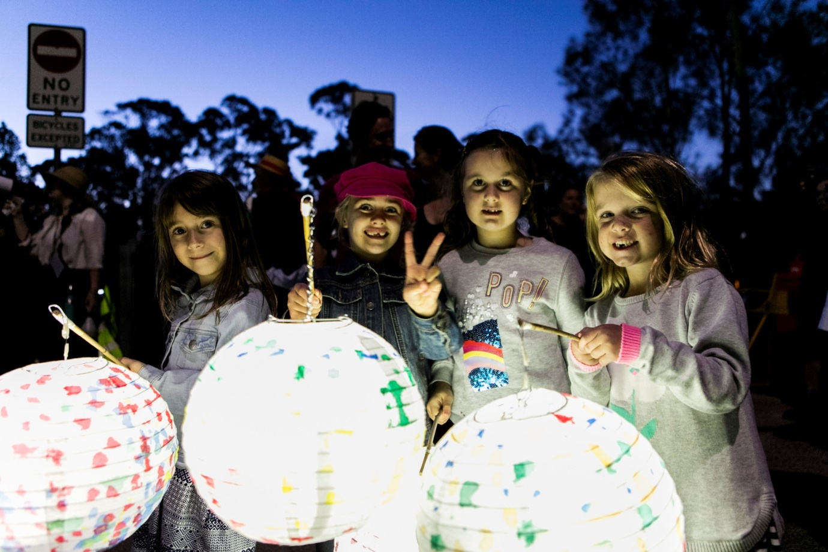
Picture: EDGE Greenway 2019

Contents
Summary 3
Background 3
Promotion 4
Engagement outcomes 5
Phase 1: 5
Background research and engagement 5
Phase 2: 6
Creative Spaces research and engagement 6
Phase 3: 8
Broader community engagement 8
Phase 4: 11
COVID Impacts on the Creative Sector 11
Phase 5: 12
Local democracy groups and internal workshopping 12

Summary

The draft Creative Inner West: Cultural Strategy responds to the views and aspirations of our community drawing on conversations among community representatives, organisations, creatives and Council. This includes Aboriginal and Torres Strait Islander peoples and organisations, culturally diverse groups and networks, a broad range of creative industries, and people from different age groups and abilities.
Community feedback was supplemented by in-depth interviews and research with cultural production spaces and venues; and a social media campaign and online survey captured people’s ideas about Inner West culture.
More than 500 artists, makers, creatives, musicians, performers, creative entrepreneurs, community members and organisational leaders participated in the development of the strategy.
The draft Creative Inner West: Cultural Strategy sets out a vision, priorities and actions for Council and community partners to respond to the community’s needs and aspirations.
Engagement phases are as follows:
- Background research and engagement (2018)
- Creative Spaces research and engagement (2017 – 2019)
- Broad Cultural Strategy development engagement (in person and online) (2019 - 2020)
- COVID impacts research (April – August 2020)
- Local democracy groups and internal workshopping (2020 – 2021)
- Community and creative sector workshopping during public exhibition (June 2021)

Background

Following Council’s 2017 Creative Communities Notice of Motion, which included a Council commitment to local creativity and culture, Council undertook:
- Research into the local creative economy (2018)
- Research into local creative spaces, including:
- Planning Cultural Creation and Production in the Inner West LGA: A case study needs analysis (Western Sydney University, 2018)
- Creative Spaces and Venues Discussion Paper (Leftbank and JOC, 2019)
Council’s Executive endorsed the launch of the two Creative Spaces research papers in November 2019 and initiated the development of a local Creative Industries Economy Strategy. This was then developed through community engagement into the draft Creative Inner West: Cultural Strategy.

Engagement Methods
- Research by Western Sydney University, case study interviews with local cultural production spaces
- Research by JOC and Leftbank, Forums and focus groups with creative venues and spaces
- Online on yoursay.innerwest.nsw.gov.au
- Instagram and social media engagement
- Focus groups: creative industries engagement sessions; Council’s Arts and Cultural Advisory Committee, Council’s Aboriginal and Torres Strait Islander Committee, Council’s Access Committee, Council’s Multicultural Advisory Committee, Boomalli, Inner West Multicultural Network, Spark Youth Theatre
- Needs analysis and engagement during COVID19 lockdown for Creative and Cultural Resilience Grants
- Ongoing engagement with Local Democracy Groups: Arts and Cultural Committee, Aboriginal and Torres Strait Islander Committee, Access Committee and Multicultural Advisory Committee

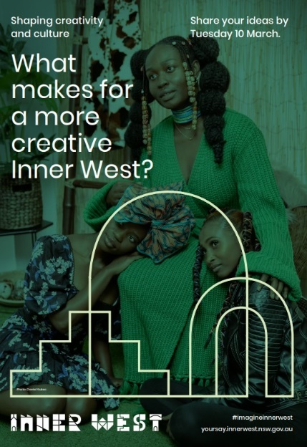
Promotion
- Posters in public spaces
- Social media, including Facebook and Instagram campaigns
- Press release
- Direct email to our creative network database,
- E-newsletter subscribers, including the Living Arts, YSIW and Fortnightly Council E-news lists
- Council website

Engagement outcomes

Phase 1: Background research and engagement
In 2016 Council developed the Community Strategic Plan. An intensive workshop titled, “Futuring Inner West Arts 2036” was produced by Fictions for Inner West Council and was attended by 20 arts sector representatives.
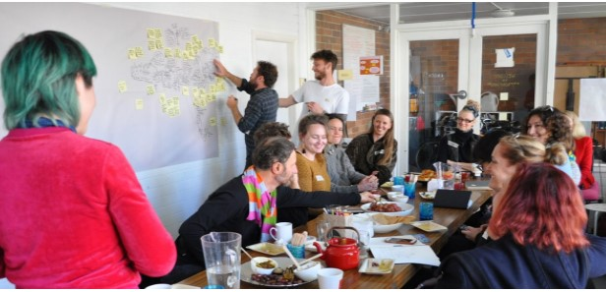

Preliminary demographic research was done to determine the economic contribution of the Creative Industries as a basis for research and engagement direction. (.id Profile, 2018)
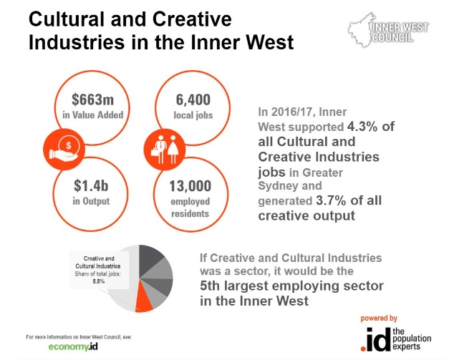

Phase 2: Creative Spaces research and engagement
In 2018, Inner West Council partnered with Western Sydney University to produce research on local Cultural Production Spaces. This was based upon in depth interviews and case studies of 11 local spaces.
Read the report: Cultural Creation and Production in the Inner West LGA: A case study needs analysis (PDF 6.6MB) (Ang et al, 2018, Western Sydney University)
Key issues emerging
- Gentrification of the Inner West
- Emergence of hybrid enterprises
- Co-location and sharing of cultural infrastructure; networks when assessing rezoning
- Lack of targeted support for creative venue managers and recognition of their function as commercial operators.

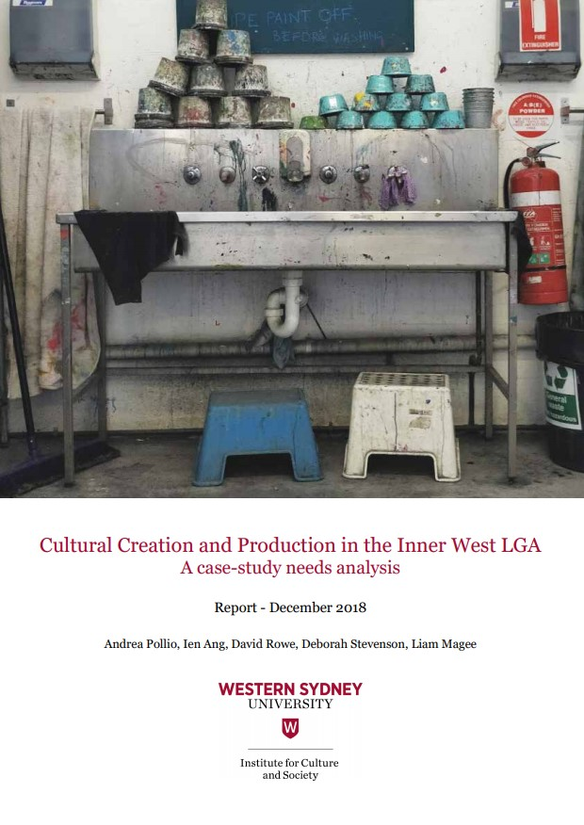

Following this, in 2019, a partnership of independent consultants conducted a needs assessment with creative spaces and venues. Left Bank Co and JOC Consulting undertook a series of forums that included:
- 50 creative spaces individual representatives
- 40 music/ music venue representatives
- 6 theatre representatives
- 3 film representatives
- 20 creative representatives at draft Economic Development Strategy and draft Retail and Employment Lands Strategy engagement
Key issues emerging:
• unaffordability and insecurity of tenure of creative space
• disappearance of industrial building stock
• rezoning as mixed-use of former industrial precincts without making provision for existing creative venues
• unsuitability of new “creative spaces” within major re- and new developments

Read the Creative Spaces and Venues Discussion Paper

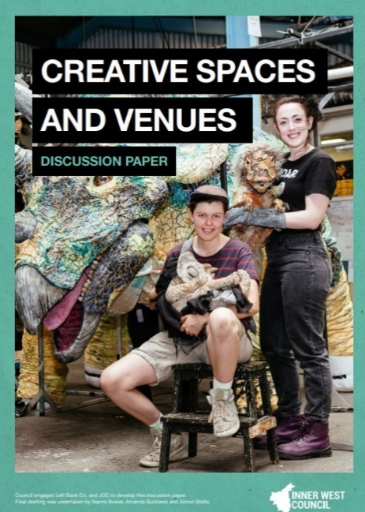

Phase 3: Broader community engagement

Overall, approximately 342 people participated in phase three. Feedback was collected in between February and March 2020 using online and face to face methods.
Methods included:
- Your Say Inner West – 92 participants
- Instagram stories – 182 participants
- Focus groups (total of 6) with local democracy groups and local art groups – 68 participants
What did they say on YSIW?
The majority of participants via YSIW were 35 – 59, women, and Inner West residents. 3% of respondents were Aboriginal and/or Torres Strait Islander, 10% were people with a disability, most respondents (80%) did not speak a language other than English at home. Respondents were from a wide spread of suburbs in the Inner West and further afield in Sydney.
Almost half respondents participate in culture once a week or more.
Key issues and opportunities arising:
- Affordable spaces
- Funding and support
- Opportunities and building audiences, including international
- Utilise recreational spaces including harbour foreshores
- Threats of Gentrification
- Inclusivity, diverse cultures, aboriginal culture
- Support live music and street life/ main streets/ street art
- Support a living wage for artists
- Support experimentation, being bold

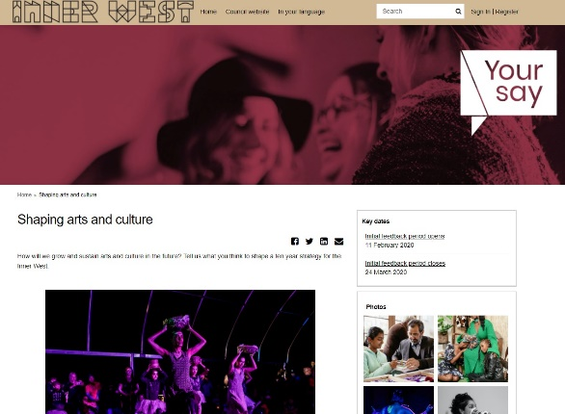

What did they say on Instagram?
An Instagram story campaign was rolled out collecting sentiments about participating in and experiencing local arts and culture. There were 182 respondents.

Key issues and opportunities:

- Fuelling creativity from natural world and larger world
- Communal spaces to create art needed
- More activation of parks and public spaces

What did the focus groups say?
- Boomalli focus group (4 participants)

Key issues:
- Boomalli is an asset but organisation still vulnerable, needs funding certainty
- Opportunities for intergenerational projects
- Need to engage Boomalli to ensure the community and artists are reached, they won’t necessarily engage with Council

- Aboriginal and Torres Strait Islander Advisory Committee (6 participants)
Key issues:
- Connection to family, people and place, including intergenerational sharing and storytelling
- More presentation and event opportunities so people can see different expressions of culture
- Focus on young people
- Importance of Language
- Importance of Aboriginal Leadership

- Spark Youth Theatre (12 participants)

Key issues:
- Arts and culture in the Inner West is about accepting, exploring and talking about who we are
- Current programming is not relatable – increase programming for other artforms
- Career pathway development
- Multi-centred nature of activity and each is distinct
- Models that create awareness in the arts and non-arts parts of our community

- Inner West Multicultural committee (25 participants)

- Provide more resources to multicultural communities, including translations/ access
- Support existing services and groups and places and spaces
- Definition of culture needs to be broadened
- Funding that goes towards EDGE/ economic/ creative industries has a disconnect
- Funding currently requires a new project and only provides part funding, or doesn’t incorporate venue hire costs; dominant groups get funding
- Educate/ ensure people feeling safe eg. police culturally informed
- Acknowledge our history
- New technologies can provide opportunities for connection
- Gentrification – rising costs living threaten diversity

- Multicultural Advisory Group (7 participants)

- Explore models for togetherness/ intersectionality and collaboration
- Provide triggers for culture to be fluid, inspire new expressions and investigations
- Provide support such as how to write a grant.
- Community led programming with Council as facilitator
- Need to understand emerging practice
- Perception that diverse groups are a problem and not an asset

- Arts and Cultural Advisory Group (14 people)
- Needs to be a whole of Council commitment to culture
- Artists’ role in placemaking and place planning
- Support across artforms
- Focus on sustainability

Phase 4: COVID Impacts on the Creative Sector
In mid-2020 during the pandemic, Council rolled out Creative Resilience Grants (totalling $300,000) to support the creative sector. Throughout the application process, email and phone engagement identified the following key issues (262 applicants):
- Lack of income/ funds
- Limited opportunity - to work / deliver events / perform
- Uncertainty due to changing Covid 19 restrictions
- Covid 19 restrictions making delivery of events unviable
- Assistance in delivering work / projects in digital formats - training and equipment plus monetarising
- Challenges accessing federal funding eg. Jobkeeper due to organisational structure or business structure
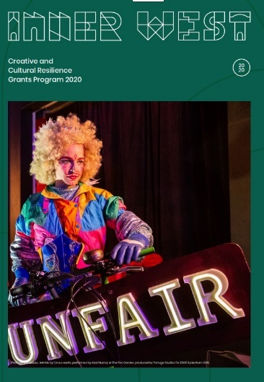

Phase 5: Local democracy groups and internal workshopping

In the final stages of the draft development, further workshopping was done with staff and Council’s Local Democracy Groups.
Key themes from internal workshopping included:
- Importance of interdisciplinary approach
- Alignment with Recreation Strategy
- Alignment with Community Assets Needs Research
- Alignment with Economic Development
- Alignment with Healthy Ageing
Key themes from Local democracy group workshopping
- Importance of inclusion and access to culture
- Diversity important to reinforce
- Aboriginal people must lead cultural solution and placemaking

