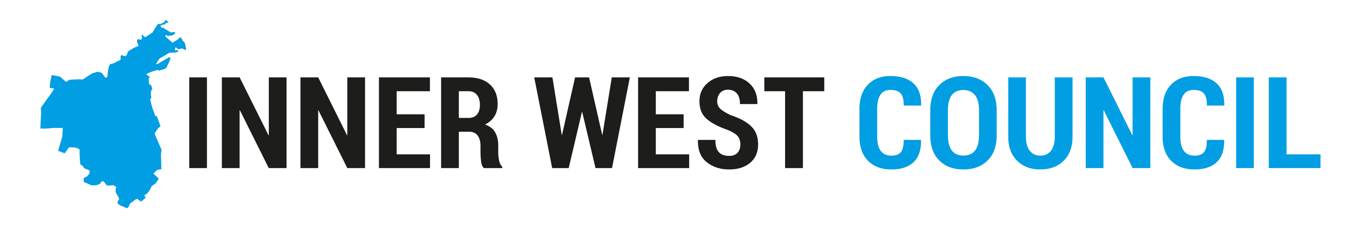

Community Engagement Policy 2017

Purpose

The purpose of the Policy is to outline Council’s commitment to Community Engagement, to articulate principles that underpin all engagement practice within Council and to outline the high-level process by which engagement is planned and implemented.

Community engagement is the process by which the community participates in and influences Council’s decision-making. Good community engagement is the basis for understanding decisions, sharing perspectives, improving outcomes and building trust between Council, the community, and other partners.

Context

Inner West Council, formed on 12 May 2016 through the amalgamation of Ashfield, Leichhardt and Marrickville Councils, is committed to delivering effective, efficient services that meet the expectations and needs of the community. Council recognises that local knowledge, ideas and feedback from the community are essential to ensuring Council’s decision-making improves community wellbeing and long-term sustainability.

Engaging with the community is one of the guiding principles for councils under the Local Government Act 1993 (section 8A) and is an important part of local democracy. Some engagement processes are prescribed by legislation and Council’s practice will always meet these requirements.

Policy Principles

- Council’s engagement practice aligns with the International Association for Public Participation (IAP2) Framework considered best practice nationally and internationally.
- Five core principles drive Council’s approach to engaging the community. A principles-based approach recognises that one size does not fit all and each engagement has a distinct purpose, with a unique set of stakeholders and specific circumstances. The principles are:
Authentic | - The purpose of the engagement and the scope of what’s being decided including which aspects the community can influence or have input into is honestly and clearly communicated  - The decision-making process is clear including how input will be used  - Community input will not be sought if a decision has already been made  - The community’s input is considered in the final decision or outcome  - Authentic engagement allows for adequate notice and time for community response, and usually excludes public and school holiday periods
Planned | - Engagement is a well-planned process with a clearly defined purpose and stages for community input  - Planning improves outcomes by engaging the community as early as possible in the process  - Planning improves outcomes by identifying critical issues and opportunities early in the process  - Planning delivers a coordinated approach to community engagement  - Coordination guards against ‘engagement fatigue’ where people within the community feel over-consulted and unheard  - Planning ensures Council has considered how individual projects fit into the ‘big picture’
Tailored | - Engagement will be tailored to particular circumstance as identified in the planning, particularly when there is complexity, risk, significance, sensitivity, timing or opportunity.  - A range of tools and techniques will be used to maximise efficiency and participation, balancing technology with traditional methods
Inclusive | - As many relevant people as possible, who have an interest in or will be affected by a decision, are identified and invited to participate. This is to avoid interest group capture or single issue hijack  - Community diversity is valued and consideration will be made of diverse needs  - Barriers to participation are identified and removed or mitigated
Transparent | - Information is clear, relevant and timely without jargon  - A summary of community feedback and how it will be used is provided  - Engagement outcomes reports are provided to the elected Council  - The decision or outcome is communicated to people involved in the process and to the broader community with an explanation of how community input influenced the decision  - A permanent record of engagements is available on the Your Say Inner West online engagement hub

Engagement Process
Council’s engagement is undertaken according to the process shown in the diagram.
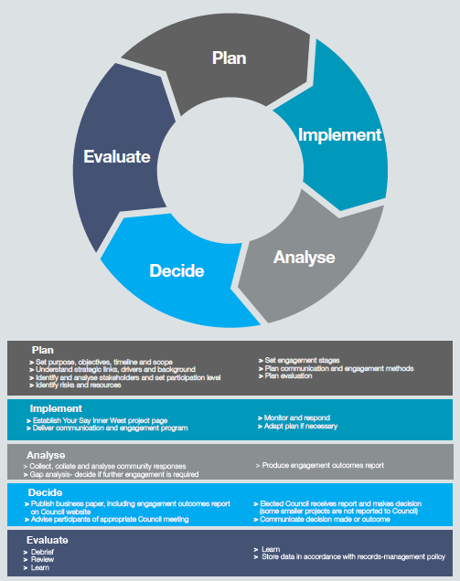

Framework elements

Four elements ensure successful implementation of the Framework.

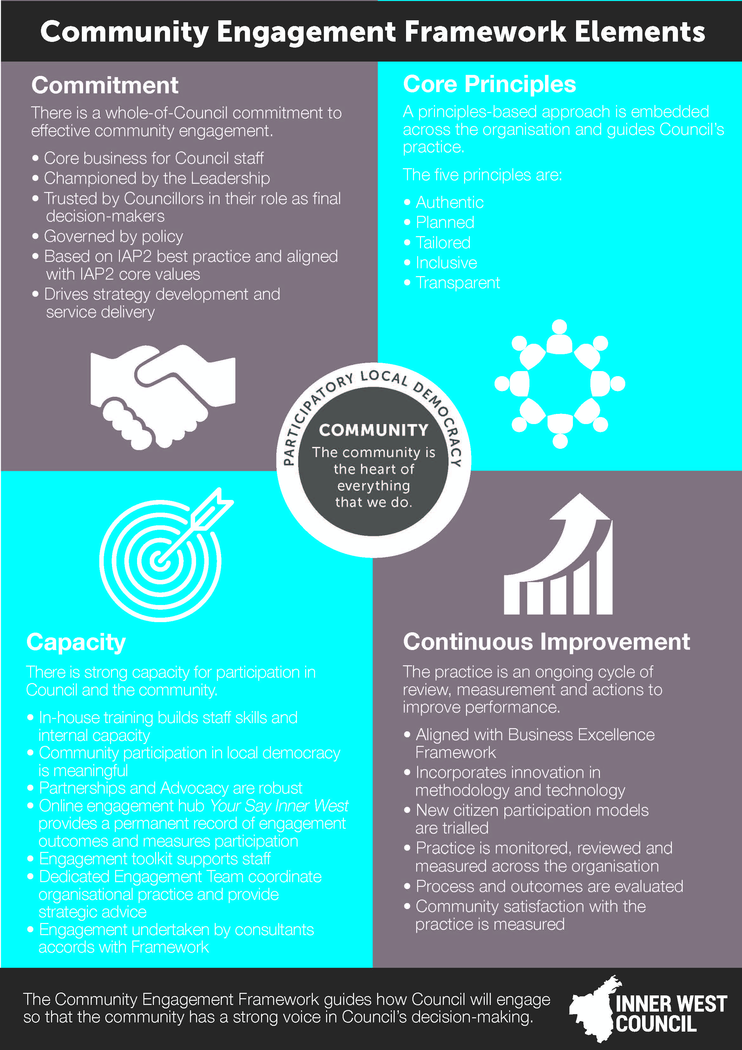
Application

The Policy applies to all staff, Councillors and contractors commissioned by Council to undertake engagement work.

Implementation

The Policy will be implemented through the Community Engagement Framework which guides how Council will engage so that that a broad range of perspectives are sought and the community has a strong voice in Council’s decision-making.

Review

The Policy will be reviewed by June 2018.

