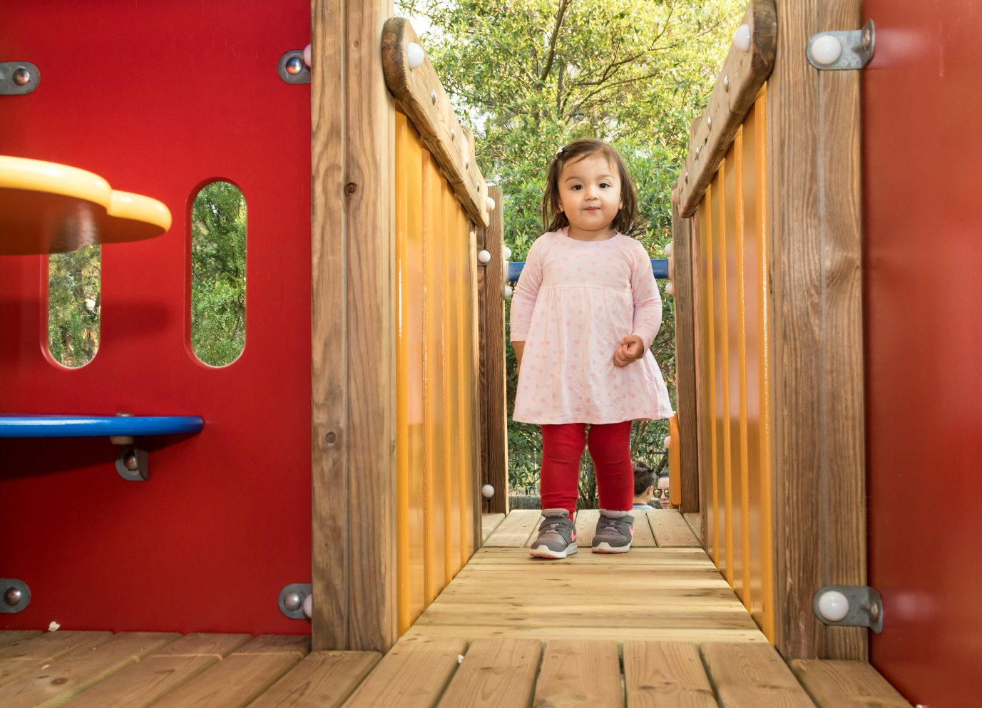

Engagement outcomes report

Upgrading playgrounds at Bain Playground and Crammond Park

Summary
Between 28 October and 25 November, the community told us what playground upgrades they would like to see at Bain Playground and Crammond Park. Upgrades could include play equipment, soft fall (rubber or mulch), new seating, bubbler and new plants. Overall, 61 people provided feedback. There were 117 individuals who viewed the project page on Your Say Inner West and 49 of these individuals provided feedback. A further three responses were received by email and 12 students from Stanmore Kindergarten sent in drawings.
Participants were predominately residents of Stanmore (42 individuals), with seven responses from Newtown, Ashfield, Lewisham and Petersham collectively. They were asked to provide feedback on what they liked about the playground, what they would like to change, what three pieces of equipment they would like to see and what other upgrades they would like prioritised.
The three things participants like most about Crammond Park are: proximity to home, open space and the playground. When asked what they would change, participants focused on modernising the play equipment, seating and fencing (including how landscaping could act as fencing).
Three things participants like most about Bain Playground are: fencing, the open space and the shade. The things that they would like changed focused on the quality of the surfaces, updating the equipment and the type of equipment.
Feedback such as painting a mural, bike paths and secure dog areas have been noted, however it is out of scope for this project.

Background
In 2018/19, Council staff conducted a review of playgrounds across the Inner West. The playgrounds at Crammond Park and Bain Playground were identified for an upgrade and $70,000 has been allocated to each site.

Engagement Methods
The community could provide feedback online via Your Say Inner West, or by contacting the council officer directly via mail, phone or email.

Promotion
The opportunity to provide feedback was promoted via:
- Social media
- Letters to residents around the parks
- Your Say Inner West e-news
- Notices in the parks

Engagement outcomes
Who did we hear from?
There were 64 individuals who provided feedback. Of the 49 individuals who provided feedback via Your Say Inner West, 37 commented on Bain Playground, 12 commented on Crammond Park with two commenting on both locations.
Three individuals provided feedback via email. Of these two responses were for Crammond Park and one for Bain Playground. A local school issued 12 responses including nine drawings of upgrades they would like to see at Bain Playground.
Participants who submitted online were predominately from Stanmore (42 individuals).

Based on the 50 individuals who commented on Bain Playground including the 12 school students and one via email
- One participant rarely used the playground
- Ten participants sometimes (a few times a month) use the playground
- Thirty-eight-participants often (weekly) use the playground
- One respondent did not provide comment
Of the online and respondents
- Seventeen respondents take children aged 0-3
- Eighteen respondents take children aged 4-7
- Ten respondents take children aged 8-12
- Six respondents take children aged 13-17

Based on the 14 individuals who provided comments on Crammond Park:
- One respondent never uses the playground
- One participant rarely uses the playground
- One participant sometimes (a few times a month) uses the playground
- Eight participants use the playground often (weekly)
- Two respondents did not provide comment

- Seven respondents take children aged 0-3
- Seven respondents take children aged 4-7
- Five respondents take children aged 8-12
- No respondents take children aged 13-17
What did they say?
Bain Playground
There were 38 participants who provided feedback on Bain Playground. They told us that they like the fencing and open space, however would like to see improvements to the surface and quality of the equipment. Participants also asked for us to consider about other types of equipment.
From the suggestions, participants would prefer swings (19 respondents), a slide (16 respondents), climbing equipment and natural play equipment (14 respondents each). One participant acknowledged the budget and asked how we might build out the playground over time.

From the other upgrades, participants would like to see landscaping, rubber soft fall and seating prioritised. Other suggestions were provided by 16 people and included greater variety in play equipment, fencing a dog area, a mural, a netball hoop and a path for children to ride bikes and scooters.
Increasing or maintaining lighting in the park was raised by four participants.
The issue of dogs in the park was raised by several responders both in support and against.

Stanmore Kindergarten
Stanmore Kindergarten provided feedback from 12 students. They told us they would like to see a slide (5 responses), swings (including a wheelchair swing), cubby house and monkey bars (4 responses each). Other suggestions included climbing frames, climbing walls, obstacle course, water play and a flying fox.
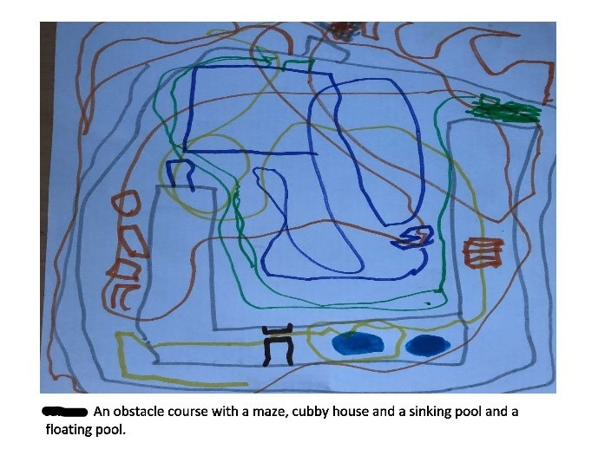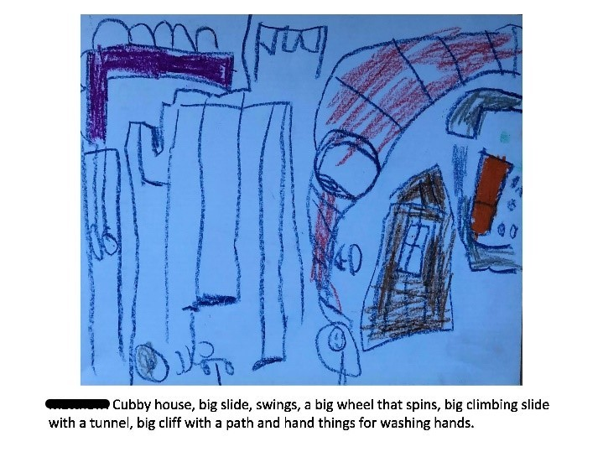
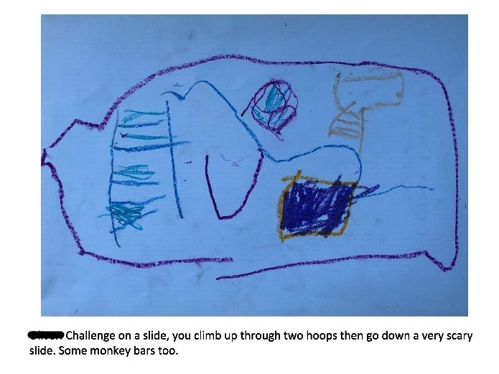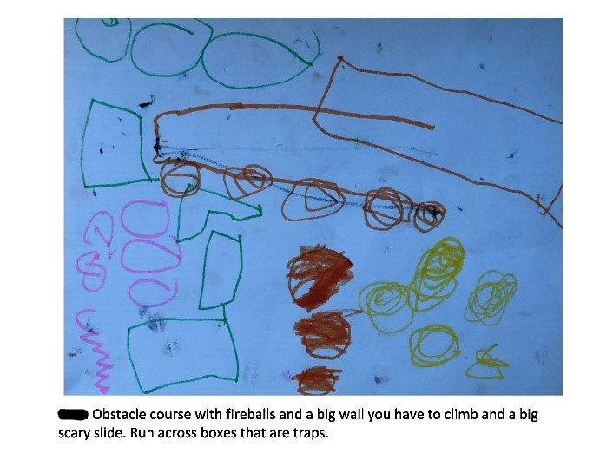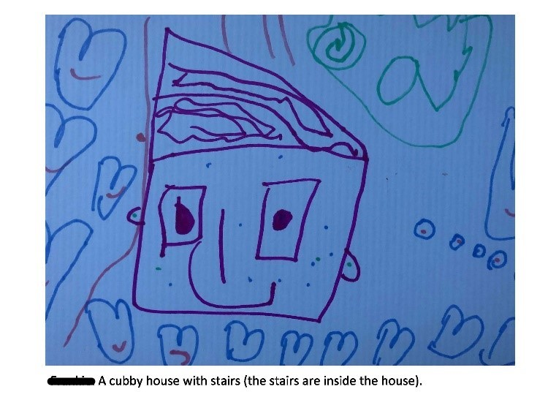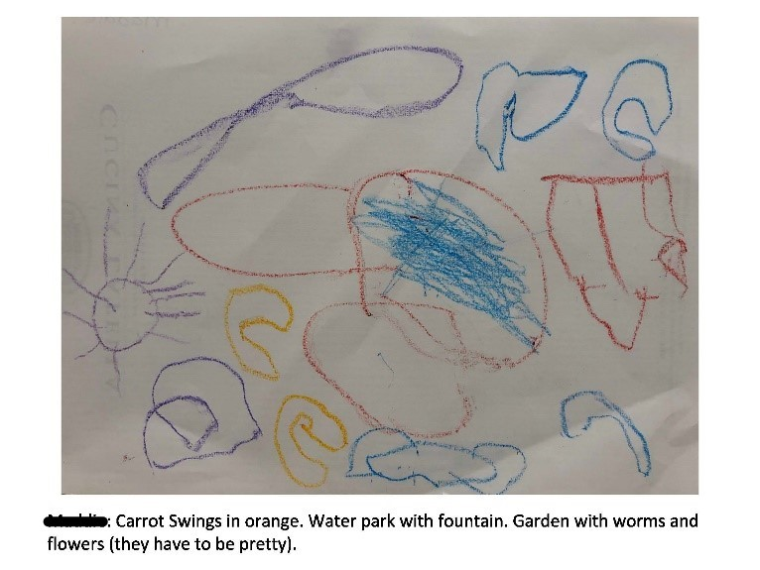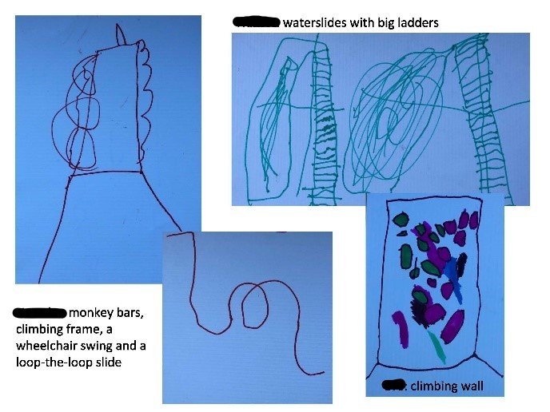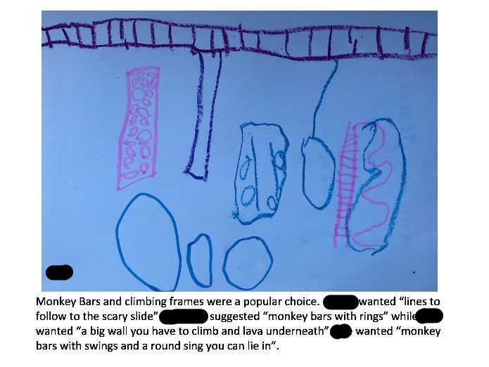

Crammond Park
There were 13 participants who provided feedback on Crammond Park. They told us that they like the playground and the space it creates for children to socialise. The main changes they would like to see are more shade, more variety in the playground equipment and improved soft fall. One participant did not support the upgrade, preferring picnic facilities.
The top three preferred equipment upgrades were slide, swings and climbing rope equipment (6 respondents each) and natural play equipment (5 respondents).

The community would like to see landscaping, rubber soft fall and seating prioritised (6 responses each). Of those who submitted other, comments related specifically to types of landscaping, shade sails/increasing tree cover, types of equipment and upgrades to elements outside of the scope such as lighting and pathways. Additional comments were concerned about illegal dumping and graffiti, modernising the playground and picnic table seating with a BBQ (three respondents each).

