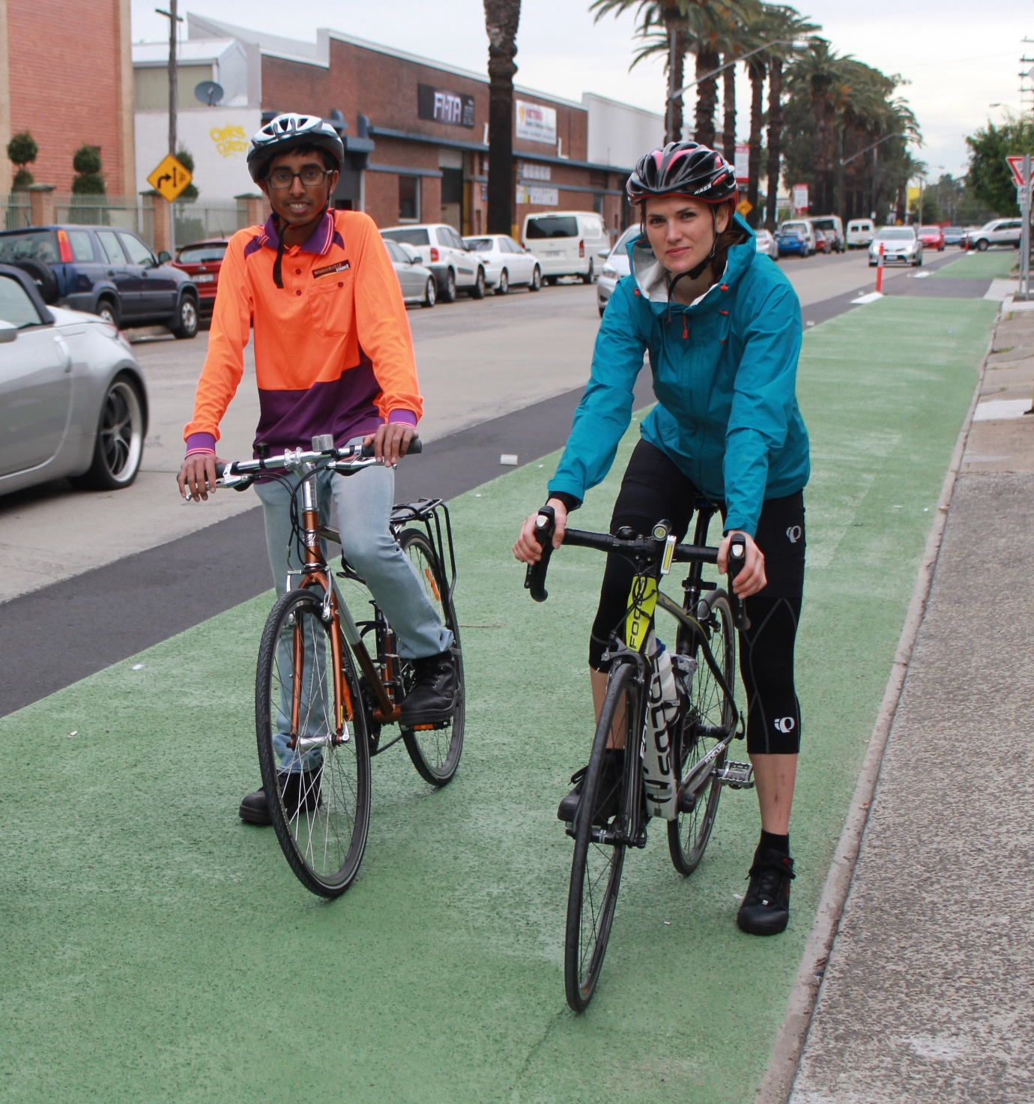

Community Engagement Outcomes Report

St Peters Interchange – Improved cycle routes

Summary

Between Monday, 21 October and Monday, 18 November 2019 the community provided feedback on bike route upgrades between Sydenham Station and the Princes Highway at Mary Street, St Peters. The engagement included consideration of the concept design for:
- Section 1 – a one way or two way kerb separated cycle way on the southern side of Burrows Avenue

- Section 2 –upgrades along Mary Street, Bakers Lane, Grove Street, Henry Street and George Street, including a widened shared path along Mary Street.
The engagement was promoted via a letter box drop, information on Council’s website and Your Say Inner West, signs along the route and on Council’s social media.
Overall, 20 responses were received from the community via the Your Say Inner West project page. The results generally indicated:
- Approximately 45% of respondents (9 individuals) supported the proposed upgrades
- Approximately 30% of respondents (6 individuals) responded negatively to the proposed upgrades
- Approximately 25% of respondents (5 individuals) responded either unsure, or neutral to the proposed upgrades

Section 1
- Approximately 30% of respondents (6 individuals) indicated a preference for Option A, a westbound kerb separated cycleway on the southern side of Burrows Avenue and an eastbound on road cycle route with improved line markings and signage because this option incurred no changes to parking spaces.
Section 2
- Overall respondents support improving this bike route, however approximately 20% of respondents (4 individuals) disapproved of the cycle route that follows Mary Street, Bakers Lane, Grove Street, Henry Street and George Street because of the narrow road widths in some of these streets.

Engagement Methods

The community could provide feedback:
- Online feedback form via yoursay.innerwest.nsw.gov.au
- Direct mail to the project lead.

Promotion
The engagement period was promoted via:
- Your Say Inner West project page and home page
- Letterbox drop
- Social media
- Council’s website
- Signage along the route
- Your Say Inner West E-news

Engagement outcomes
Who did we hear from?
20 responses were received for this project.
75% of respondents (15 individuals) were residents from the immediate local area, and the remaining 25% (5 individuals) were cyclists who regularly used this route as their commute or for recreation.
What did they say?

There were 16 responses for Section 1. Of these:
- 11 respondents (55%) support the proposal because it offers a safer route for cyclists along Burrows Avenue
- Six respondents (55% of the 11 respondents) prefer Option A because it has no impact to existing parking spaces
- Five respondents (45% of the 11 respondents) prefer Option B because it offers a separated cycle way for both east and west bound cyclists
- Five respondents (25%) do not support the proposal because they disapprove of cyclists travelling down George Street as they were afraid cyclists would travel at fast speeds.
- Four respondents (20%) chose not to comment on this section
- Five respondents (15%) specifically indicated that they were against the loss of any parking along Burrows Ave.

There were 20 responses for Section 2. Of these:
- Eight respondents (40%) were supportive of the proposal because they agree with improving bike routes
- Four respondents (20%) were against the proposal because they disapprove of cyclists travelling along Grove Street, or George Street. Why?
- Five respondents (25%) chose not to comment
- Three respondents (15% of the four respondents) specifically commented that they would prefer an alternative route along neighbouring streets instead of the cycle route proposed. Alfred Street was suggested as an alternative to Grove Street.
- Three respondents (15%) were against speed cushions along George Street, preferring speed humps for speed management.
Comments relating to light timings and improvements of the route along Unwins Bridge Road have been noted, however they are out of scope for this project.
It is noted that respondents typically offered more than one comment in each submission.
Respondents who left a comment, generally commented on both Section 1 and Section 2. For Section 1 the overall preference was for Option A, with the main issue raised, by 25% (five respondents), being the loss of parking in Option B.

Next Steps

The next steps in delivering the cycle route upgrades as part of the St Peters Interchange Active Transport Works will be to take the outcomes of the community engagement process and develop a concept design that incorporates the feedback received. The developed concept designs will then be presented to Council for final comments before the project moves on to the Detailed Design Stage.

