Engagement outcomes report

Revised Community Engagement Framework

Summary
Council revised the Community Engagement Framework to include a new section about land use planning and development assessment, as required by legislation. Minor changes were also made to include new information such as community profile data.
The revised draft Community Engagement Framework was publicly exhibited from 15 October-12 November 2019.
Six submissions were received, five of which supported or were unsure/neutral about the Framework. One was opposed as the respondent believed the planning section should have been in a separate document.

Background

Recent State Government reforms to the Environmental Planning and Assessment Act aim to increase community participation in planning matters by making the process easier to understand. Council has amended its Community Engagement Framework to incorporate the changes.
The new section 5 in the draft Community Engagement Framework outlines how and when Council engages the community around its planning functions. It includes the minimum mandatory public exhibition timeframes for strategic planning matters including LEP amendments/planning proposals, contributions plans, development control plans, planning agreements, environmental impact assessments, and development and related applications. The section also contains notification requirements for DAs which will replace information currently contained in the three legacy DCPs of the former councils.

Engagement Methods
The document was placed on public exhibition:
- Online at Your Say Inner West
- In hard copy at Council’s Service Centres

Promotion
The exhibition was promoted through:
- Council page in the Inner West Courier
- Social media
- E-news
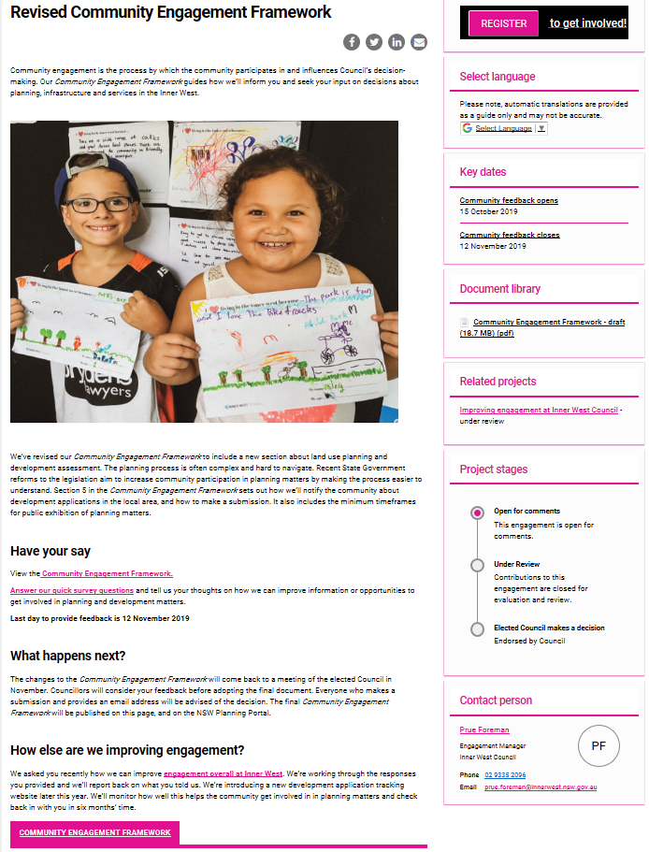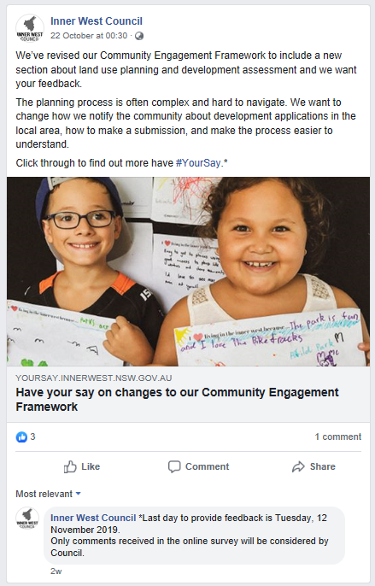
Your Say Inner West project page Social media post

Engagement outcomes
There were six responses, one of whom did not support the draft Community Engagement Framework as they believed the planning section should have been in a separate document. Two supported and three were unsure/neutral.
All respondents reported that it was ‘very’ or ‘moderately’ easy to understand how Council makes decisions about planning matters or development applications.
Four respondents had made a submission on a planning matter or development application in their local area while two had not.
Four people who responded to the question found it ‘very’ or ‘moderately’ easy to find information on a planning matter or development application in their local area and to make a submission on a planning matter or development application. All four reported they were informed of the decision.
Comments:
It's all pretty common sense--and doesn't appear to be significantly different to the policy it replaces. All good in theory, but not necessarily put ino practise. As part of the Community Engagement process the one that existed in Leich. LGA prior to amalgamation was extremelt efficient and should be re-inststaed across the IWC LGA--precinct committees.
Framework is comprehensive and provides many avenues for engagement
Not sure how it has changed from the previous procedures.
The Revised Community Engagement Framework appears only to be revised in that an additional section has been added regarding planning and infrastructure. This could have been put in a separate document rather than in the broader community engagement framework.
I'm not sure how it has changed. It seems quite good.
How can Council improve information or opportunities to get involved in planning and development matters?
Council's decisions on DA's etc. is, at times, inconsistent with prev. "like" DA's--depends on which staff in planning or compliance is dealing with the matter. Some decisions are made without staff even attending the site.
The radii for notifications of nearby residents who could be affected by nearby developments is 50 metres for a residential flat building and 75 metres for a commercial development over $30 million. These radii are too small: in winter a four or five story building will cast shadows much longer than this; neighbourhood impacts are even wider spread. The radii should be increased to 100 metres and 150 metres respectively.
The process of looking up and making a submission to Council with regard to a development applications was relatively easy but the correspondence informing me of the decision felt like a form letter, only stating that my concerns were considered in making the decision. Council staff should address each concern raised in any submission and state why they either agreed or disagreed with those concerns if they want to make the decision making process truly transparent.
Were you to make use of an online voting platform that could help engage lost of people in a very simple and straightforward manner; I would appreciate an easy way to voice my support or opposition to some developments, and especially some planning matters.
Do you have any other comments on the Community Engagement Framework?
Council seems to consider each development application on its own. For example, a medium or high density development on its own may be deemed not to have a significant effect in the immediate area of the development, but 10 or 20 or however many developments across the municipality have an impact on the overall level of traffic in the municipality. These cumulative effects of development to not seem to be taken into consideration in the approval process.
What evaluation has been done on the 'your say' site? This could have been part of the 'revised' document. Why is feedback not a key part of the community engagement framework? The IPA2 spectrum has been adapted in this document.

