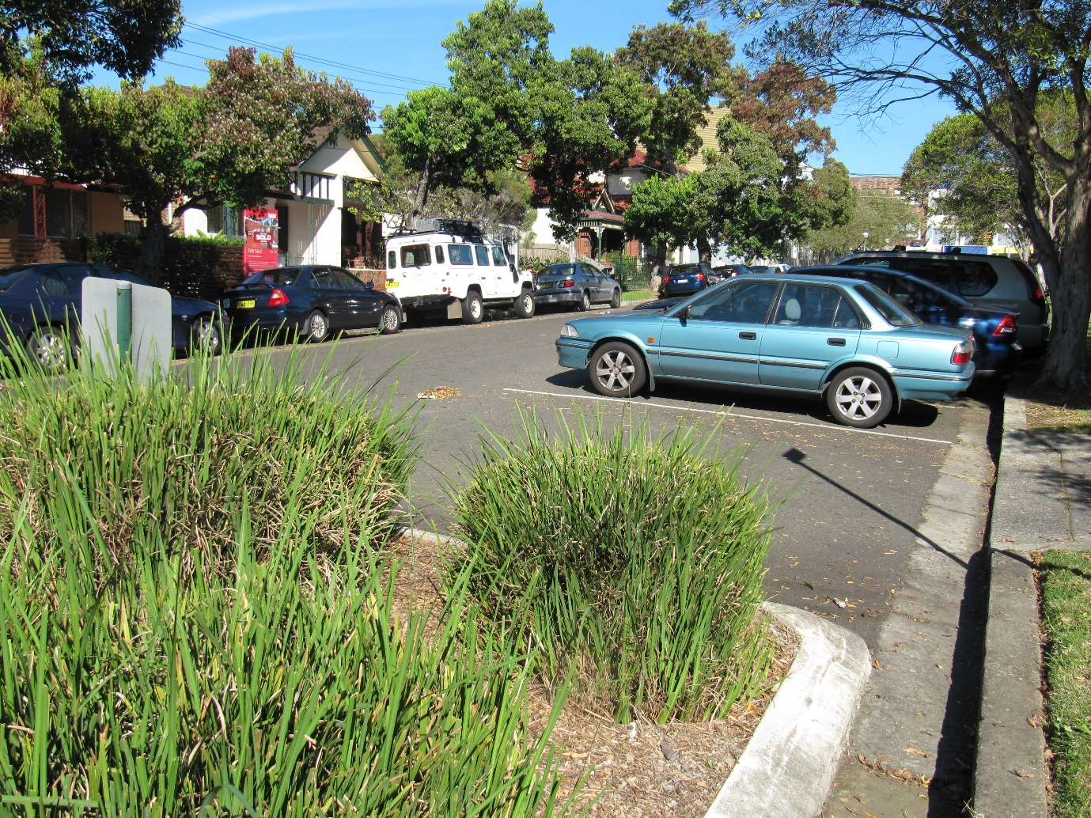

Engagement outcomes report
Public Domain Parking Policy

Summary
Between 21 October and 27 November 2019, the community provided feedback on the draft Public Domain Parking Policy. This new policy sought to manage the excessive demand and competing needs for parking in public places through one consistent approach.
The opportunity for feedback was promoted through various print and online channels. There were 1,700 individuals who visited the project page more than 2,000 times. The draft policy was downloaded 581 times, with 597 individuals providing feedback. Most respondents (73.2% or 440 respondents) do not support the proposed policy. The residents living in Balmain are the highest respondents not in support of the Public Domain Parking Policy with the main reason stated being the issue of visitor parking permits being limited to 30 permits per year.
There were 93 respondents (15.5%) who supported the policy, but with changes. These changes included: annual visitor parking permits, more emphasis on public transport, retain biannual resident parking permits, removal of boat, trailer and caravan parking and increase limit on business parking permits.
Of the residents who supported the proposed policy and commented, their main themes included: freeing up parking spaces and misuse of annual visitor parking permits.
Overall, the key themes were:
- Proposal to introduce the 30 visitor day permits was not supported. The main reason was that residents used this permit for either carers, nannies or family members and visitors. There was a strong preference to maintain the annual visitor parking permit from the former Leichhardt LGA suburbs.
- Perception that the policy is a revenue raising exercise
- The policy won’t work and doesn’t benefit residents, leave current policy in place. Many of the residents who echoed this theme live in the former Leichhardt LGA suburbs.
- Bi-annual to annual permits
- The residents who lived and owned a business in the Inner West were also not in support of the proposed parking policy with the vast majority of respondents concerned with the proposed changes to the parking current visitor arrangement in the former Leichhardt LGA area.

Background

Parking in the public domain across the Inner West is in very high demand. The proposed Public Domain Parking Policy provides a framework to manage and review parking regulations. These restrictions include but are not limited to timed parking, permits and no parking zones. This will enable Council to better manage and balance the competing needs for parking in public places.
The proposed Policy will compliment other strategies which are being developed or are currently in place such as the draft Transport Strategy and Council’s LEPs and DCPs.

Engagement Methods

The main method of engagement was online via yoursay.innerwest.nsw.gov.au.

Promotion
The draft Public Domain Parking Policy was promoted via:
- Council column in Inner West Courier
- Direct email to business stakeholders, including the chambers of commerce
- Your Say Inner West e-newsletter
- Your Say Inner West homepage
- Your Say Inner West stall at Norton Street Festa
- Across council’s social media channels.

Engagement outcomes

Who did we hear from?
There were 597 responses received from businesses and individuals across the area. Most responses (392) were received from residents in Balmain, Leichhardt and Rozelle.
There were eight businesses who provided feedback on behalf of a business, however 60 respondents identified as business owners when asked question 3, ‘which of the following describes you?’. They were based in Balmain and Rozelle (two responses each), and Leichhardt, Summer Hill, Croydon and Canterbury (one response each).
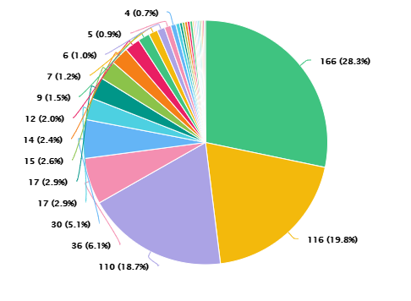

What did they say?
There were 440 (73.2%) respondents that did not support the draft Public Domain Parking Policy. The next highest level in relation to type of support was ‘yes, with changes’ with 93 respondents representing 15.5%. There were 46 people (7.7%) who did support the policy, with those who were unsure and neutral representing 1.8% respectively.

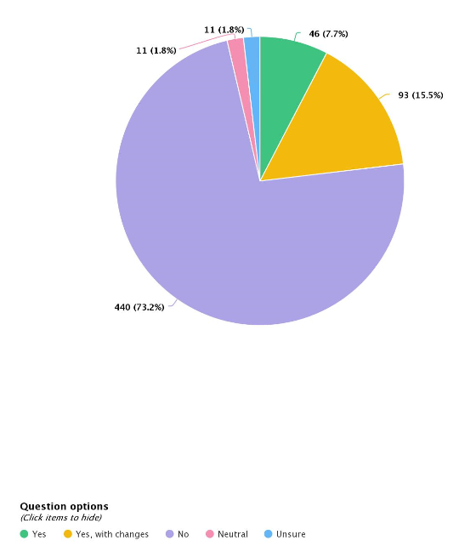

The main themes raised in the comments are:
- Proposal to introduce the 30 visitor permits not supported
- The policy is a revenue raising exercise
- The policy won’t work and doesn’t benefit residents, leave current policy in place.

