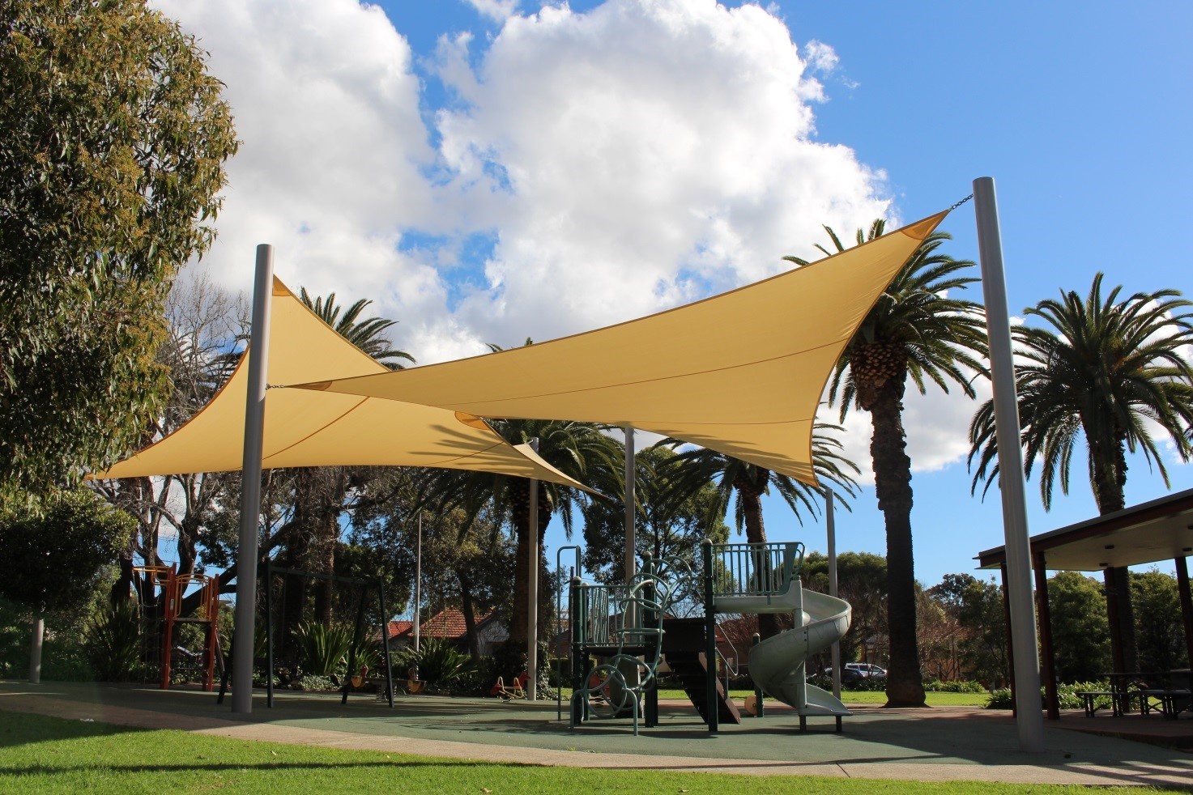

Engagement outcomes report

Shade Sail Program 2019

Summary
Council engaged the community on its proposal to install shade sails in nine parks across the Inner West. The proposal was open for feedback between 18 October and 15 November 2019 via Your Say Inner West. Overall, 37 individuals participated in the feedback process and 149 people reviewed the project page.
Respondents were predominately residents living next to the proposed locations. They were asked to identify which parks they wanted to provide feedback on, if they supported the proposed location and to provide any related comments. We heard that there is support for shade sails generally, however there are concerns for the longevity of sails, the areas covered and a need for long term natural shade. Feedback about the overall maintenance of the parks and play equipment has been noted, however it is out of scope for this project.

Background
The shade sail program helps to improve sun protection during the hottest times of the day in summer. Last year Council installed shade sails at 13 parks across the Inner West to make sure playgrounds can be enjoyed year-round, especially in the warmer weather. Now we’re continuing the program with a $275,000 proposal to install up to nine shade sails in parks across three Council wards.
The locations were chosen via desktop research and site assessment of the parks to determine where shade sails would be of most value.

Engagement Methods
The primary method to provide feedback was online via Your Say Inner West (yoursay.innerwest.nsw.gov.au). Staff were also available to discuss the proposed locations at our stall at Marrickville Festival.

Promotion
The opportunity for feedback was promoted via:
- Onsite posters at each park
- Letters to nearby residents for each park
- Your Say Inner West e-news
- Direct email to child care centres near the parks

Engagement outcomes
Who did we hear from?
Overall, 37 people responded, 12 online and 25 at Marrickville Festival. Online respondents were asked to choose which statements best described their relationship to the park/s. Of the 12 responses, seven individuals chose more than one statement.
- 5 respondents identified as local residents
- 7 respondents identified as living next to the park
- 8 respondents identified as visitors the park

What did they say?
  - Online via yoursay.innerwest.nsw.gov.au
- Carrington Street Playground, Summer Hill. Four respondents supported the shade sail at this location. Concerns raised included: the sustainability and durability of shade sails, and whether natural shade could be considered for a long term solution; extending the cloth so that the poles were outside the path, providing more shade for parents pushing prams; covering the swing set.
- Brighton Street Park, Petersham. There were three responses for this park. One did not support the shade sail because they did not believe the playground was used. Two supported the shade sail, with one citing the need to include where parents sit and the other requesting maintenance that is beyond the scope of this project.
- Matt Hogan Reserve, Camden Street, Newtown. One respondent supported a shade sail at this reserve, commenting that the location should be optimised for effectiveness. For example, the right angle or height to maximise shade.
- Salmon Playground, Station Street, Newtown. One respondent did not support a shade sail at this location, believing there are other issues to address and that there is enough natural shade.
- Ness Park, Hollands Ave, Marrickville. Three respondents supported the shade sail at this location, expressing that it was an overdue improvement to improve safety.
- Tempe Reserve, Holbeach Avenue, Tempe. One respondent supported this location however, they did not include any comments.
- Wicks Park, Victoria Road, Marrickville. One respondent disagreed with this location, requesting that other maintenance be prioritised to deter anti-social behaviour. Additionally, they observe other shade sources, such as trees and children wearing hats.
- There were no responses for John Paton Reserve, Short Street, Summer Hill and Louisa Lawson Reserve, Roach Road, Marrickville.

  - Face to face engagement at Your Say Inner West stall at Marrickville Festival
Attendees at Marrickville Festival could show their support by placing a blue dot below the park name. A red dot indicates that they did not support the project. Not everyone who expressed support for the project placed a dot. The general sentiment was support for the initiative overall and that more shade at any location was a great outcome.
