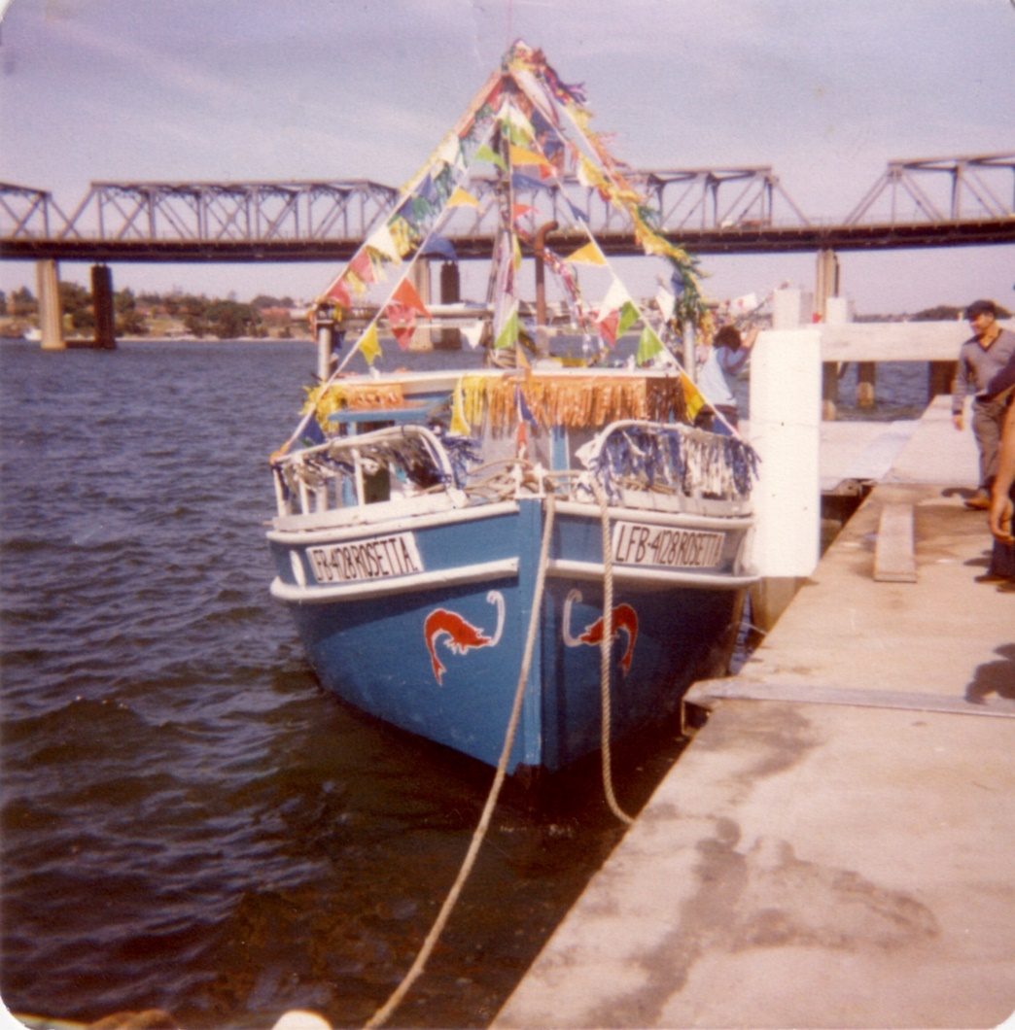

Identifying an Italian precinct/s

Engagement outcomes report

Summary
Between 25 October and 24 November 2019, Council asked the community about naming an Italian precinct/s in the Gulgadya ward (Leichhardt ward). The community could provide feedback on the geographical location and the proposed name, Little Italy. There was also space for the community to share their memories using the storytelling feature.
Approximately 118 people provided feedback on this proposal. Feedback was collected online via an interactive map on Your Say Inner West (YSIW), at the YSIW stall at Norton Street Festa, three meetings with community groups and door knocking businesses along Ramsay Street and Norton Street. Face to face was the most effective method of communication, with only eleven people completing the interactive map via Your Say Inner West, despite 250 people visiting the page.
Preferred location of the precinct/s:
- 85 individuals supported Leichhardt
- 27 individuals supported Haberfield
- 2 individuals supported both areas
- 3 individuals opposed the precinct
There was unanimous support for the name ‘Little Italy’. Respondents reflected on the counterparts in other major cities, such as New York, their memories of Leichhardt and Haberfield, and the density of Italian shops in Haberfield.
Regardless of where the precinct/s are, there was a strong sentiment that naming a precinct was not enough. The community want economic growth with more events and activations in public spaces. For Leichhardt, it was about the historical significance of the Forum, cultural centre, and the businesses, such as Bar Sport. However, in Haberfield, sentiments were for the Italian grocers and density of Italo-Australian residents.
Five Dock also came up, however it is out of the Inner West local government area.
The Italian Consulate and their staff made a single submission noting that although Italian nationals are well integrated across NSW, Leichhardt retains a highly symbolic and historical significance for its strong Italian cultural heritage. Consulate staff supported ‘Little Italy - Il Bel Paese’ (Little Italy - the Beautiful Country) as the preferred name, and Leichhardt as the preferred area.

Haberfield Association members oppose naming a ‘Little Italy’ in Haberfield as they are seeking official recognition of Haberfield as the ‘Garden Suburb’ from the State Heritage Register.

Background
On 24 September 2019, Council resolved to celebrate the long-standing relationship between Italo-Australians and the Inner West community.
There are two areas that shape the Italo-Australian identity in the Inner West. We wanted to know if they could they both be a part of Little Italy. Historically, Leichhardt has supported the Italian migrant community since early settlement, such as the fishermen at Iron Cove. In the post-war years Leichhardt provided a social, cultural, economic and spiritual meeting place. More recently, Haberfield (the Garden Suburb) has emerged as a thriving hub for Italian family-run businesses.
Historians and media reports dating back to the 1980s have referred to Leichhardt as Little Italy. More recently, bloggers have referred to Haberfield as the New Little Italy. We wanted to know if the community agreed with naming a precinct Little Italy and why/why not.
Engagement Methods
A combination of online and face to face engagement methods were used.
      - Online on yoursay.innerwest.nsw.gov.au
- Interactive map
- Storytelling feature
- Face to face
  - Your Say Inner West stall at Norton Street Festa
  - Paper surveys distributed to approximately 80 businesses along Ramsay Street, Haberfield and Norton Street, Leichhardt
  - Meetings with three community groups across Leichhardt and Haberfield
  - A meeting with businesses was proposed, with a local business offering to organise it, however it did not eventuate

Promotion
The opportunity to provide feedback was promoted via:
- Social media, with posts in English and one in Italian
- Press release resulting in content in Inner West Courier, La Fiamma and Il Globo
- Direct email to identified stakeholders, such as the Italian Consulate
- Your Say Inner West stall at Norton Festa (and included in the Mayor’s address)
- Letters distributed to businesses along Ramsay Street and Norton Street
- YSIW e-news
- Council page in the Inner West Courier

Engagement outcomes
Who did we hear from?
Approximately 118 people participated in this engagement. We heard from a mix of businesses, residents, staff at the Italian Consulate and visitors to the area. Most residents were 60+ years old and were from Leichhardt or Haberfield.
The Italian Consulate provided a group response after conducting their own internal engagement with staff.
What did they say?
Online via yoursay.innerwest.nsw.gov.au
- Five pins were placed in Haberfield around the intersection of Ramsay and Dalhousie Streets. Respectfully, residents acknowledged that Leichardt used to be the centre for Italian culture, food and socialising, however Haberfield is more connected now.
- Seven pins were placed in Leichhardt. Of these, six were between Parramatta Road and Marion Street. One was at the intersection of Norton and Marlborough Streets. Comments reflected on the historical significance of Bar Sport, the Forum, cultural centre and architecture more broadly.
Face to face at Your Say Stall, Norton Street Festa
Officers had over 200 conversations at the Your Say Inner West stall, with approximately 82 individuals actively participating in this project. This was a mix of residents and visitors to the area. Of these:
  - Approximately 17 people marked Haberfield as the heart of an Italian precinct. One post-it mentioned that there is enough in Leichhardt and to acknowledge Haberfield
  - One person marked the corner of Marion and Edith Streets, where Frattini’s is located
  - Approximately 64 people marked Norton Street. Of these 30 marked between Parramatta Road and Marion street, while 34 people marked between Marion and William Street. Comments included:
    - need to revitalise the area including the Forum, fill vacant shops
    - lack of atmosphere
    - public art on the footpaths
    - permanently pave as a piazza.
Some attendees had assumed that Leichhardt was already informally Little Italy and did not see the need for formal naming, therefore did not engage with the activity.

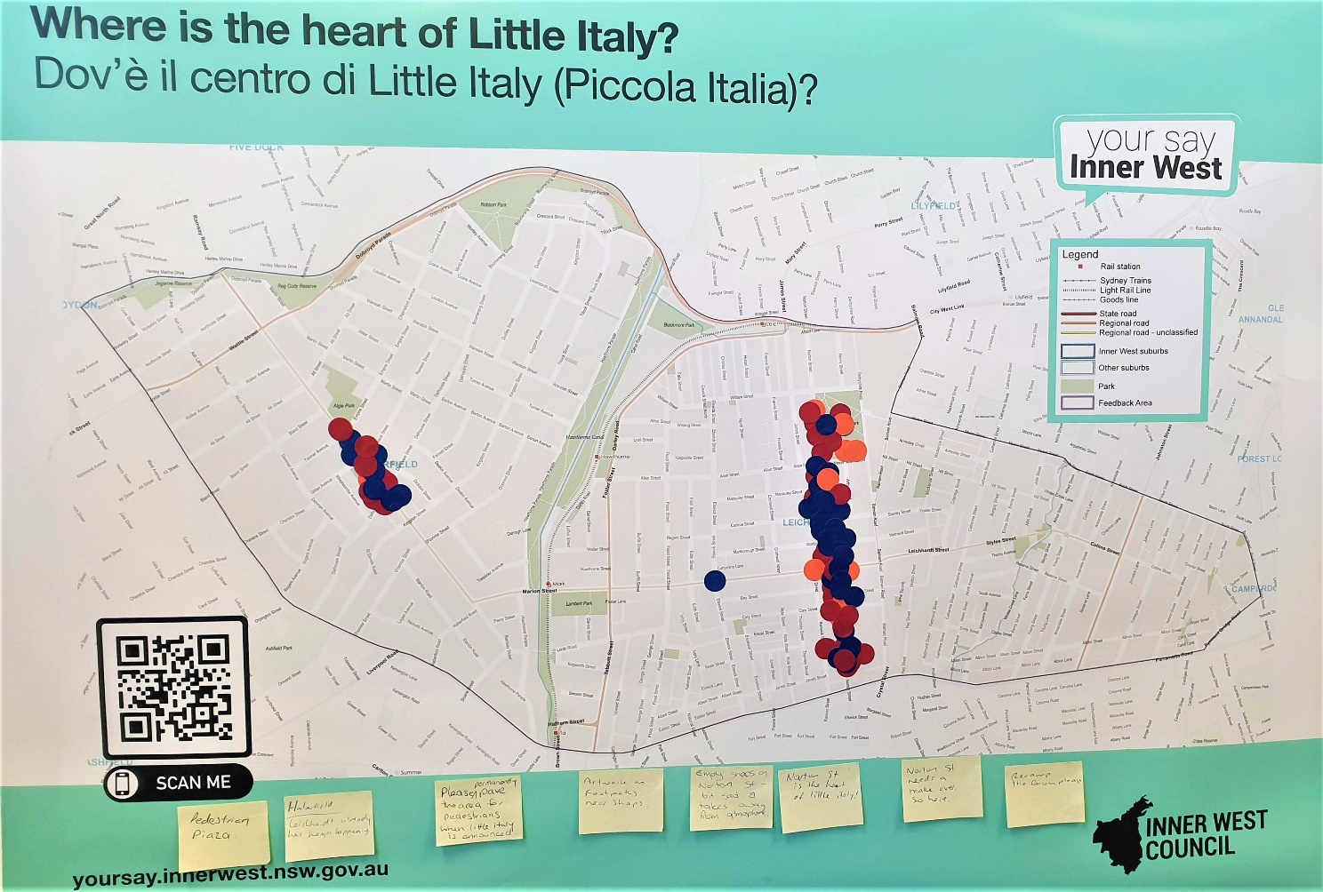
Figure 1 Map showing were visitors marked the centre of Little Italy at Norton Street Festa
Emailed feedback
Five individuals provided feedback via email. Four of these opposed including Haberfield in the precinct, as the Haberfield Association has an application seeking recognition on the State Heritage Register as the ‘Garden Suburb’. Already acknowledged in the Local Environment Plan (LEP), this recognition would bring national recognition to the suburb, connecting the character of the area with Federation.
One respondent felt that identifying a precinct was not enough and more had to be done to revitalise both areas.
Comments received from organisations/groups/stakeholders
  - Italian Consulate
The Italian Consulate and their staff made a single submission noting that although Italian nationals are well integrated across NSW, Leichhardt retains a highly symbolic and historical significance for its strong Italian cultural heritage. Consulate staff supported ‘Little Italy - Il Bel Paese’ (Little Italy - the Beautiful Country) as the preferred name, and Leichhardt as the preferred area.

  - Community groups
Council staff received recommendations from Co.As.It for groups to visit. A craft group in Leichardt acknowledged that many Italians had left the area. There were 12 members present, of which ten agreed that Leichhardt, specifically the stretch of Norton Street between Parramatta Road and Marion Street, should be the geographical precinct. Everyone agreed that Little Italy was an appropriate name. One attendee commented that naming it after a pioneering woman who focused on health would be extraordinary.
Council staff met with 38 people across two community groups at Haberfield Library. A group of eight women believed that Haberfield was the heart of Little Italy because of residential density, socialising and proximity to Italian shops. One remarked that a Big Italy could envelope Leichardt, Haberfield and Five Dock. In the second group of 30 people, the majority agreed on Little Italy and that both Haberfield and Leichhardt (as well as Five Dock) should be included. Meanwhile, a few said only one suburb should be included.
  - Comments whilst visiting businesses in Haberfield on Wednesday, 6 November 2019
Two council staff visited businesses along Ramsay Street, Haberfield from mid-morning. The overall sentiment was that this initiative could have more of an impact to support Italian businesses in Haberfield. There was a sentiment that the pensioner permit should be removed because they take up prime locations all day, minimising turnover for shops. Businesses wanted to see more than a precinct naming, calling for strategies to drive visitation during the mid-week and weekend.
A group of residents meeting at a coffee shop agreed that identifying a precinct is only a start. They wanted to see more tangible support, such as marketing, changes to timed parking zones and activations/events in public spaces.

