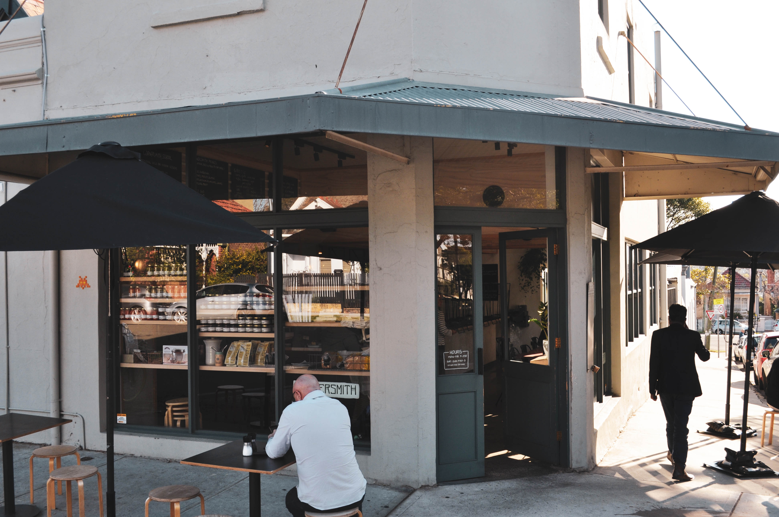

Engagement outcomes report: Inner West Local Approvals Policy 2020

Summary
The draft Local Approvals Policy provides an outline of the matters relevant to obtaining an approval from Council under Section 68 of the Local Government Act, setting the framework for types of activities and circumstances relevant for such applications. It also provides circumstances for exemptions from the need to gain an approval.
The draft Policy was publicly exhibited 8 May 2020 to 22 June 2020 to get community input. Three community submissions were received as part of this exhibition process highlighting that safe access is maintained for activities on the footpath.
In accordance with Clause 162 of the Local Government Act 1993, Inner West Council is seeking approval from Office of Local Government in relation to the proposed exemptions from Section 68 approval outlined in the draft Policy.
Once a response is received from the Office of Local Government, the Policy will be presented to Council, for their endorsement.

Background
The draft Local Approvals Policy (LAP) has been prepared to achieve a harmonised approach to the use of public domain across the Inner West. Once adopted, the LAP will reduce red tape, costs and resources by streamlining and simplifying the application and approval processes for events and activities in the public domain.
The LAP controls activities under Section 68 of the Local Government Act 1993. The policy:
- identifies works that are exempt i.e. can be undertaken without prior approval;
- identifies works that require approval through an activity application; and
- outlines criteria for consideration in the approval of activity applications.
Part 2 (pp.16 - 28) of the LAP lists activities which require approval under Section 68 of the Local Government Act 1993. Examples of works that require approval under Section 68 include mobile food vending vehicles (food trucks), outdoor dining and market stalls on public land.
Table 3 of the LAP (pp. 7-15) lists works which are proposed to be exempt from Section 68 approval. It also outlines if other approvals are required for the proposed works. For example, busking requires the completion of a busking permit application.

Engagement Methods and outcomes
In accordance with the Local Government Act 1993 and Local Government (General) Regulation 2005, the LAP was placed on public exhibition on Your Say Inner West from 8 May 2020 to 22 June 2020.
Community feedback was sought on a range of activities including dining and retail trading on footpaths, market stalls, food trucks and A-frame signage.
Feedback was collected online on Your Say Inner West from 8 May 2020 to 22 June 2020. Participants could access the draft Plan and were also provided with a summary of the project and a feedback form.
The engagement was promoted via:
- Online on Your Say Inner West
- Inner West Council website
- Inner West Council Facebook and Twitter.
Three written community submissions were received. All highlighted the importance of maintaining an adequate path of travel for activities on the footpath. One submission provided detailed comments on the need to carefully consider the needs of wheelchair users and interpretation of sight lines.
Feedback received from the submissions will help inform the assessment and compliance processes associated with the implementation of the LAP, as well as the standard conditions of approval if consent is granted to a local approval application.
The final LAP will be reported to Council later this year following approval from the Office of Local Government.

