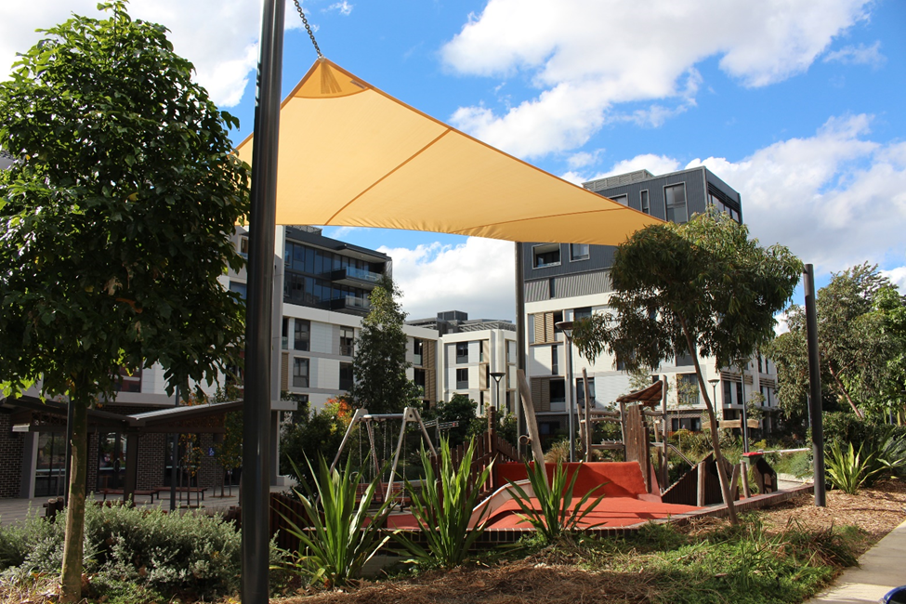

Engagement outcomes report

Neighbourhood and Pocket Park Generic Plan of Management

Contents
Summary 3
Background 3
Engagement Methods 3
Promotion 3
Engagement outcomes 4
Officer comments 5

Summary
Pocket Parks and Neighbourhood Parks are important parts of the green network in the Inner West. These spaces provide opportunities for leisure, relaxation and exercise. Parks and green spaces are also fundamental to community cohesion, physical and mental health and wellbeing, biodiversity, climate change mitigation, and local economic growth.
Council is developing a generic Plan of Management (POM) for Pocket and Neighbourhood parks in the Inner West and conducted initial community engagement to inform the POM from 25 July – 29 August 2019.
93 participants gave feedback via Your Say Inner West and one participant gave feedback via email. Participants gave feedback via interactive maps by dropping virtual pins on individual parks to mark what they loved about them and what they thought could be improved.

Background
By law, all parks on community land are required to have a Plan of Management. Depending on the previous LGA, some pocket parks and neighbourhood parks don’t have POMs and some are due for renewal. Therefore, all pocket parks and neighbourhood parks are going being addressed as part of a generic Plan of Management.
A Recreation Needs study of the Inner West completed last year indicated that Parks are the most common facility used for recreation. 80% of the 2,000 people who participated in community engagement use parks at least weekly.
There is tremendous value in asking community members about their local parks. Regular users can share important insights on what is working well in local green spaces and what can work better. What we learn from the community can be incorporated into the POM and Master Plan ensuring our parks are meeting community needs into the future.

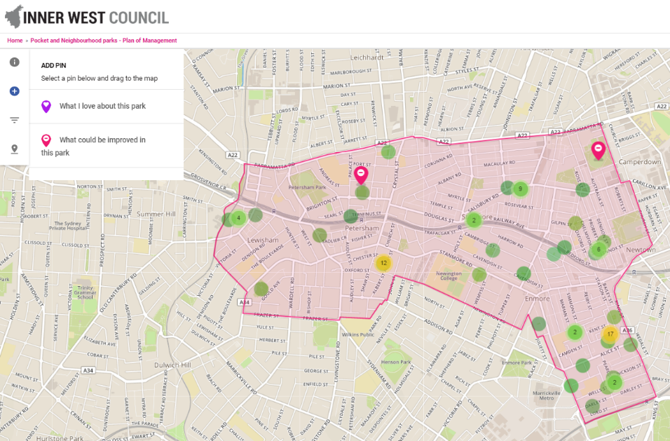
Engagement Methods
The Pocket and Neighbourhood Park POM engagement was hosted on Your Say Inner West from 25 July – 29 August 2019. Feedback was collected via interactive maps where community members could drop pins and provide comments about their local pocket and neighbourhood parks by ward (See figure 1).
Figure 1: Stanmore Ward interactive map

When dropping a pin to say what they loved or what could be improved, participants were asked the following survey questions to contextualise their comments:
- How do you use the park?
- How often do you use this park?
- What suburb do you live in?

Promotion
The online engagement was promoted via:
- Your Say Inner West August 2019 E-newsletter
- Inner West Council Facebook page with posts on 7, 16, 26 August 2019
- Inner West Council website
- Inner West Courier, Council Column 13 August 2019
- Posters in high traffic parks including:

- Allman Park, Ashfield
- Allison Playground, Dulwich Hill
- Colgate Ave Reserve, Balmain
- Rozelle Common, Rozelle
- Arguimbau Street Playground, Annandale
- 36th Battalion Park, Leichhardt
- Evan Jones Playground, Leichhardt
- Douglas Grant Park, Annandale
- Amy Street Playground, Marrickville
- McNeily Park, Marrickville
- Louisa Lawson Reserve, Marrickville
- Toyer Street Reserve, Tempe
- Montague Gardens, Stanmore
- Marr Playground, Petersham
- Morton Park, Lewisham

Engagement outcomes

Who did we hear from?
Participants in the Pocket and Neighbourhood Parks engagement were only asked to provide their suburb of residence. Participants provided feedback on parks that were in their ward with contributors to each interactive map, residents of the ward the within which they were commenting on.
In total, we heard from 93 members of the community who dropped 181 pins. We also received one email from a community member.

What we heard
From the 93 contributors, there were 132 pins to mark parks that could be improved and 49 pins to mark what was loved about parks. It is important to note that some of these comments referred to parks not included in this Plan of Management. The feedback has been taken on by Council but is not being reported on in this summary.
The main themes of the identified in the engagement are listed below. Detailed feedback on each park is featured by ward begins on page 6.
The following themes have been drawn from comments made by participants on ‘What I love’ about this park:
- Plantings and mature trees are great, especially as they attract local wildlife
- Fenced playgrounds/parks work well for keeping little kids, pets and balls at bay
- Great facilities including off-leash areas, doggy bags and bins, bubblers and dog bowls
- A wonderful mix of uses and users facilitated by a variety of passive and active activities in the park
- A great mix of sun and shade
- A well-maintained space.
The following ideas for improvement came up consistently throughout comments made by participants on ‘What could be improved’ in this park:
- Explore possibilities for dog off leash areas or off leash times of the day
- Better enforcement of on leash zones
- Regular maintenance and rubbish bin emptying
- Cycling or scooter track for kids
- More plantings generally, and especially along the borders of parks on busy roads
- More seating and picnic facilities
- Community Garden
- Playground equipment maintenance and refresh
- More shade from either trees or shade sails
- Connection of green spaces especially along waterways
- Diverse active and passive recreation activities.

Balmain Ward
Park name | What I love | What could be improved
Ann Cashman Reserve | - Wonderful hub for social connection for all members of the community  - Buzzing with picnics and play  - Great design with an immediate ‘sense of place’  - Dog off leash area provides good balance
Arguimbau Street Playground |  | - Netball ring is underutilised, it could be relocated
Buruwan Park | - A beautiful park with huge old trees and a good through way to the waterfront
Colgate Reserve |  | - It would be great to have one of the parks along the harbour without dogs. Dog on leash rules are ignored
Fitzroy Reserve |  | - It would be great to see a skateboarding feature reactivated here. A good spot for a small mini ramp or bowl
Issy Weiner Reserve | - Such a cute park perfect for little kids | - Could have a more regular tidy up as there’s often a lot of tree debris
Lilyfield Road Greenway |  | - This would be a great spot for an asphalt or concrete pump track to suit younger riders on scooters, bikes and skateboards. There are not a lot of safe riding areas for children in the area
O’Conner Reserve |  | - This would be a great spot for an asphalt or concrete pump track to suit younger riders on scooters, bikes and skateboards. There are not a lot of safe riding areas for children in the area  - This could be used as a dog off leash area on weekday morning before 7:30 and after sunset when the park is quiet
Paringa Reserve |  | - This would be a great spot for an asphalt or concrete pump track to suit younger riders on scooters, bikes and skateboards. There are not a lot of safe riding areas for children in the area

Ashfield Ward
Park name | What I love | What could be improved
Beatrice Street Reserve |  | - It would be great if the strip of open area along Frederick Street was filled with trees (especially native food trees) to filter some car pollution  - Not a very usable space, encourage tree plantings as there is so much concrete and many buildings in the area
Brown Street Reserve/The Esplanade | - The Ashfield upgrade made this area more walkable and cleaner. Please make sure that it continues to be maintained | - Would like to see more plants/shrubbery here. Bollards should be installed soon  - Speed limit should be lowered as it’s a high pedestrian area  - Regular maintenance including bin emptying
Bruce Street Reserve |  | - Bare and not used regularly. Would be great to see more tree plantings and a seat
Cadigal Reserve | - A beautiful area to enjoy nature | - The off-leash dog park on the east side of the canal is unsafe with only one entry/exit point and no passive surveillance. To improve safety, measures could include building at least one other bridge, thinning the trees which screen the park, CCTV.
Edward Street Reserve |  | - A lot of rubbish is dumped here
Graham Reserve |  | - A poorly utilised space
Lion Street Playground |  | - The park is poorly maintained, it needs a playground upgrade with shade.  - It is used as a dog off leash area and owners do not clean up
Mallam Reserve |  | - Great trees, needs more shrubs including planting next to the toilets  - Replant the Peppercorn and Jacaranda  - A sign for the park.
Park Avenue Playground |  | - Fences make it feel like a jail
Robert Street Reserve | - Love this park
Rose Street Playground |  | - Poorly utilised space, high fences make it feel like a jail
Thomas Street Reserve |  | - Better protection from the pollution and noise of Frederick St  - Maintenance of fencing  - Could become an off-leash dog park, include a cycling/scooter track. Needs park benches, chairs and shade  - The sign says the land is reserved for future road use, it would be great to protect the space
Victoria Square |  | - An important Park because of its heritage value and plantings. It needs to have more funding for upgrades  - It is often used as a pedestrian thoroughfare, but connections are poor  - Cars sometimes park in in the park

Stanmore Ward
Park name | What I love | What could be improved
Bain Playground | - A lovely park, a great size for younger kids. Fence is a plus | - Lots of potential. The size means there could be a community garden  - Structure could be painted by a local artist  - The whole playground needs an upgrade, with a focus on natural play, soft fall, landscaping  - Astro turf is buckled and torn which kids trip over. Astroturf on big patch of dirt would be great  - Regular maintenance, often a lot of rubbish  - Additional seating
Brighton Street Park |  | - Shade cloths in particular above the playground area, more seating and tables. A good cross section of community users
Collyer Playground | - A great well used little park. Great that it’s securely gated. Playground has a variety of activities | - A BBQ and some picnic benches would be a great addition
Enmore Tafe Park | - Good lighting for use at night, fully enclosed fencing of off leash area, always parking, park is always clean thanks to the free poo bags, water tap and bowl
Fleming Playground | - A lovely park enjoyed by local children. It has a good mix of sun and shade, could do with an update | - Play equipment is tired, graffitied or damaged as is the entire park which needs a refresh/upgrade  - There needs to be more shade over the play area  - More work to discourage drinking in the park
Garavel Playground | - Love the snow gum in the centre and the raised park above the street | - Park is a little run down and play area is in poor condition  - The big pine trees detract rather than enhance  - Retaining wall onto Chelmsford is unstable
Hudson Park | - A nice little park. Like the logs of wood  - The shade built over the slide recently, keeps it from heating up too much | - The park is fragmented with little spaces divided be unnecessary paths. This reduces its usability  - The section east of the new playground adjacent to the light rail could be fenced off for an off-leash area  - More regular maintenance of gardens and cleaning up rubbish including a possible education campaign around littering
Marr Playground | - A good size with enough diverse space for multiple uses and users  - A good mix of sun and shade for all seasons  - A beautiful and calm spot on Albert St for kids, dogs and passers-by. The eucalypts from the neighbouring substation are great, attractive to birds  - Great fencing for small children | - Would love to see scent garden fenced off and revamped  - Community garden would be great at North West end  - Park lighting  - More better benches and a picnic table for kids’ birthday parties  - Planted area within the hedges is dusty and has failed plantings. It would benefit from harder thicker edges to stop trampling  - Include a doggy bag station  - A source of water including a bubbler and a dog bowl or tap
Matt Hogan Reserve | - Love how well used this park is. It makes it a safer place for kids to go  - Lots of space for kids to run around. Variety in equipment and big grassy areas  - Mostly well maintained | - Improved shade  - More emphasis on the ‘on leash’ as many dog owners let their dogs off. Dog poo bags  - Include gates at the Alice St End  - Zebra crossing on the Camden St side for safety  - Something to discourage cyclists traveling through at speed  - Basketball hoop or synthetic turf in the middle area that becomes mud  - Netball /basketball rings  - Installing a fence along the edge of the grass area and the road would prevent children and balls going onto the road  - Realignment of the footpath further to the side so dog owners don’t have to walk through the playground
Maundrell Park |  | - This would be a great spot for an asphalt or concrete pump track to suit younger riders on scooters, bikes and skateboards. There are not a lot of safe riding areas for children in the area  - This could be used as a dog off leash area on weekday morning before 7:30 and after sunset when the park is quiet
Salmon Playground |  | - A dark space which feels a bit unsafe. Trees are great but make the ground hard to utilise. Perhaps landscaping around trees  - Move children’s play equipment under the fig trees and turn the sunny patch into grass or table tennis table  - Block off access from Camden Lane to make it feel safer  - Upgrade play equipment, perhaps provide a basketball ring or climbing frame, especially for teens that occupy the park  - The has few amenities and could have seats around the trees  - The park needs better maintenance and lighting to discourage certain behaviours
Stanmore Reserve | - Lots of people enjoy this space. People eat lunch, relax on the benches, have picnics with small children, group meetings after library story time, kids playing with balls  - Nice to have green space next to the library | - Would be great to have shade from mature trees  - Currently used mainly as a thoroughfare. Would be great if it was turned into an urban farm or community fruit and veggie garden. Stanmore businesses could use it for compost, locals could grow or purchase and local preschools could visit the garden and library. This would activate the area

Marrickville Ward
Park name | What I love | What could be improved
Amy Street Playground | - This is a great little gated playground, well maintained. Recent refurbishment was great, love shade sails  - Great that it’s next to Henson Park which means dog owners don’t bring dogs to the playground | - Would benefit from having more mulch to raise the area up to the elevated soft fall areas  - Would benefit from having a bubbler and rubbish bin (which was recently removed)  - The small grassy area alongside the park would benefit for native tree plantings
Cooks River Foreshore | - The foreshore is fantastic in most place. This particular location is a beautiful spot and great for exercising
Francis Playground |  | - The large wheelie bin gets used by people for their household waste. It’s regularly overfilled and spills out. Replacing it with a smaller bin may improve the park
McNeily Park | - Great social off leash dog park with water bowls and plenty of space to run.  - Park is always in use, playground basketball court and BBQs | - Would be great to see another down light in the north west corner near the trainline
Ness Park | - Great community/neighbourhood park, well maintained | - Shade sails for playground  - New soft fall  - A mural on the wall of 45 Pine Street as it’s always graffitied
Petersham Rest Area |  | - Needs a bin and doggy bags. There is a lot of rubbish in this park  - Would be good to have a small fence around the park so children don’t run onto the street
Roswell Playground | - Nice little park in a quiet location, a bit of play space
Toyer Street Reserve | - I love this park, tree canopy for animals  - Well used by local families as well as parents who take kids swimming  - Gathering spot for xmas parties, street library and herb garden  - The tree and landscaping are great

Leichhardt Ward
Park name | What I love | What could be improved
36th Battalion Park |  | - Would be great if there were more tables and chairs and a toilet block
Albert Parade Reserve | - Wonderful shady reserve with mature trees and play equipment. A great spot for summer | - Please plant more trees, there is limited shade in the summer  - Install bird nesting boxes in the large mature trees
Badu Park |  | - Allow the café access to the park  - The park should be part of a joined-up walkway all the way along the water course to Douglas Grant Park, Chester St Playground and Hogben Park. Native shrubs could be planted along walkway
Banks Street Reserve |  | - It would be great if rubbish was cleaned up more regularly  - Extra lights as some parts are quite dark  - To help filter Frederick St noise and pollution, plant more native trees along Frederick St side of the park
Bridges Reserve |  | - This space could support a community garden. The reserve is a central focal point for apartment blocks in the neighbourhood
Dalhousie Street Reserve |  | - Needs to be better identified as a public space and not a part of the library
Darley Road Reserve |  | - Quite open and bare. The canal banks would be a perfect opportunity to plan native plants and trees to promote wild life in the area
Douglas Grant Memorial Park |  | - This should be part of a joined-up walkway along the water course  - You can’t push a pram easily from one level to another. A ramp from Chester St to the lower level would improve access  - Include play equipment for young infants  - Remove concrete path that goes through the grassed play area. It goes nowhere and takes up too much green space
Evan Jones Playground |  | - This is a lovely well used park. Could there be off leash times e.g. between 4pm and 10am as most people in the park at those times are dog owners and walkers
Falls Street Reserve |  | - This park is underutilised. Include proper fencing as it is busy along Darley Rd, bench street, trees to buffer the traffic and a swing
Hammond Park | - Great expansive spacious green. Always being used | - More undercover planting of trees along the Frederick St boundary  - Plant more larger trees  - More seating
Hawthorne Parade Reserve |  | - The green space is too hidden, it might as well be private land. With some thoughtful landscaping and seating, could be a lovely space for anyone to enjoy
J G McCartney Playground |  | - Hedging and more plants along the Frederick St boundary
Marlborough Street Playground | - Great little fenced park with toddler sized play equipment and nice grassed area  - Veggie garden is a lovely addition
Marr Reserve |  | - The park has no activities for children over 6yrs. Older children climb over the electrical transformer
Mathieson Street Reserve |  | - This park should be part of a joined-up walkway all along the water course
Rotary Park | - Lots of wildlife (birds, bats, possums)  - Lovely big gum tree which provides shade | - Would be great to see new trees planted to replace those removed and ensure that wildlife is attracted into the future  - Rubbish is left here occasionally
Taringa Street Reserve | - The community garden is a wonderful little piece of and  - It is a sunny spot in winter, great for picnics  - I walk through on my way to Ashfield Station, it’s great to see new growth in community garden and birds enjoyed established Banksia tree | - Park bench to sit on, zone the park as rec rather than residential to protect it
Tillock Street Reserve |  | - Some garden landscaping with native plantings would encourage birds and people to use this space
Wangal Nura Park | - This park is great for kids to play, picnics and running around with dog | - Could be improved by having BBQs, undercover areas for when it rains and toilets.

