Help upgrade Elizabeth Street playground, Ashfield

Engagement Summary

Summary
Council engaged the Inner West Community on playground upgrades at Elizabeth Street playground via engagement platform, Your Say Inner West (YSIW). The proposal was open for feedback from 17 June until 14 July 2019. The project page received 122 visits and 24 responses via the online feedback form. One response was received via mail and a second via email. Respondents were predominately local residents in Ashfield and Croydon area.
The feedback form provided on Your Say Inner West asked participants to identify:
- how often they/their children visit the playground and their ages
- what they/their children like about the playground
- what they/their children would like to change about the playground
- what three pieces of equipment they’d like to see in the playground
- what three upgrades were most important to them/their children.
By requesting their street name and suburb, it is understood that the majority of respondents were within the catchment area and 88% (21 respondents) were existing users of the park. Their use varied from weekly (6 respondents), monthly (4 respondents) to a couple of times a year (11 respondents).

Background
Elizabeth Street playground is a neighbourhood park on the northern side of the train line. It was installed in 2004 and is due for renewal between 2024 and 2029 as a part of Council’s playground policy in 2022-2023. Softfall repairs were completed recently and the fence, which is shared with private residents, was due to be repaired.
This upgrade was prioritised and brought forward following a Notice of Motion from Councillor Julie Passas. It was resolved in council meeting dated 30 October 2018 (council resolution C1018(2) Item 28) to carry out upgrade/repair works for the Elizabeth Street Playground as part of the Ashfield SRV Parks renewal fund.

Promotion
The public exhibition period was promoted via:
- Your Say Inner West project page
- Letterbox drop to approximately 800 properties near the playground
- Signage in the park
- Social media
- YSIW e-News monthly newsletter
- Council website
All collateral directed people to the online feedback form on YSIW.

Engagement outcomes
An analysis

Who did we hear from?
Twenty-six response were received for this project.
Twenty-four responses were collected via Your Say Inner West. Of these 44% (11 respondents) only use the park a couple of times a year, followed by 24% (6 respondents) who use the park weekly. Almost all respondents live within the park’s catchment area: 79% (19 respondents) live in Ashfield, 20.8% (5 respondents) live in Croydon and one respondent lives in Marrickville.
One written response was made by local children from the Ashfield area. They sent an A1 poster full of hand-written ideas and images showing examples of playground equipment from other parks that they would like in the new Elizabeth Street playground.
One email response was made by a local resident.

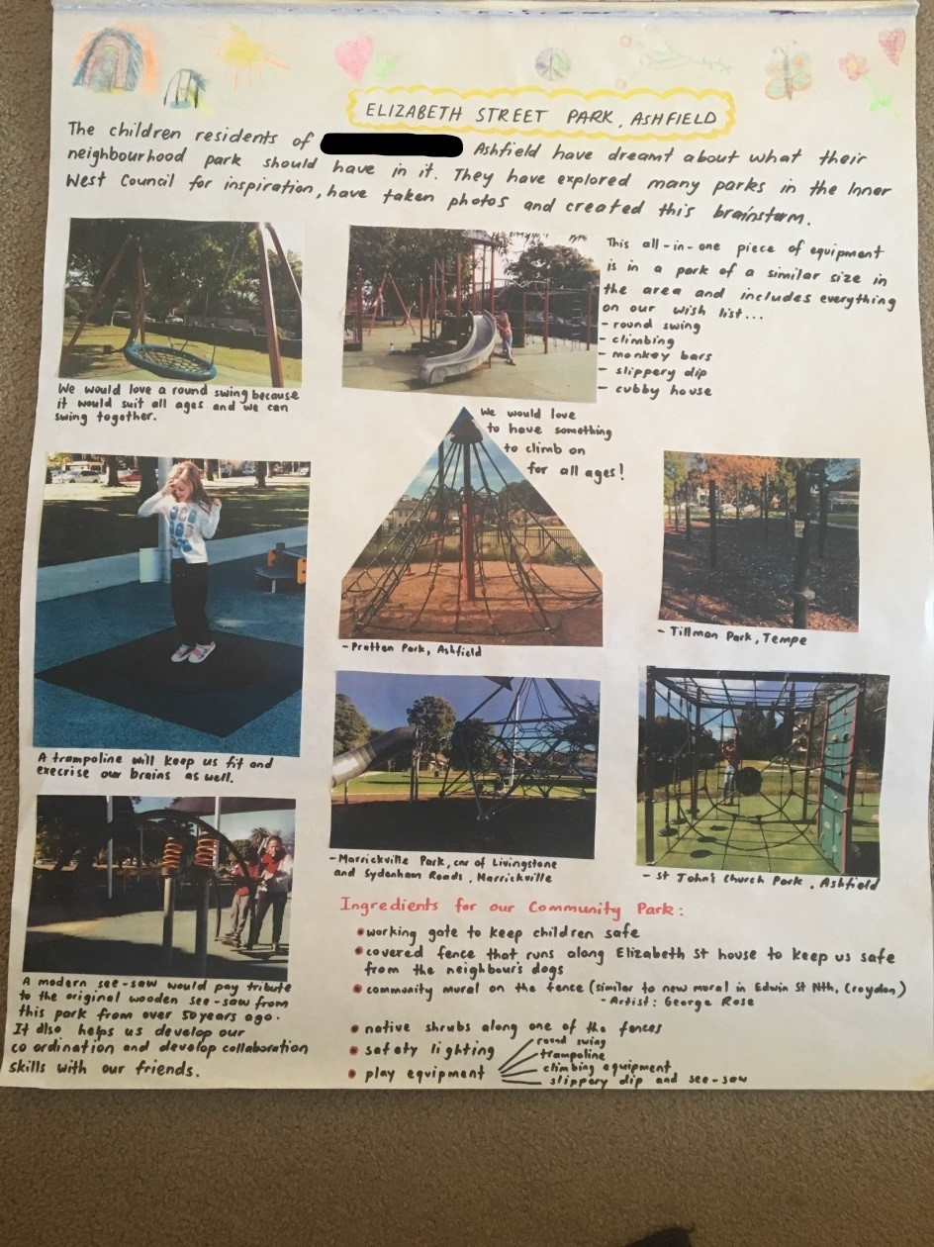

What did they say?

Equipment to prioritise
Participants were asked to choose three pieces of equipment that they’d like to see in the playground. The results show that swings, natural play equipment (boulders and logs) and a slide were the most popular among respondents via Your Say Inner West.

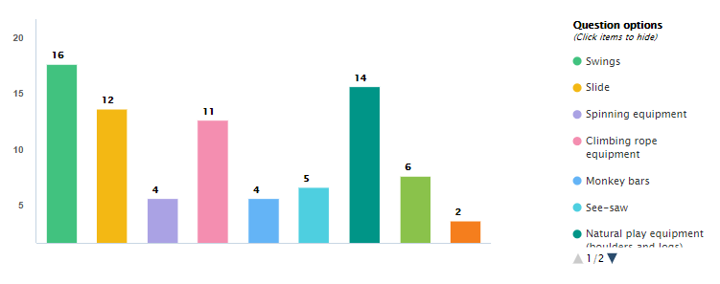
Comparatively, the six respondents who use the park weekly would like to see the swings, a slide and climbing rope prioritised. Natural play equipment was predominately voted for by those who aren’t currently using the park weekly (13 of the 14 total votes). Whilst this doesn’t necessarily indicate that they will become more frequent users of the park, it is important to identify and consider these different perspectives when design a park for long-term benefit.

Additional upgrades to prioritise
Participants were also asked to choose three other upgrades that were important to them or their children. The intention was to help Council design the best outcome with the space and budget available. Seating, fencing, rubber soft fall and landscaping were the preferred upgrades overall.
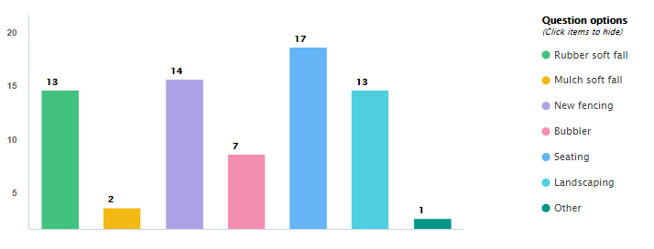
A closer analysis shows that those who rarely visit the park would prefer improvements to seating, landscaping and fencing be prioritised. This differs slightly from those who visit weekly who would prefer to see rubber soft fall prioritised over landscaping (below right).
Other upgrades to prioritise based on those who currently rarely use the park.  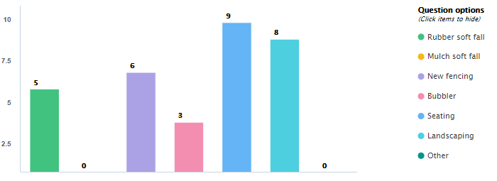 | Other upgrades to prioritise based on those who currently use the park weekly.  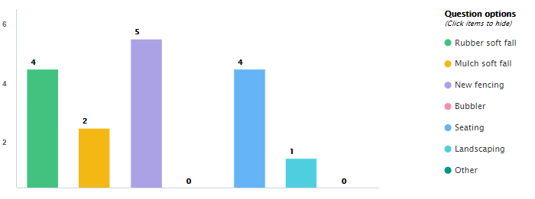
Issues
Open comment areas reflected generic issues of the playground that this upgrade will address. This includes support for the upgrade, current lack of play opportunities and the need to repair existing fence. A summary of some of the top issues are in the table below.
Issue | No. respondents | Reasoning
Keep the big tree | 3 | Kids love it  It is important to protect mature trees, especially for the shade it provides
Upgrade the existing fencing | 4 | It detracts from the park  If made taller the park could accommodate ball games.  There is a big hole in it  Better secured to minimise misuse at night.
Uninspired space | 3 | Didn’t know it was a park  It needs TLC (tender, loving, care)
Clear signage for no dogs | 1
Shade | 2 | Natural landscaping  Protect equipment on hot days (increase useability).
Keep the back area open | 1 | Grassed area for picnics or flexibility
maintenance | 1 | Bins that are regularly emptied  Frequent cleaning or grooming

Next steps
All twenty-six responses supported the upgrade to Elizabeth Street Playground. A variety of suggestions for the play equipment, park furniture and landscaping were provided. As detailed above, the results showed preference for natural play elements, seating, natural shade and landscaping, and new fencing for the playground. The project team will prepare a concept design. It will be made available for viewing on Your Say Inner West and in the park. The timber fence is along a shared boundary with no. 132 Elizabeth Street. The project team will communicate with the owner individually to address it’s need for improvement.

