Croydon draft Parking Strategy public exhibition

Engagement Outcomes Report

# Summary

Council undertook Public Exhibition of the draft Croydon Parking Strategy in November and December 2019 inviting the community to comment on the proposed introduction of Resident Permit Parking (RPS) for certain streets in Croydon.

The engagement commenced on 12 November 2019 and closed on 15 December 2019 with a total of 176 responses, with 158 online submissions, and 18 separate submissions, including two petitions.

# Background

* The Croydon Parking Study was arranged in response to representations received from the community regarding parking in residential areas near the Croydon Railway Station. The study was established with an aim to understand the parking situation, reflect on the community’s parking needs and desires, and to develop an effective parking management strategy.
* The Croydon Parking Study was bounded by Frederick Street, Church Street, Lang Street, Queen Street and the common local government boundary between Inner West and Burwood Councils.
* Current RPS parking operating in the study area includes Horden Parade, Railway Street, Milton Street, Thomas Street and Wetherill Street.
* Initial community engagement was undertaken in March 2019 via yoursay.innerwest.nsw.gov.au with approximately 2,100 letters sent to affected stakeholders and residents inviting to complete an online survey. Engagement ended with 256 surveys completed and submissions relating to the study. A summary of the main issues were outlined in the Croydon Parking Study report.
* The Local Traffic Committee endorsed the draft Croydon Parking Study in October 2019 and resolved by Council to be placed on Public Exhibition for 28 days.

# Promotion

The project was promoted via usual suite of communications channels including:

* Social media
* Inner West Council website
* Direct email to those who participated in the initial survey
* Letters to business and residents living in and around the impacted area. (see map below)

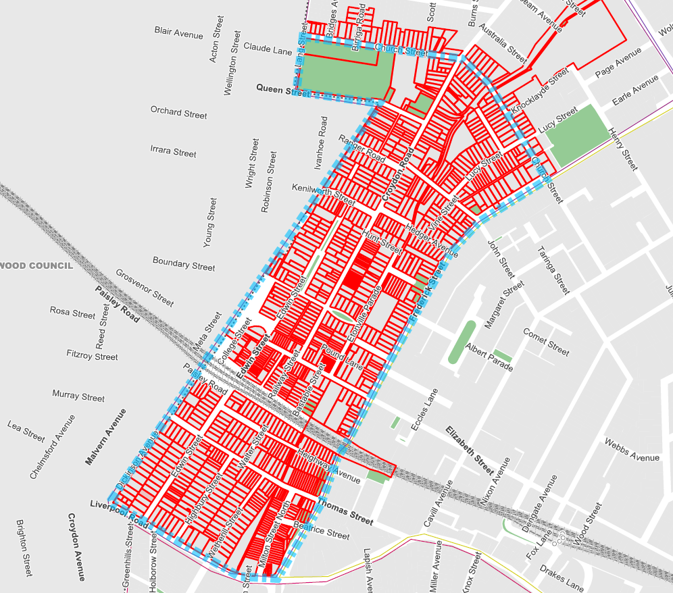

**Distribution map**

Blue line indicates study area

# Engagement outcomes

A total of 176 submissions were received comprising of 158 online responses and 18 responses received via other means (paper letters and emails) and two petitions.

The above represent a response rate of 8% from the community, which was lower than the initial survey response of 12% undertaken in 2019. Approximately 30% of received submissions were from outside the proposed RPS areas.

## Who did we hear from?

Responses were received from businesses, residents, employees, commuters, and a school. The majority of respondents were Croydon residents.

## What did they say?

### Online responses on Your Say Inner West

Do you support the draft Croydon Parking Strategy?

The table below summarises all responses.



Most comments related to the eligibility criteria and cost of the residential parking permits. Top three themes:

* Resident parking schemes penalise residents with driveways
* Minimum of two permits per household
* Transferable visitor parking permit available to each housed

### Feedback received from organisations/groups/stakeholders

A response was received from the Presbyterian Ladies College (PLC) and expressed a need to increase parking supply, compliance patrols to encourage good parking behaviour.

In addition, Burwood Council provided comments that they do not raise any objections with the proposed draft Croydon Parking Strategy.

### Other responses from individuals

Most submissions received from the community via mail, email and phone included comments regarding their preferences.

### Petitions

Two petitions were received during the engagement period. Both petitions were generally not in support of the strategy. The main issues raised in the petitions are outlined below:

Petition one 36 names from 25 properties:

* Residents are penalised for parking in their own street. The permit scheme should cater for all residents, not just those who have no off-street parking.
* Two permits should be issued per household regardless of whether they have off-street parking spaces or not. Third permit should require an explanation of need. Transferrable visitor permit to be made available to each household and linked to a residence.

Petition two 14 names and signatures from 5 properties.

* There is inconsistency in Thomas Street, with much higher concentration of parking on the south side, and none or a very few on the north side. Currently the north side has an RPS restriction and south side has unrestricted parking.
* Request for RPS to be extended to the south side of Thomas Street (generally between Frederick Street and Highbury Street), or similar to Brady Street, Croydon.
* A scheme that is issued 2 parking permits regardless of off-street parking provision, with free permits being transferable, and free visitor’s permits to be issued to residents.