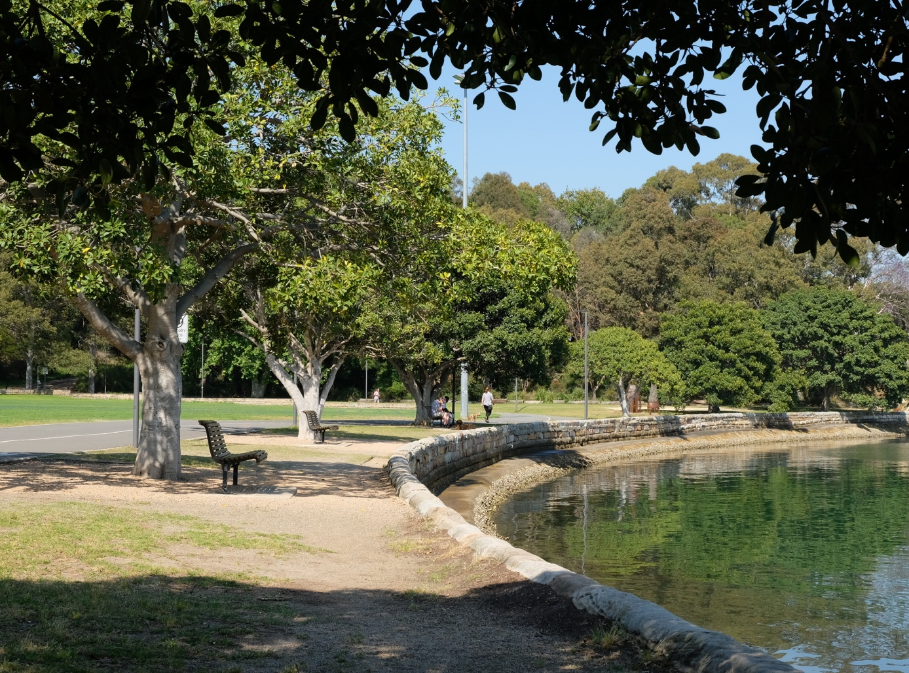

King George Park - Plan of Management and Master Plan

Engagement outcomes report

Contents
Stage 1 Engagement 3
Summary 3
Background 4
Engagement Methods 4
Promotion 4
Engagement outcomes 4
Stage 2 Engagement 23
Summary 23
Background 23
Engagement Methods 23
Promotion 23
Engagement outcomes 24
Officer comments in response to public exhibition 28

Stage 1 Engagement

Summary
Throughout November and December 2020, engagement was conducted in preparation for a new Plan of Management and Master Plan for King George Park. The community was invited to provide feedback on how they use the park and key issues via Your Say Inner West. Feedback was collected over five weeks, from 2 November until 7 December 2020.
The project page received 473 visits. Documents and information were viewed by 167 visitors, of whom 91 visitors contributed to the online feedback form. Responses were received from representatives of three sports organisations via email.
Generally, respondents were very positive about King George Park, but commented that they would like to see improvements to some areas including:
- Tension between users on shared paths
- Poor playing field condition
- Poor after dark conditions
- Demand for parking and pedestrian safety
- Litter management
- More landscaping
- Balancing the needs of organised sports and general users

Due to the timing of the engagement, respondents were asked how COVID-19 impacted their use of KGP. General users responses were equally split between those who used the park more often, the same amount, or less because felt it was too crowded. For spectators and sports players, their use was different due to impacts on training and game programs.
Key concerns from sporting organisations were:
- Poor field conditions creating safety issues for all users
- No change rooms
- Insufficient floodlighting
- Equipment storage is not fit for purpose
- Safety concerns with the Bay Run for all users
- Demand for parking creating stress in local streets.

Background
Plans of Management must be prepared for all types of parks on community land. Inner West Council has established a ‘Parks Planning Priority’ list, which nominates open spaces in greatest need of new or updated Plans of Management. King George Park is identified as high priority. We are engaging with the community to understand how visitors use the park and how their experiences could be improved, with the intention of integrating their feedback into the Plan of Management and Master Plan where possible.

Engagement Methods
Due to Covid-19 restrictions, the engagement was held on Your Say Inner West and other remote means of communication, such as email.

Promotion
The engagement was promoted by Council’s usual channels, including:
- Your Say Inner West project page
- On-site signage
- Social media
- Council website
- Email to identified groups
- Your Say Inner West E-news
All promotion collateral directed people to Your Say Inner West to participate.

Engagement outcomes
Who did we hear from?
We asked the following questions to determine the demographic of the engaged respondents:

What is your age group?
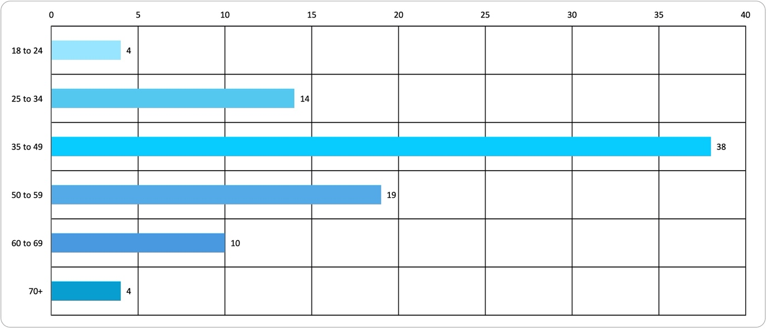

Figure 1 : This question had 89 respondents. Respondents ranged in age from 18 to over 70, with the primary contributors in the 35-49 age range.

What is your gender?

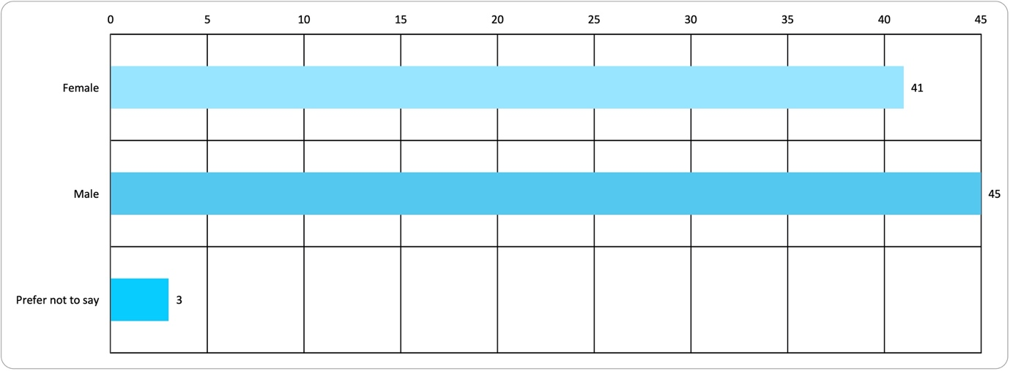

Figure 2 : This question had 89 respondents. We heard from a balanced gender range.

Do you identify as Aboriginal or Torres Strait Islander?

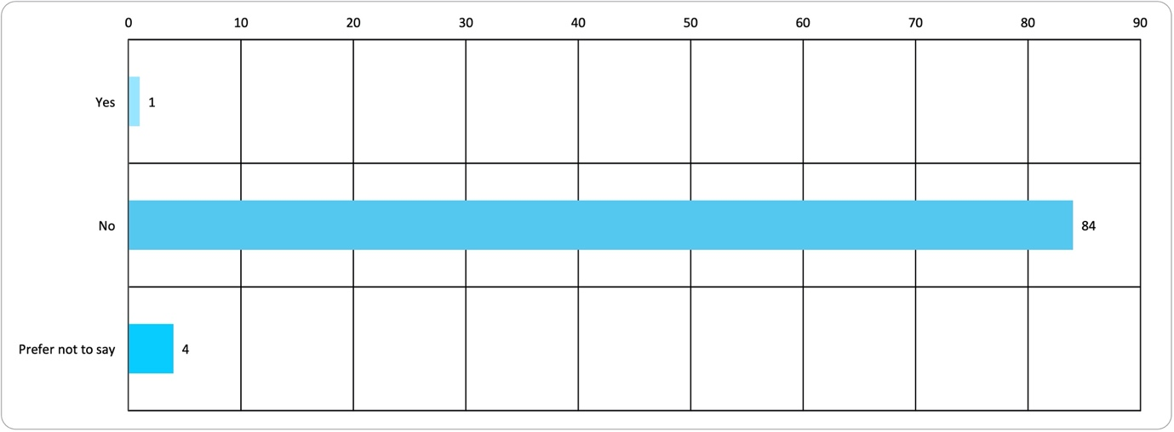

Figure 3 : This question had 89 respondents. The majority of respondents did not identify as Aboriginal or Torres Strait Islander.

Do you identify as someone with a disability?

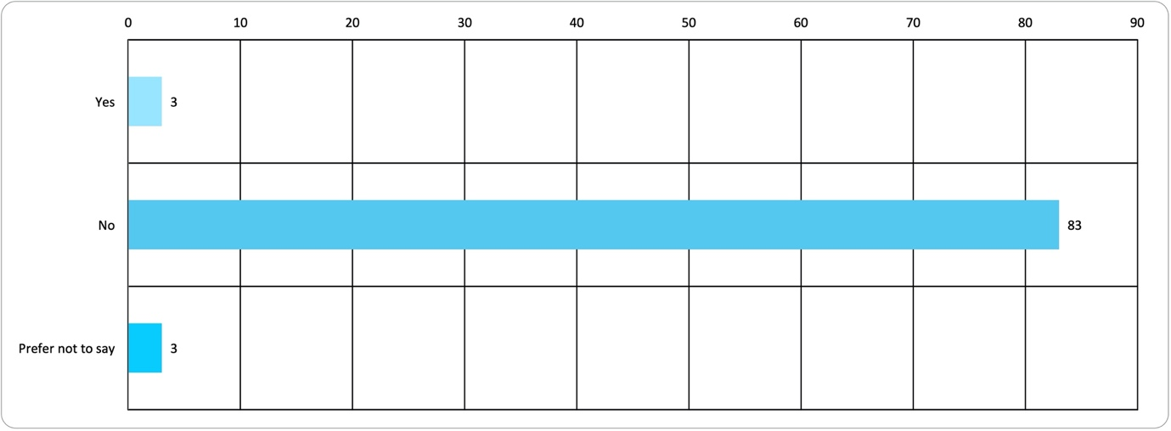

Figure 4 : This question had 89 respondents. The majority of respondents did not have disability.
Suburb What suburb do you live in?

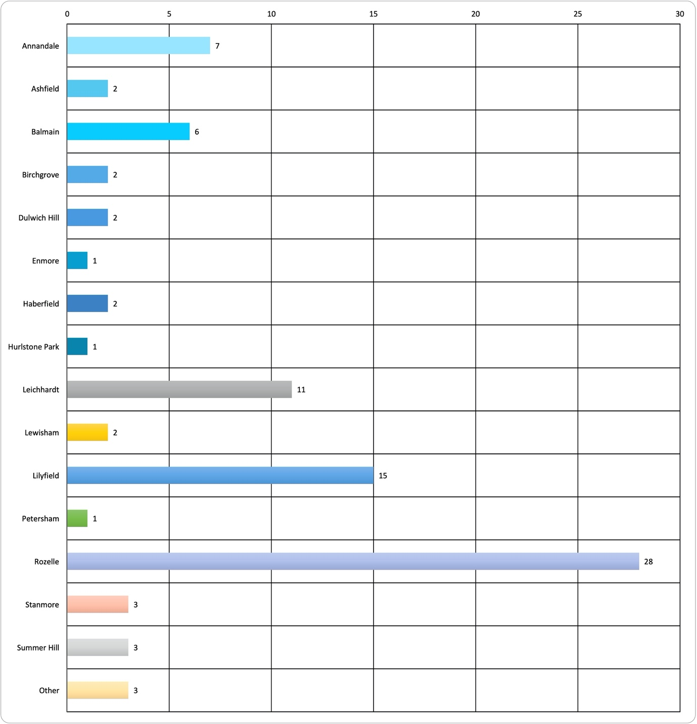

Figure 5 : This question had 89 respondents. The majority of respondents lived locally in Roselle, Lilyfield and Leichhardt.

How do they use the park?
How often do you visit King George Park?
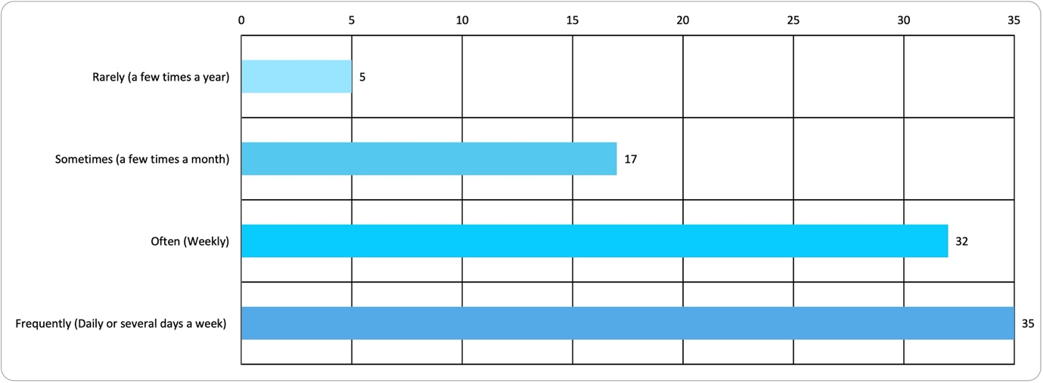

Figure 6: This question had 89 respondents. 75% of respondents use the park weekly or more often. It should be noted that this survey was undertaken while many people were working at home due to Covid-19 precautions. It can be assumed that generally respondents use of public parkland has altered as a consequence of Covid-19.

How do you get to King George Park?
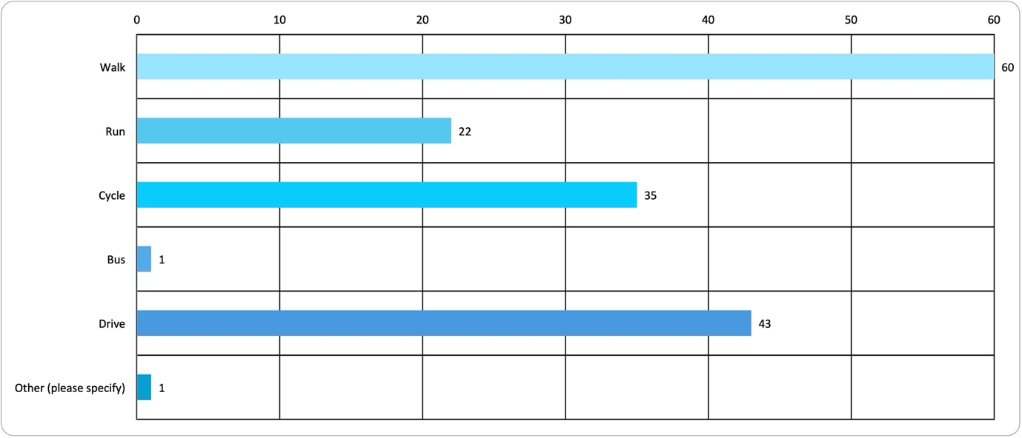
Figure 7: This question had 162 answers from 89 respondents. Most respondents travel to the park in different ways, presumably this is dependent on where they are travelling from and what activity they are plan to undertake while in the park 50% of respondents travel to the park on foot (walk or run), followed by 27% who drive and 22% who cycle. Very few respondents arrived by bus
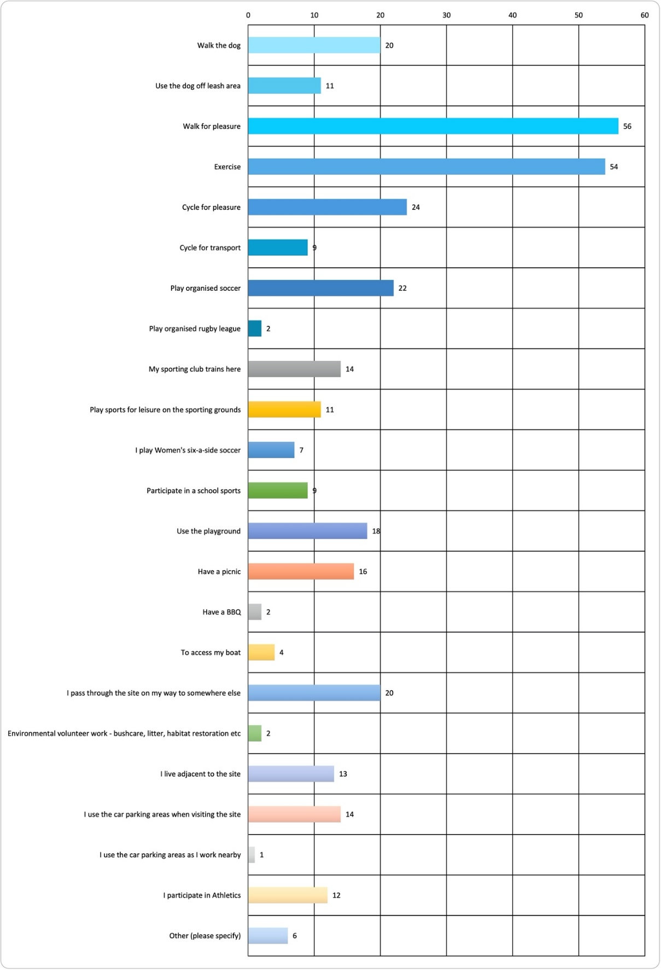
What are the main reasons that you visit King George Park?

Figure 7: This question had 347 answers from 89 respondents. Most respondents use the park for a range of reasons, the most popular activities are by far walking for pleasure and exercising, with 32% of responses. 19% of respondents use the park for organised sports. Other popular activists include cycling for pleasure, walking the dog, using the playground and having picnics, with 5 to 10% respondents citing these uses. Only 4% of respondents noted that they use the car parking areas.
What did they say?
The respondents were asked to what extent they agree with the following statements.
The response options were:
- Strongly agree
- Agree
- Unsure/ not applicable
- Disagree
- Strongly disagree

When I visit during the day I feel safe

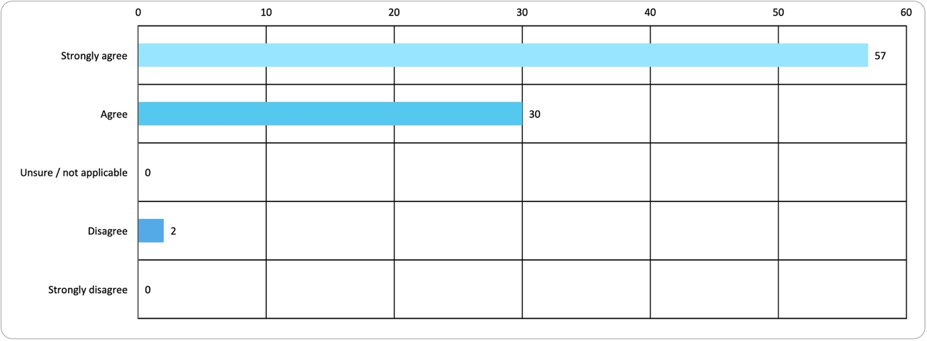

Figure 9: This question had 89 respondents. The majority of respondents (97%) agreed that they did feel safe visiting during the day

When I visit in the evening and at night I feel safe

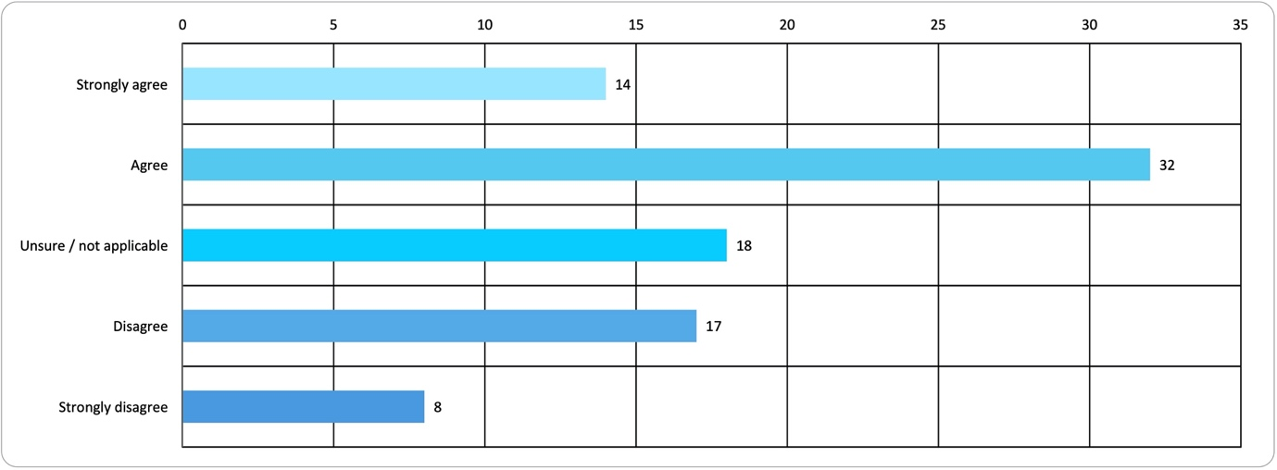

Figure 10: This question had 89 respondents. Only 50% of respondents felt safe agreed that they felt safe when visiting in the evening and at night - 30% responded that they did not agree with the statement that they felt safe.

I feel part of the community when I visit

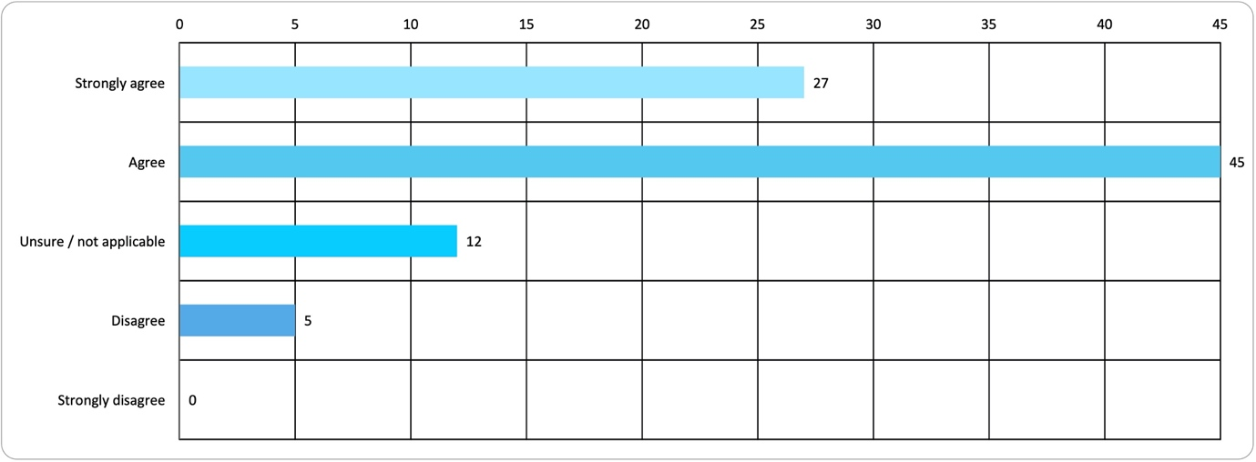

Figure 11: This question had 89 respondents. Most respondents agreed that they do feel like part of the community when they visit the park

King George Park is easy to walk around

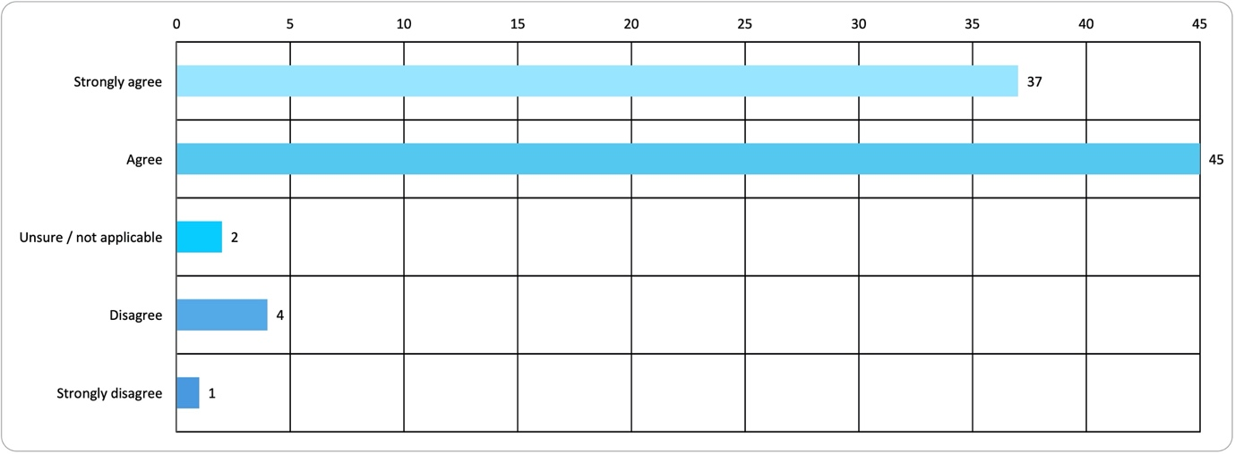

Figure 12: This question had 89 respondents. The vast proportion of respondents agreed that KGP is easy to walk around.

It’s easy to find information about King George Park

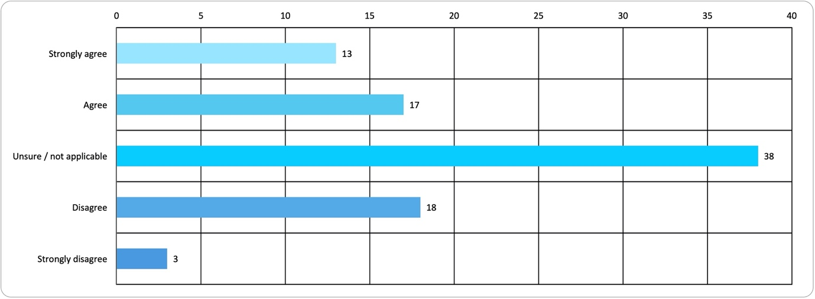

Figure 13: This question had 89 respondents. The response was very mixed – about 20% disagreed with this. The majority of respondents were not sure/ not applicable.

King George Park caters for all ages

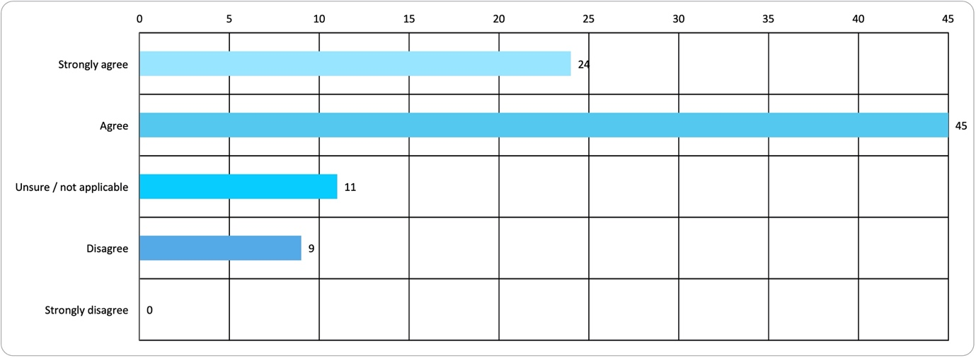

Figure 14: This question had 89 respondents. There was general agreement with this statement.

King George Park meets the needs of the community

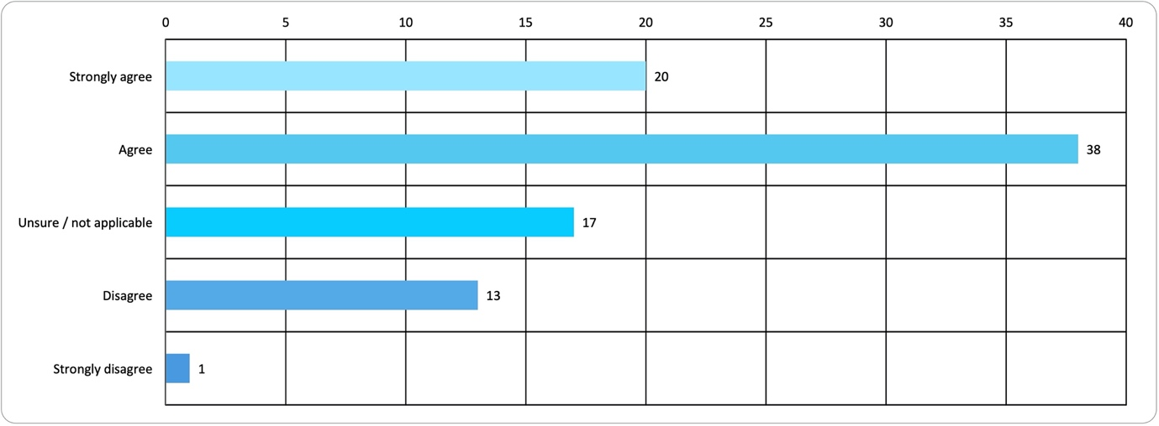

Figure 15: This question had 89 respondents. There was mixed feedback about whether KGP meets the needs of the community, with 35% unsure or in disagreement over this statement.

King George Park is well maintained

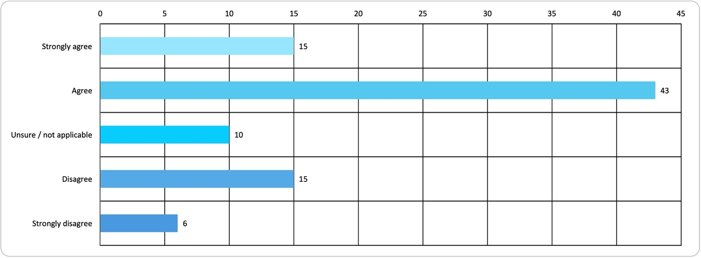

Figure 16: This question had 89 respondents. Though many respondents agreed with this statement there was also a relatively large proportion of strong disagreement with this statement

King George Park has a nice character

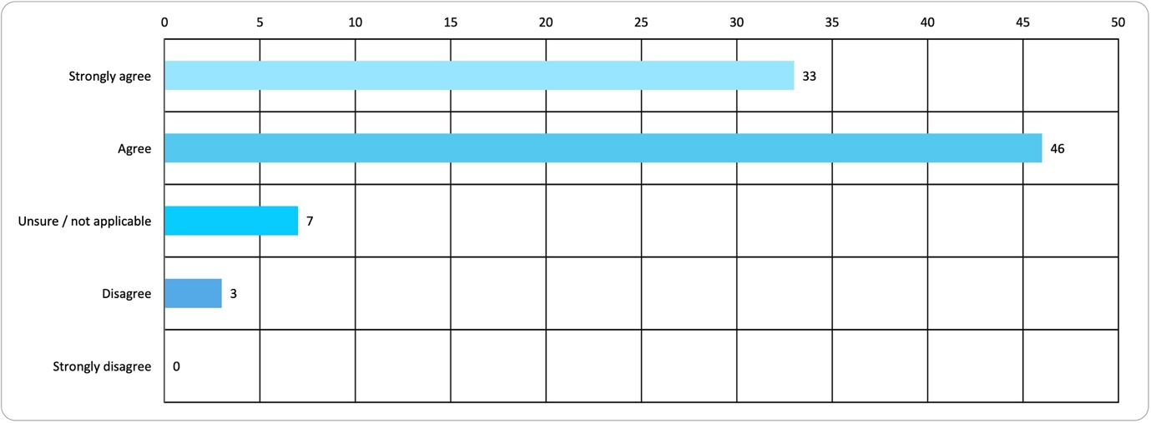

Figure 17: This question had 89 respondents. 90% of respondents agreed with this statement.

Overall does King George Park meet your needs?

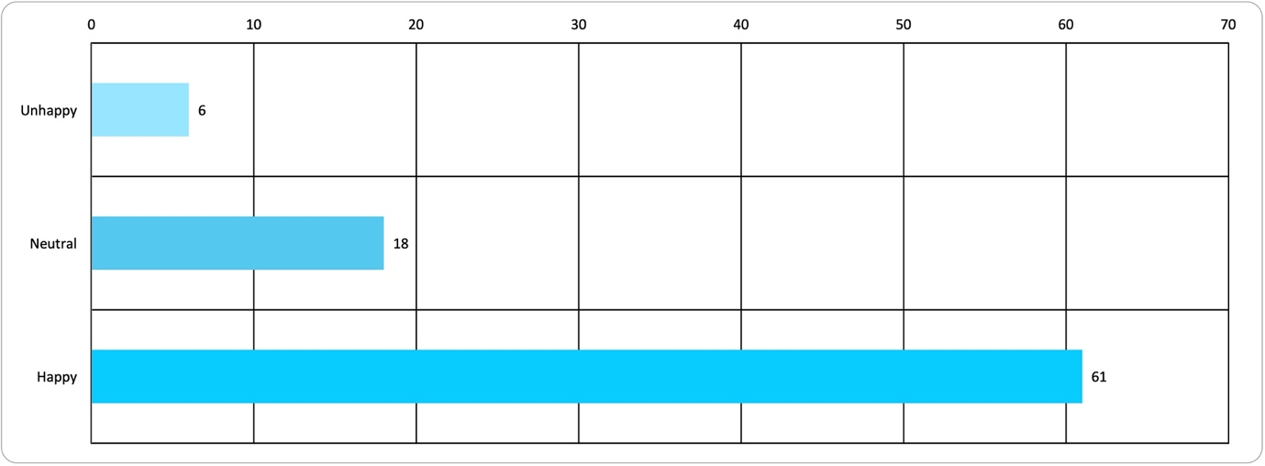

Figure 18: This question had 85 respondents. The majority of respondents (72%) were happy that KGP meets their needs, 21% were neutral. Of the 7% were unhappy with the park.
Respondents were asked a number of open-ended questions about the park. Their responses are summarised below for each question.

‘What don’t you like about King George Park?’
This question had 80 respondents. A number of common themes emerged in their responses.
Key issues include:
- Shared pedestrian and cycle path
  - Pedestrians think cyclists are going too fast
  - Cyclists think it is dangerous that pedestrians cross the path without looking
  - Many suggest path segregation
- Playing field condition
  - Poor pitch condition, potholes, safety concerns
  - Lack of suitable lighting
- After dark conditions
  - Lack of lighting around water’s edge, under bridge and car park
  - Lack of passive surveillance at water’s edge
- Car park
  - Pedestrian access through and across car park
  - Capacity of car park during events
  - Unstructured parking and regulation for residents
Other strong themes
- Amenities block - discontentment over lack of maintenance and use of shipping containers as storage facilities
- Litter - throughout the park
- Landscaping – there is a lack of vegetation and shading on waterfront and at park boundaries
- Park focus – it is too heavily skewed towards organised sports and non-public activities (private operators)
Other comments:
- Lack of seating, artwork, Information on park, history, culture and events
- Degradation of aboriginal sites
- Impact of WestConnex work and tunnel mouth on park
- Long term storage of vehicles and boats within car park and on waterfront
- Lack of surveillance, security and maintenance of playpark and long jump pit
- Lack of options for younger children within playpark
- Lack of bike racks

‘What do you value most about King George Park. You may like to describe what it looks like, how you use it or how it makes you feel.’
This question had 72 respondents.
Main themes:
- Location and situation
  - By far, the most valued aspect of the park was its location and situation.
  - Almost all respondents commented on their appreciation of waterfront access, beauty of the view and connection to harbour.
  - Many appreciated the combination of conditions – waterfront, bushland and open green space.
  - People stated that they find the park calming and peaceful.
  - Many respondents commented positively on the proximity of the park to their homes and the city – they placed very high value having open space within an urban area.

- Active recreation
  - Many respondents commented on the value they place on availability of the park for sport.
  - Positive comments were made relating to the range of organised activities on offer for both children and adults, that it achieves a good inclusive balance.
  - Appreciation that the park is well used.
Other comments:
- Dog access and dog friendly beach
- The Bay Run
- The connection with Callan Park
- The park feels safe and clean
- Very little vehicular access

People did not often comment on the amenities, the playground, the outdoor gym, the sculpture and cultural value.

How did COVID-19 change your use of the park?
This question had 80 respondents. Respondents answers focussed on how much they used the park, how they used it, and why.
The responses were split relatively equally between those who used the park more often, the same amount, or felt it was too crowded.
- The respondents who used the park more often did so for the following reasons:
  - To walk their dogs more often
  - For the positive impact that the park had on their mental health
  - Increased use of the park is ongoing for those who have continued to work from home
- Many respondents commented that the park because too crowded. These respondents:
  - Stopped using the park
  - Used the park less
  - Used Callan Park instead
  - Used local footpaths instead
  - Used more caution when visiting the park, such as social distancing, avoiding use of shared equipment and amenities (water bubblers and outdoor gym)
Both sports players and spectators noted that their use of the park changed due to the impact of Covid-19 impact on the sports programme.

What improvements would you like to see?
This question had 74 respondents. The main themes of their responses were:
- Playing fields
  - Improve playing surface
  - Take measures to avoid dogs digging holes in playing surface
  - Improve lighting provision
  - Increase time that lights stay on after dark
  - Install artificial running and athletics track to prevent wear on natural turf.
- Car park
  - Improve surface condition and levels
  - Improve clarity of signage
  - Improve pedestrian safety
  - Rationalise parking spaces
Other strong themes:
- Shared pedestrian and cycle path - Definition between cycle and pedestrian pathways, either by segregation or surface marking
- Landscaping - Increase in vegetation on the water’s edge, Manning Street boundary and generally throughout the park
- Storage - Resolution of shipping container dumping ground, improvements to existing amenities and integration of storage with amenities.
- Seating - More waterside seating, general seating, picnic tables or creation of level areas for picnics
- Footpath lighting - specifically around car park and lower part of waterfront walk.
- Maintenance - general ongoing maintenance, cleaning the amenities, rectifying vandalism, litter clearance and collection.
Other comments:
- Create equitable access to amenities from waterfront (via accessible pathway)
- Improve outdoor gym equipment, addition of pull up bars
- Introduction of basketball facilities
- Additional bicycle parking
- Additional shade structures in playpark, and improved playpark surface
- Boat + kayak hire
- Balance of sports field use for visitors who don’t take part in organised sports
- Introduction of pump track

What do you think should be the main priority of the park plans?
This question had 74 respondents. There were a huge range of responses to this question but some recurring themes included:
- Keep the park open
  - Maintain access to the park for all
  - Retain the friendly community aspect of the park
  - It is a place for visitors to benefit both their physical and mental health
  - Retaining the availability of the park for organised sports

- Balance
  - Retaining the existing balance of uses which currently occur within the park
  - Reduce the skew towards organised sports
  - Make more space available for unstructured recreation, whether exercise, picnicking or other.

- Improvements to the sports facilities
  - Playing field surface
  - Playing field lighting
  - Amenities and storage

- Biodiversity
  - Preserve and continue to develop and increase the biodiversity and greening of the park, and bush land around and within the park.

Do you have any other comments about King George Park?
This question had 34 respondents. There were a wide range of additional comments, the majority of which were reiterations of responses to the earlier questions. Some items not covered elsewhere:
- More events, markets festivals
- Expand focus to include Bushcare and aboriginal culture
- Change name of park
- Avoid privatisation of public space
- Introduce a speed limit for cycle path
- Park maintenance is not commensurate with increased usage

Comments received from organisations/ groups
Direct invitations were sent to sporting clubs who use KGP to invite their comments. Representatives from three sporting clubs provided detailed responses. Key issues include:
- Poor field conditions leading to safety issues for all users:
  - Not enough time for the field to recover and routine maintenance between seasonal uses
  - Violation of no-dogs on the field signage, resulting in holes on the field or dogs running through training sessions
  - Prone to flooding due to poor drainage
  - Require a raised edge around the long jump pit to stop sand blowing onto the Bay Run
  - Field is not accessible
- Demand for parking
  - Impact on side streets due to demand
  - Parking used for long term storage of vehicles
- Storage is not fit for purpose
  - Require a solution for long-term, suitably insulated and secure storage. Equipment has been deteriorating rapidly in the shipping containers due to hot, humid conditions and there has been vandalism and break-ins, despite introduction of CCTV
  - Shipping containers detract from the aesthetic of the park
  - Possibly commission public mural or scoreboard on the new facility
- Safety (Bay run)
  - Observe that incidents occur on the Bay Run route, specifically to:
    - Cyclists who skid off their bikes due to debris on the path
    - Collisions between cyclists + pedestrians moving between allocated lanes
    - Athletes moving between the playing fields and long jump pit
  - Suggest that some of these incidents could be avoided by:
    - Path maintenance
    - Clearer line marking + lane awareness
    - Signage for those using and crossing the path
- No change rooms
  - Not available at KGP
  - Required for players and referees
  - Lack of female changing room seen as a barrier to female sports participation
- Floodlighting not sufficient
  - Current level of floodlighting not suitable for night-time games
  - Ability to hold games at alterative game times is key to increasing capacity of field use, and offering diverse game times

Stage 2 Engagement

Summary
Following the Stage 1 engagement, Council drafted the 10-year plan for King George Park, which includes a Plan of Management and Master Plan, using the community feedback, research and other information. The draft was then put on public exhibition for community comment via the engagement platform Your Say Inner West (YSIW).
The public exhibition ran between 26 August 2021 and 7 October 2021. The project page received 791 visits. Of those visitors, 124 provided feedback. The questions asked visitors to express whether they support the draft Plan of Management and Master Plan and comments to explain their answer.

Engagement Methods
The methods of engagement were:
- Online on yoursay.innerwest.nsw.gov.au through survey
- Written feedback

Promotion
The public exhibition period was promoted by Inner West Council using a number of means, including:
- Social media
- ‘Your Say Inner West’ monthly update
- Email to participants of Stage 1 Engagement
- Council Website
- Onsite posters
- Letterbox drop to surrounding residents

Engagement outcomes
Outcomes of community engagement received through the online survey and written feedback forms have been collated within this report. Feedback to questions has been arranged so that comments which were more common are presented first.
What did they say?
- Online via yoursay.innerwest.nsw.gov.au

Do you support the proposed Plan of Management and Master Plan?

The online survey asked respondents ‘Do you support the proposed Plan of Management and Master Plan?’. One hundred and twenty four responses were received to this question. Eighty eight (70.9%) participants responded ‘yes’, twenty four (19.3%) responded ‘no’ and twelve (9.6%) responded ‘unsure/don’t know’. The chart below illustrates the quantitative response to this question.
Participants were then asked ‘Please provide comments to support your answer’. There was strong support for upgrades to the carpark area, playground, and sporting ground surface. Key areas of concern raised in the written submissions included:
  - Location of proposed pavilion
  - Inclusion and location of proposed café
  - Carpark area
  - Exclusion of changerooms from plans

Location of proposed storage pavilion
Overall responses support the provision of a storage pavilion. Concerns were raised regarding the location of the proposed pavilion on the southern side of the sporting ground. Concerns centre around the structure’s footprint, accessibility and the impact (physically and visually) of the structures on the adjacent restored bushland.

Inclusion and location of proposed café
Most respondents supported the inclusion of a café. Those that did not support the proposal raised concerns regarding the café’s proximity to the sewage pit, accessibility issues, the impact a café would have on the sporting organisations canteen operations, impacts on adjacent bushland and the location potentially being hazardous.

Carpark area
Overall respondents support the carpark area proposals. Several respondents requested that the carpark is surface is permeable and sufficient vegetation cover is provided to minimise the impact of heat in the area.

Exclusion of changerooms from plans
Many respondents noted that change rooms have not been included in the proposals. Several requests for change rooms were made with justification for the amenity including safety for children, strong demand for them and a current lack of facilities.

- Comments received from organisations/groups/stakeholders
A total of six submissions were received from organisations who use King George Park. These organisations are as follows:
- Callan Park Bushcare Inc
- Leichhardt Saints Football Club – 1200 members
- Leichhardt Juniors Rugby League Football Club – 200 members (three submissions)
- Football NSW
There was strong support for upgrades to the car park, lighting and resurfacing of the sporting ground. Feedback centred around the following key areas:
- Storage Pavilion
- Pump Station Café
- Carpark
- Exclusion of changerooms from plans

Storage pavilion
Overall responses support the need for storage area. Concerns were raised regarding the location of the proposed pavilion and the impact the structure would have on the adjacent restored bushland. Potential issues regarding antisocial behaviour and litter were also raised. Some organisations requested the proposed pavilion provided adequate space for all sporting ground users.

Pump Station Cafe
Concerns were raised regarding the impact the proposed café would have financially on existing canteen facilities, the cost of repurposing the pump station structure, the odour of the adjacent vent pipe and potential impacts on nearby bushland area.

Carpark area
Overall respondents support the carpark area proposals. Some organisations requested the surface be a permeable material.

Exclusion of changerooms from plans
Several requests for change rooms were made with justification for the amenity including health, safety and a current lack of facilities in King George Park.

- Other responses from individuals
Several email responses were received directly to staff members. Key issues from these responses included:
- Storage Pavilion
- Pump Station Café
- Carpark
- Inclusivity and accessibility

Storage pavilion
Feedback supports the requirement for storage facilities. Concerns centre around the location, scale, orientation and accessibility of the proposed storage pavilion, the impact on adjacent bushland and potential antisocial behaviour.
Pump Station Cafe
Concerns include the cost to convert the building into a café, potential impact on surrounding bushland, odour from adjacent vent and several submissions questioned the location and necessity given existing coffee cart and canteen facilities.

Carpark area
Responses largely support the proposed carpark upgrades with feedback requesting the inclusion of permeable pavement and additional planting.

Inclusivity and accessibility
Responses emphasised the importance of accessibility and inclusivity to cater for the wide range of park users.

Submission for additional skate facilities
A submission was received highlighting five key areas within King George Park as potential spaces for additional park facilities. The areas and proposed facilities are as follows:
- Under the Iron Cove Bridge – ball court, mini ramp/bowl, table tennis, chess table or street skate features
- Playground Precinct – small pump track, mini ramp, bowl or street skate features
- Car Park access area – small pump track, mini ramp, bowl or street skate features
- Long jump corner – small pump track, mini ramp, bowl or street skate features
- Outdoor gym / oval corner – small pump track, mini ramp, bowl or street skate features

Officer comments in response to public exhibition
Council officers reviewed the public submissions which were received as part of the exhibition of the draft plan of management. Responses to specific issues are as follows:
Theme | Concern | Response
Storage pavilion | Proposed location | Council acknowledges concerns raised regarding the current location of the storage pavilion. However, due to underground services on site, required building size and no alternative positions the current location will remain. Council is committed to working with relevant entities to ensure the building is sensitive to its surroundings. The documents have been amended to outline this.
Pump Station Café Proposal | Cost, impact on surroundings, odour from vent and feasibility | This proposal will remain in the Plan of Management and Master Plan as an option to allow for flexibility in the future. Council highlights that the proposal is not critical and an option only. Council emphasises that additional community consultation and feasibility would need to occur prior to any work. The documents have been amended to explain this.
Carpark area | Request for porous paving material | Council supports the use of porous paving materials in the carpark upgrades and will include additional planting where possible and appropriate. The documents have been updated to include these proposals.
Changerooms | Changerooms not included in Plan of Management | Council acknowledges the request for changerooms and notes that if there is a continued need for club change rooms they will be considered in nearby location. Council highlight that the three sporting clubs who use King George Park were involved in previous consultation and design decisions of the storage pavilion. The option of change rooms was not supported by the sporting clubs during the design phase of the new amenities block. In addition to the above, King George Park has limited space on where new facilities including changing rooms and storage facilities can be located. Blocking residential view lines into the park by constructing a new facility where the former amenities block was located is not recommended as the new amenities block was purposely located to improve visual surveillance of the park and improve residential amenity and park user experiences.  It is recommended that should the need for changing rooms still be an issue moving forward that junior rugby league club is relocated to the new Rozelle Parklands once constructed (subject to allocation assessment) as this new purpose built facility will include new amenities with shower facilities.
Request for additional park facilities | Skate facilities requested at five locations | Council acknowledges the request for additional park facilities proposed at five locations. Council does not support the additional proposals for the reasons outlined below:  - Under the Iron Cove Bridge – This location is unsuitable due to safety along the Bay Run and the proximity to the water’s edge  - Playground Precinct – This location is unsuitable because of the impact on adjacent residents and the space is currently used as a passive recreational area  - Car Park access area – This location is unsuitable due to space limitations  - Long jump corner – This location is unsuitable as it is already used as a recreational space and there is a lack of space  - Outdoor gym / oval corner – This location is unsuitable as it is already in use and there is a lack of space

