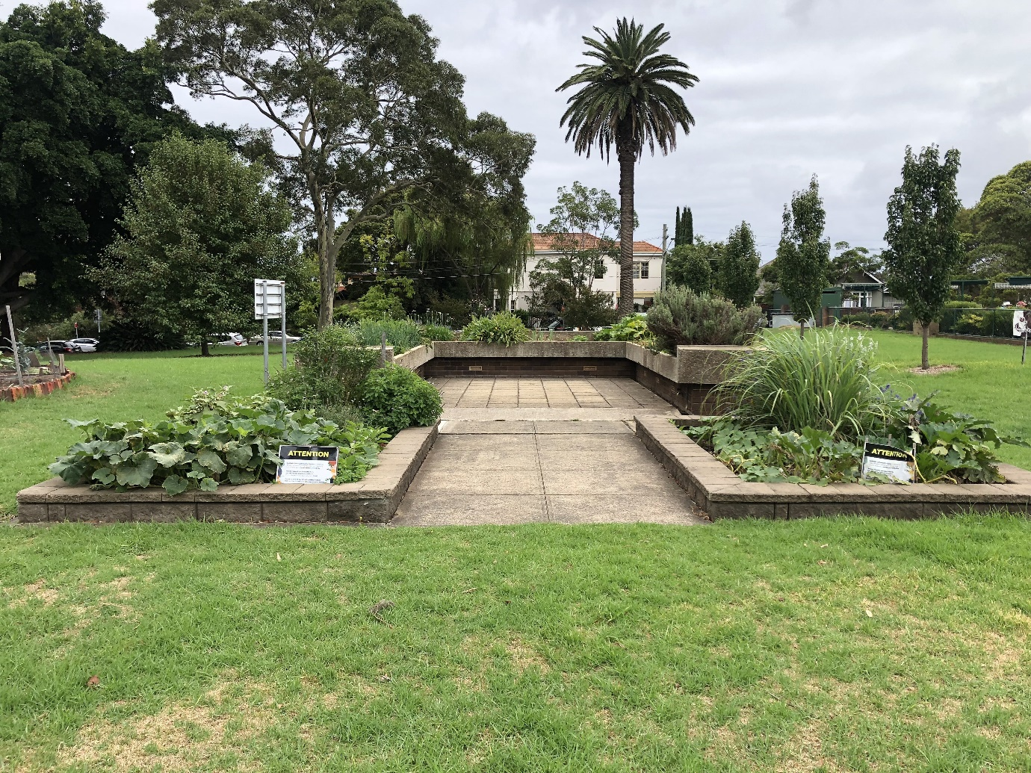

Engagement outcomes report

Ashfield Park Plan of Management and Master Plan

Contents
Stage 1: Initial Engagement 3
Summary 3
Background 3
Engagement Methods 3
Engagement outcomes 4
Who did we hear from? 4
What did you say? 7
Stage 2: Draft Plan of Management and Master Plan engagement 14
Summary 14
Background 14
Who did we hear from? 14
What did they say? 17
Officer Comments 21

Stage 1: Initial Engagement

Summary
Council consulted the Inner West community as part of the development of a 10-year plan for Ashfield Park, which includes a Plan of Management and Master Plan. Community engagement was carried out via the online engagement platform Your Say Inner West (YSIW) between 2 March and 31 March 2020.
The project page received 327 visits. Of those visitors, 113 visitors left feedback. The questions prompted visitors to express their thoughts on Ashfield Park in general, including what visitors currently value and dislike about the park; what improvements visitors would like to see; and what should be prioritised within the plan.

Background
Plans of management must be prepared for all types of parks on community land. Community engagement is a critical step in the preparation of a Plan of Management, forming one of the first stages of the process. Community feedback is then taken into consideration alongside stakeholders and expert advice to draft plan of management and master plan, which is presented for further community input before the elected Council adopts the document
Inner West Council established a park planning priority list, which nominates which open spaces are in greatest need of new or updated Plans of Management. Ashfield Park has been nominated as high priority within the Inner West council area.
The purpose of engagement was to establish any key issues that the community may have in relation to Ashfield Park, as well as highlighting aspects of the park which are highly valued. Contributors were encouraged to include ideas, comments and suggestions to assist in prioritising the focus of key strategies and outcomes for the future.

Engagement Methods
The methods of engagement were:
- Online on yoursay.innerwest.nsw.gov.au
- Engagement with existing park organisations (formal and informal) including dog owners and the community garden
Planned drop-in sessions were cancelled due to Council’s Covid-19 response.
Promotion
The engagement was promoted by Inner West Council using a number of means, including:
- Social media
- Your Say Inner West monthly e-news
- Council Column Inner West Courier
- Council website
- Email to identified groups

Engagement outcomes
Outcomes of community engagement received through the online survey and written feedback forms have been collated within this report. Feedback to questions has been arranged so that comments which were more common are presented first.

Who did we hear from?
The demographics of respondents were collected through the online survey and is represented in graph form within this report. The most significant age group of respondents was between 35-49 (38% of respondents) followed by 25-34 (32% of respondents).
Most respondents identified as living in Ashfield (64% of respondents) followed by Summer Hill (16% of respondents).

What did you say?
The online survey included multiple choice and essay style questions for more detailed feedback. Quantitative responses to the multiple-choice questions are displayed visually in the Engagement Outcomes section below. Written responses have been themed and are presented a in descending order of common themes raised.
Feedback from organisations was also sought through the online engagement format, with the ability for organisations to upload documents and provide comments.
Input was also received by council in the form of written surveys and feedback posted to council to ensure that there were opportunities to provide feedback beyond the online portal. This feedback has been themed and collated with the online feedback.
Online via yoursay.innerwest.nsw.gov.au
The main reasons people visit Ashfield Park are as follows:

Respondents were asked to describe what they value about Ashfield Park.
- Most people valued the open green spaces and established trees. Many people commented on the sense of calm the park brings their life and saw it as a refuge from the urban environment.
- The size, the open space and the areas for unstructured recreation were all common themes which people valued about the park.
- Many people valued it as a space they could walk their dog and meet other dog owners. Many people requested a dog off leash area in the park, whilst some other respondents requested that the park remain an on-leash area.
- Respondents commented on the available facilities for children and families including the fenced playground with surrounding tree cover.
- Many people commented that the paths were well laid out and allowed for easy access for a pram, running or jogging.
- People enjoyed the community garden and how it brought the community together and how people interacted and enjoyed it.
- The shade and established trees were important to the community, along with the wildlife and birdlife that the vegetation supports.
- The variety of facilities the park provided was also valued. This includes the playground, playing field, community garden, exercise equipment, open space, and Bowling Club.
- Respondents mentioned the memorial walks and war memorial as having a special place. There was a request to focus on the first nations people history within the park.

Respondents were asked what they don’t like about Ashfield Park?

- Many participants noted that the park was generally very good.
- Lacks off-leash dog areas, timed or otherwise.
- Lack of parking during sports events and training makes it difficult for residents and other visitors. Respondents mentioned that the park being overrun with sporting groups and training.
- The community mentioned that there is a lack of shady picnic benches with tables. There was also a lack of shelter, particularly from the sun but also for wet weather gatherings and additional picnic shelters would be welcome.
- Lack of toilets within the park, along with upgrade of the existing toilets. The current toilets are considered too small. Respondents mentioned that they are unpleasant and should be better maintained to keep up with use. There was also confusion about where toilets are located with people mentioning that signage was confusing, and they were hard to find.
- Dogs being off leash throughout the park regardless of this not being permitted.
- Some residents noted a lack of trees in the park with a request for additional native plants and fauna habitat.
- There were comments regarding the upkeep and placement of facilities throughout the park. These included maintaining bindii in the turf, upgrading planting and lighting in and around Begonia House, a lack of strategically placed bins, along with the number of bins. There was also mention that the current water fountains are out of order and they are not well placed. There is also not enough seating within the park.
- Respondents noted that recent additions that do not sit well with the timeless character of the park such as new lighting and display board at sporting field. It was also noted that the provision of lighting could be improved throughout the park.
- The impact of the busy Parramatta Road on the park is of a concern from the perspective of visual and noise impact and safety and accessibility. There is a post at the ramp at Paramatta Road that causes users some concern.
- Need more areas with playground equipment, such as more smaller play areas, more play structures, such as waterplay, and play equipment for older children. The footpaths within the playground are uneven, and kids running /riding around often trip over.
- Vegetables being stolen from the community garden was a concern for some users.
- General consideration of residents and users could be improved, including removal of rubbish being left in the park from visitors getting takeaway from the nearby McDonalds. Loud parties and events being held at the park which continue into the night.
- The footpath around the Anzac memorial could be improved and wider. Memorials and statues are hard to interpret, lacking context to justify why they are in the park.
- The bowling club was considered a positive contributor to the community with many respondents requesting that the club be better integrated into the park. The bowling club could use an upgrade, and include a pet and child friendly element, such as a cafe. The park would benefit from improved food and beverage venues and a good coffee shop, pop-up or coffee van would be welcomed as the bowling club ‘Homer’s Cafe’ has closed.
- Additional picnic facilities including BBQ’s and picnic tables were requested. It was noted that some spaces can be overtaken with large groups. Spacing of BBQ facilities and picnic tables should be considered.
- There were conflicting responses about planting within the park, with some responses noting that the manicured gardens are neglected, and the garden beds are too manicured.

What do you think should be the main priority of the parks plans?
The main themes identified within the engagement could be grouped into 3 main priorities;
- Managing open space and the provision of facilities
- Community facilities
- Safety
Managing open space and the provision of facilities:
- The main priority raised amongst the community was to manage and maintain the current availability of open space.
- There were many requests to install a dog off leash area within the park. Some suggestions included using the existing sporting ground when not in use, or a time share arrangement. A fenced off leash area with a fence along Parramatta Road was also mentioned. However, there were also requests to keep the park as an on-leash park. These competing interests need to be managed.
- There were requests to limit new additions or developments within the park as it is currently a versatile, open and welcoming space for all.
- There were numerous requests for toilet upgrades, additional toilets, and better signage to the location of the facilities.
- More barbecue facilities, sheltered picnic spaces for all-weather use, and better picnic facilities to support smaller groups.
- Add more bicycle parking, pavement upgrades to make jogging and cycling easier and upgrade paths to be shared paths with cyclist signage. There was also a request for a specialised running and cycling track.
- There was a request to upgrade the exercise equipment with chin-up bars; parallel bars; dip bars; callisthenics equipment.
- Additional play and active facilities including cricket nets, upgrade of the existing playground, bike riding facilities and additional play facilities in another part of the park.
- There was a suggestion to theme the park into quadrants to strengthen the character of the various areas, such as; leisure; formal/ceremonial; play; activity.
- There were requests for a sensory garden, for example in the locations of the existing ornamental garden beds. A water feature for local birds to drink, particularly during the drought when a water source is important.
- Respondents noted that there are many memorials and information but there should be a focus that celebrates first nations people, history and local indigenous culture.
Community events
- Respondents requested that there were more community events within the park, for example small, free festivals, with music, activities, food stalls, etc. However there were concerns about noise levels around events and functions at the park. This will need to be managed in future.
- Improve the planning around events held at the park.
- The bowling club is considered a great place for the community. It was noted that it was a great place to gather with friends and family and could be expanded.
- Respondents requested shady areas for tai-chi and other community social events.
- There were concerns that the sportsground was not available enough for community use. Respondents noted that the sports ground should be more available for the community to use.
- Responses from the engagement asked for there to be greater focus on recreation for smaller groups and individuals rather than sporting groups.
Safety
- There were many concerns regarding safety for children and animals along the Parramatta Road boundary. There were requests for sympathetic fencing or mass planting along Parramatta Road to manage safety and the visual impact of the road.
- There were requests to reduce the speed limit on roads around the park to make access safer for people crossing the road to the park.
- Remove outdated signage and ensure new signage meets current guidelines. There was a request for signage for cyclist and footpaths upgraded to shared paths.
- Respondents mentioned that there were issues with shopping trolleys being left in the park.

Comments received from organisations/groups/stakeholders
During the community engagement period, Inner West Council received a submission from the Ashfield Park dog community. The submission noted that the suburb of Ashfield is in the top 4 suburbs in the Inner West for dog ownership. However, the suburb of Ashfield does not have a single dedicated dog park or dog off leash area. The submission requests the following:
- A time-share arrangement for local residents and their dogs only and not include commercial dog walking businesses or trainers.
- The time for off-leash use would be limited to 6:00am - 10:00am and 3:00pm - 7:00pm, Monday - Sunday. All other times dog walking and exercise must be on-leash
- The space would be limited to grass areas closest to Ormond and Gower streets entrance to the park, but not close to the footpath entering the BBQ or playground areas.
Inner West Council also engaged with members of the community garden to establish an understanding of how the garden was used by members and the public. The main outcomes from the engagement were as follows;
- There were concerns about non-members harvesting produce from the garden to the detriment of paying, working members
- Members would appreciate a small amount of storage and potentially an area for composting. At present, the Bowling Club is kindly providing a small amount of storage.

Stage 2: Draft Plan of Management and Master Plan engagement

Summary
Following the Stage 1 engagement, Council drafted the 10-year plan for King George Park, which includes a Plan of Management and Master Plan, using the community feedback, research and other information. The draft was then put on public exhibition for community comment via the engagement platform Your Say Inner West (YSIW).
The exhibition was open online between 12 July 2021 and 24 August 2021. The project page received 773 visits. Of those visitors, 196 visitors left feedback. The questions asked visitors to read the draft Plan of Management and Master Plan and express their feedback on the plans.

Background
Outcomes of community engagement received through the online survey and written feedback forms have been collated within this report. Feedback to questions has been arranged so that comments which were more common are presented first.

Who did we hear from?
Online via yoursay.innerwest.nsw.gov.au
The majority of respondents (65%) identified as being a resident of Ashfield. 28 respondents were from Summer Hill and 21 respondents were from Haberfield.

What did they say?
The majority of respondents supported the draft Plan of Management and Master Plan (71%). Sixteen percent (16%) of respondents were unsure if they supported the plan and 12% did not support the current draft Plan of Management and Master Plan.

Respondents were asked to comment on their support of a dog off leashed area within the park. Sixty four percent (64%) of respondents support a dog off leash area in the park and 28% of respondents did not support the introduction of a dog off leash are within the park.

Common themes that were raised within the community engagement were:
Heritage and Character
- Heritage themes and elements are valued by park users.
- Respondents were concerned about intensification of park usage through the introduction of additional recreation opportunities. The community want to ensure there are still opportunities for passive recreation throughout the park.
- There were mixed responses in support of the planted hedge in the shape of “Ashfield Park”. Some respondents considered it important to the character of the park whilst other respondents considered it a waste of money.
- Respondents were concerned that some of the suggestions within the draft Master Plan may conflict with the heritage nature of the park. There were concerns that the park would become occupied with too many fences and too much segregation and this would detract from the historical aesthetic of the park along with the reduced accessibility and responsibility as a park user.
Community garden
- The community garden was well supported by the respondents.
- There were some requests for the community garden to be fenced to reduce potential theft and provide the opportunity to sell produce.
Exercise equipment
- There was a high volume of support for the upgrade/expansion of exercise equipment within the park.
- There were numerous requests to upgrade the pull up bars citing the current height was too low.
- Upgrade exercise equipment with additional body weighted equipment.
Dog off leash area
- The majority of respondents supported a dog off leash area within the park.
- There were conflicting opinions on if the dog off leash area should be fenced or unfenced.
Bowling Club
- Many respondents noted that the club needed to do more to engage with its park location. This included a café that fronts the park or providing food and beverages to park users and picnickers.
- The synthetic bowling green was not supported by respondents with the community preferring to retain the natural turf.
Recreation opportunities
- Ping Pong Tables
  - Respondents were supportive of the ping pong tables with many people expressing their excitement.
  - There was a respondent who was concerned about the additional concrete and concrete pad being placed in the park.
- Netball/basketball hoop
  - There were numerous requests for a netball hoop and basketball hoop within the park confines.
- Cricket Nets
  - Cricket nets were not supported by the majority of respondents.
- Skate facilities
  - There were requests for skate facilities within the park including street skate elements.
- Tennis courts
  - There were numerous requests for Tennis Courts within the park
- Girl’s cricket
  - The community were supportive in Council supporting women and girls in sports, namely girls’ cricket.
Public toilets
- There was strong support for the public toilets to be upgraded
Vegetation
- Respondents appreciated the established tree canopy within the park.
- The community were in favour of increasing planting density along the Parramatta Road boundary of the park.
Parking
- There were requests for lined parking along adjacent streets
- There was strong support for reducing traffic speed on surrounding roads
- A respondent requested an electric vehicle charging stations at the park

Other responses from individuals
- Respondents were not in favour of the cricket nets as the space is currently used as a quiet space for passive recreation.
- Respondents requested a volleyball post and net set up, basketball ring, badminton, futsal and tennis court within the park.
- The community requested to be engaged prior to the installation of ping pong tables to ensure wind direction and sun glare were well considered.
- There was support for increased seating throughout the park.
- Respondents appreciated that it was a delicate balance between the provision of additional infrastructure and priceless open space.
- A respondent requested additional low native flora to provide habitat for native fauna and the planting of turpentine trees.
- A respondent requested recycling bins within the park along with additional waste bins.
- There was a request for signage within the community garden requesting people not to take produce along with a fence to protect produce and allow for the sale of produce.
- A respondent requested a coffee shop servicing the park.
- There were concerns about the sportsground being used intensively and on Sundays.
- Speed of cars along Orpington Street is an issue with the request for speed bumps and zebra crossings.
Petition
Council received a petition with 122 signatures requesting additional swings within the park. The petition requests an additional swing set within the existing playground and an additional swing set outside the existing playground.
Organisations
Knights of Rizal – there was strong support for the retention of the Dr. Jose P. Rizal monument within the park.
Ashfield & District Historical Society Inc. – The society considered the historical background to be too minimal to base a 10-year master plan for Ashfield Park. The society requested additional information be sought on adjacent heritage items, planting, path layout and surviving built elements. The historical society requested that a CMP be established, and all initiatives undertaken within the Master Plan be supported by the CMP first.

Officer Comments
Character
- The Plan of Management and Master Plan has been updated to ensure a Conservation Management Plan is established and that all amendments to the park are to complement the historical significance of the park.
- Recreation infrastructure was minimised throughout the park to ensure the historical character and area for passive recreation remains.
Community garden
- The community garden will remain unfenced as per the Council’s Community Garden recommendations. Additional fencing throughout the park would detract from the heritage character of the park and reduce accessibility for the community.
Exercise equipment
- The Plan of Management was updated to specifically note the upgrade of chin up bars to be higher and expanded to allow for additional body weighted equipment.
Dog off leash area
- The dog off leash area will remain within the Plan of Management and Master Plan. To ensure that the historical character of the park is preserved and that the park services the local community and does not become a ‘destination’ the dog off leash area will remain unfenced.
Bowling Club
- The synthetic turf on the bowling green has been removed from the Plan of Management.
Recreation opportunities
- Ping Pong Tables
  - The Plan of Management has been updated to ensure further community engagement occurs prior to installation of the Ping Pong tables
- Netball/basketball hoop
  - Due to strong community support for the protection of the heritage character of the park, additional recreation infrastructure is not considered appropriate for the park.
  - Additional recreation facilities will be considered in the Neighbourhood and Pocket Parks Plan of Management which will go on public exhibition in mid 2022.
- Cricket Nets
  - Cricket nets were not supported by the majority of respondents and have been removed from the Plan of Management.
- Skate facilities
  - Due to strong community support for the protection of the heritage character of the park, additional recreation infrastructure is not considered appropriate for the park.
- Tennis courts
  - Due to strong community support for the protection of the heritage character of the park, additional recreation infrastructure is not considered appropriate for the park.
  - Additional recreation facilities will be considered in the Neighbourhood and Pocket Parks Plan of Management which will go on public exhibition in mid-2022.
- Girl’s cricket
  - Council is supporting women and girls in sports.
- Additional swings
  - The provision of additional swings will be provided in surrounding local playgrounds.
Public toilets
- The Plan of Management prioritised the upgrade of Public Toilet Facilities
Vegetation
- The Plan of Management has been updated to request a Conservation Management Plan with a vegetation inventory.
Parking
- The Plan of Management has been updated to prioritise a traffic management plan for the adjacent streets.

