12 July 2021

Dear resident,

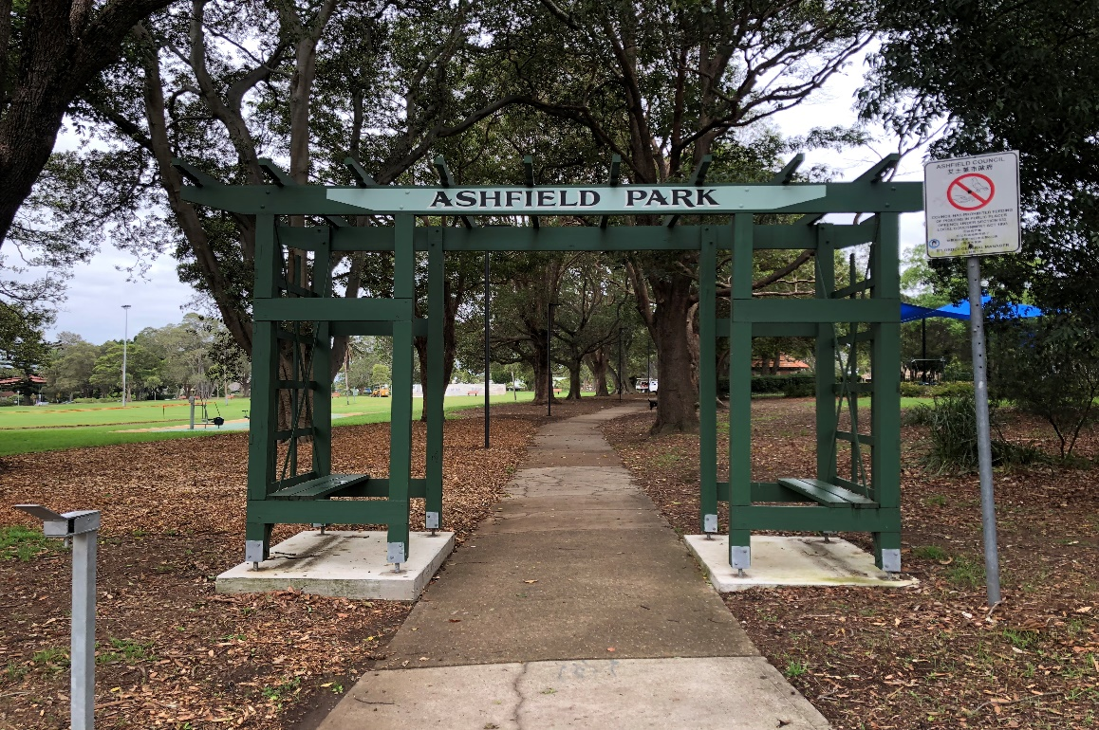

Ashfield Park is one of the great parks of the Inner West. It’s vital that we protect its heritage value and continue to properly maintain and improve this beautiful community asset.

Please take the time to make a submission about your priorities for the park as it belongs to you.

Sincerely,

Darcy Byrne
Inner West Mayor

Have your say
Draft Plan of Management and Master Plan for Ashfield Park
In March 2020 we sought community input on how to care for and manage Ashfield Park over the next 10 years. That feedback has been combined with expert advice and other information in the draft Plan of Management and Master Plan (PoM). The drafts are now on public exhibition for review - did we capture your ideas?
Key proposals include:
- A new interpretation strategy to highlight significant historic aspects of the park
- New park furniture in selected shaded locations
- Establishing a biodiversity area to the southern corner of the park
- Continue to maintain the practice of cutting the parks’ shrubs into ornamental shapes and keep the name ‘Ashfield Park’.
- Install two table tennis tables with concrete pads, accessible path and spectator seating.
- Extend and improve the community garden.
- Upgrade of one of the grass bowling greens to a synthetic green
- An off-leash dog area in the north-east corner of the park
- Upgrade the existing playground
- Provide two new cricket nets
- Extend existing BBQ area and include additional natural play elements

Read the full draft documents
There are two ways you can inspect the documents in a Covid-Safe way during public exhibition:
- Download a copy from yoursay.innerwest.nsw.gov.au
- Contact me to request a paper copy posted to your address.
Note: Hardcopies of POM documents are usually available to view at the following locations
- Ashfield Service Centre, 260 Liverpool Road, Ashfield. Monday to Friday 8.30am to 5pm
- Leichhardt Service Centre, 7-15 Wetherill Street, Leichhardt. Monday to Friday 8.30am to 5pm
- Petersham Service Centre, 2-14 Fisher Street, Petersham. Monday to Friday 8.30am to 5pm
- Balmain Library, 370 Darling Street, Balmain. Monday to Thursday 9am to 7.30pm, Friday 9am to 5.30pm, Saturday and Sunday 10am to 5pm.
but due to the current lockdown, those facilities are closed. As soon as they open, hard copies will be available there.
Have your say
- Online at yoursay.innerwest.nsw.gov.au
- By mail addressed to: Inner West Council, PO Box 14, Petersham 2049, ATTN Mandy Smith
- Email your feedback to
Mandy.Smith@innerwest.nsw.gov.au with the subject line ‘Ashfield Park POM: Feedback’
Final day for submissions is Monday 23 August 2021
Enquiries
Please contact me by phone 9392 5635 or email mandy.smith@innerwest.nsw.gov.au.
Sincerely,
Mandy Smith
Coordinator Parks Planning

