29 March 2021

Pratten Park is one of the most beautiful and historic precincts in the Inner West.

Three current users, Western Suburbs Lawn Tennis Association, Western Districts Cricket Club and Pratten Park Bowling Club have all called Pratten Park home for nearly a century.

Pratten Park isn’t only a site for organised sport, but a place that local families rely on for exercise and recreation.

The new Masterplan for Pratten Park is an opportunity to make sure the park benefits our community even more into the future.

The community can look forward to the ongoing growth of the location as an arts and music hub. The Pratten Park Community Sports and Bowling Club is also the base for the important work of the Ashfield Historical Society, a key cultural asset for the local community.

Darcy Byrne
Mayor of the Inner West

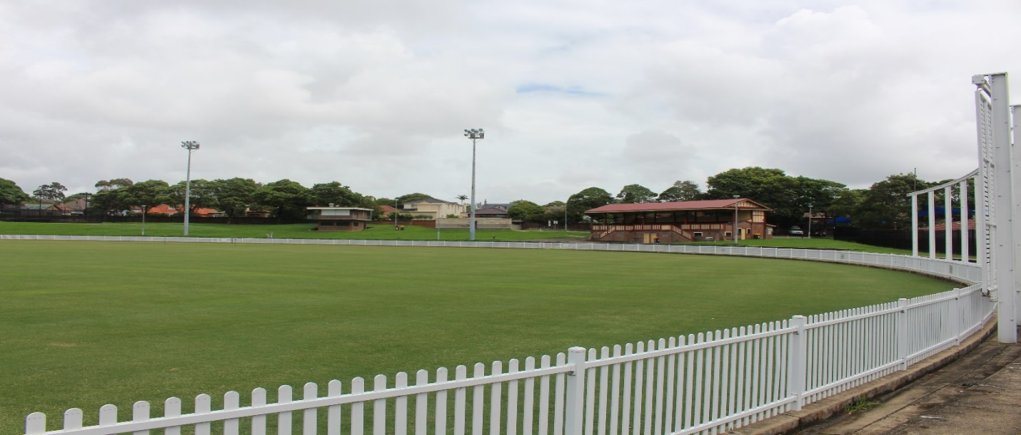

Have your say on the draft Pratten Park Plan of Management and Master Plan

Inner West Council developed a Pratten Park Plan of Management (PoM) and Master Plan with community input. Now, the community is invited to have their say on the key proposals before it goes to Council for endorsement and then the State Government for approval. Following State Government’s approval, the plans will be placed on public exhibition before they are adopted by Council.
Key proposals:
- Park entrance and car parking upgrades
- Improved pedestrian access
- New recreational spaces and playground upgrade
- Repurpose the turnstile building
- Major upgrade for the Bowling Club building including a potential second storey facing the sports ground.
- Additional planting and new trees

The Pratten Park Plan of Management will guide the Park’s use, facilities and improvements over the next 10 years.
The draft Plan of Management documents are available to read online at yoursay.innerwest.nsw.gov.au
Contact Mandy Smith, Coordinator Parks Planning on 9392 5635 for any enquiries and if you would like to a hardcopy of the draft PoM documents.
Comments open on Monday 29 March and close Monday 10 May 2021
Also at Pratten Park
Council continues to maintain the grounds and carry out planned works. The most recent work was the lighting upgrade in 2019.

