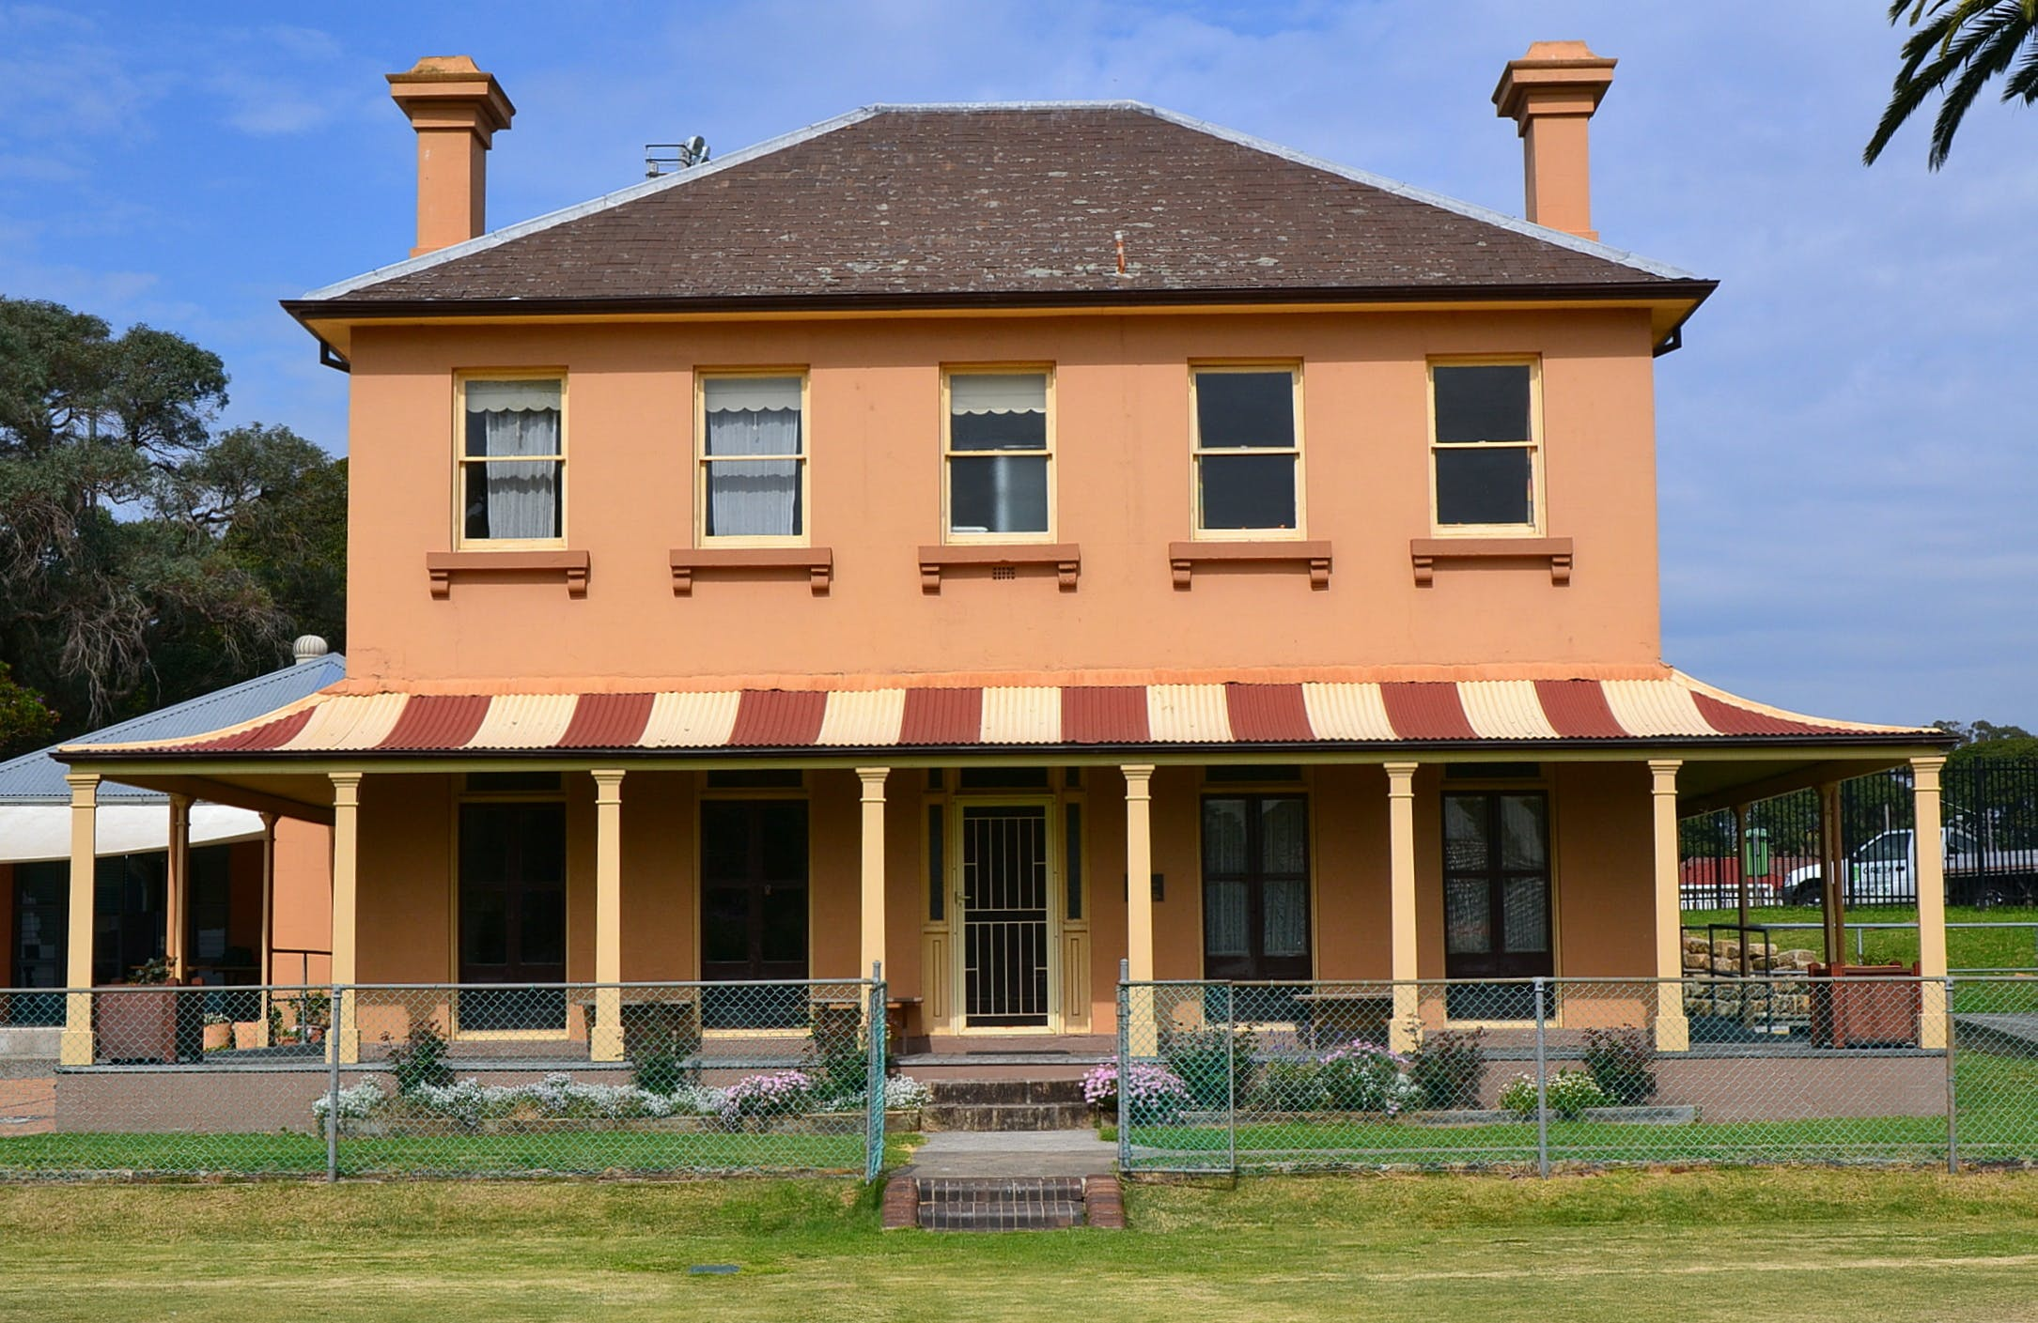

Engagement outcomes Report

Pratten Park Plan of Management and Master Plan

Contents
Summary 3
Background 3
Engagement Methods and Promotion 4
Engagement outcomes 4
Who did we hear from? 4
What did they say? 6

Summary
Council engaged the Inner West community for input in the preparation of a 10-year plan for Pratten Park, which is to include a Plan of Management and Master Plan. Community engagement was carried out via the engagement platform Your Say Inner West (YSIW) and two drop-in sessions at Pratten Park, which occurred on Wednesday 30 October and Saturday 9 November 2019.
The drop-in sessions provided visitors the opportunity to view the community engagement material in person and give feedback in an informal setting. The park was busy with a range of users stopping to discuss the material. Printed boards outlined potential ideas for the park as well as a map indicating the site area. Members of the public were asked to identify the facilities and areas of the park that they liked the most, and which facilities and areas they felt had room for improvement. Comments on other aspects of the park were also welcomed.
The project was open for community comment from the 21 October to 18 November 2019. The project page received close to 115 visits. Of those visitors, close to 40 left feedback. The questions prompted visitors to express their thoughts on Pratten Park in general, including what visitors currently value and dislike about Pratten Park, what improvements visitors would like to see in Park; and what should be prioritised within the plan.

Background
Plans of management must be prepared for all types of parks on community land. Inner West Council established a parks’ planning priority list, which nominates which open spaces in greatest need of new or updated Plans of Management. Pratten Park has been nominated as high priority within the Inner West council area. A previous plan of management for Pratten Park was prepared by the former Ashfield Council was not adopted at the time.

Engagement Methods

- Online survey on yoursay.inner.nsw.gov.au
- Face to face sessions in the park

Promotion

The engagement was promoted by Inner West Council using a number of means, including:
- Your Say Inner West home page
- Inner West Courier
- Community flyer to the surrounding residents
- Social media
- E-news
- Council website
All promotion collateral directed people to the online submission form on YSIW and to the two park drop-in sessions

Engagement outcomes

Who did we hear from?

What did they say?
Report on the data from the method/s you used such as:
- Online via yoursay.innerwest.nsw.gov.au

Please describe what you value about Pratten Park. You may like to describe what it looks like, how you use it or how it makes you feel.

Variety of recreation facilities
- It is a nice place for dog walking.
- I like the open green areas for morning runs.
- The park is a valuable resource for the community, particularly sporting organisations and schools.
- The park is multifunctional.
- The lawn tennis centre which is a unique asset and one of the few remaining of its kind.

Events
- The music events held at the bowling club. The recent attempts to make the bowling club more vibrant with music festivals and food offerings, which contributes to a sense of community.
- The artist residency at Thirning Villa, as an important community resource which also holds great events.
- Thirning Villa and its use for events.

Open space
- The open grass areas and trees which are an urban oasis in an otherwise built up area.
- Walking on the well maintained grassed surfaces.
- The shady spots and open spaces.
- The trees which line the perimeter.
- The view of the sky.
- The open spaces for children to play.
- The terrace seating around the oval.

Heritage
- The heritage value of the park, including its historic feel and nostalgic value.
- Heritage value of the surrounding palms.
- Value of the Grandstand and oval.

Community
- It is a great hub for the community.
- That the park is used by school and childhood clubs.
- It is a fantastic place to have lunch for local workers and residents.
- The playground with grass and plants is great for kids.
- The spider web in the playground is very popular with children and can let many play at once.
- That the oval is used by many different people in the community, such as walkers, families, kite flyers and sports.

Sporting venue
- The playing field is of very high quality for playing soccer and cricket and is of a good size for multiple teams.
- The rich sporting history of the park.

Other comments
- Good bubbler facility.

What don’t you like about Pratten Park?

Shade and planting
- There is a lack of shady spaces, and no shady picnic areas.
- There is no understorey planting, only lawn and trees.

Provision of facilities
- There is not enough park furniture.
- The removal of the basketball hoop at the cricket nets site as it was heavily used by the community.
- Spectators for soccer games cannot sit close enough to the field.

Accessibility
- Passive recreation is poorly provided for. Walking and running around the oval is made difficult by the lack of footpath. The tiered seating around the oval makes walking difficult. The park is extremely difficult for prams and wheelchair users especially from Park Lane.
- Parking is unsealed and poorly accessible.
- Areas of uneven ground can be slippery and make access for some people difficult.
- The grandstand is not very accessible.
- There is no access between the cricket ground and bowling club and the bowling club is poorly integrated into the park.
- The playground is not fenced off.

Maintenance and upgrade of existing facilities
- All facilities including the playground, grandstand, amenities blocks and kiosk require significant upgrade works.
- The playground needs renovation, it lacks a variety equipment and is poorly maintained.
- The bowling club is underused and visually unattractive. The dining facilities in the bowling club need to be upgraded so that they attract more visitors, including upgrading chairs, tables, and lighting.
- The disused toilets and the scoreboard need redevelopment.
- The park isn’t locked at night, even though signs say that it is.

Bowling Club
- The metro assist program at the bowling club is a good initiative but could be better executed, with improved food offerings and quality.

Safety and noise
- Safety at night is considered an issue with the park visited by intoxicated people or rough sleepers.
- When the park is occasionally used for music festivals the noise that it creates can be a nuisance.

Animals
- There is no off-leash dog area.

Waste Management
- The lack of rubbish bins particularly in the grassy areas at the eastern gates.
- The lack of ventilated dog waste bins.

Behavior of sporting clubs
- At least one of the cricket nets should always be publicly accessible.
- There is a lack of sharing spirit between the sporting clubs and the wider community, with people yelled at to get off the field.

What improvements would you like at Pratten Park?

The following items received the most requests during community engagement. They are listed in order of preference from the community.
- Include a circular path around the oval. It is currently difficult to walk around the oval perimeter due to the uneven concrete surface and objects in the way.
- A fenced off or time-based Off-Leash dog area, potentially during the morning or evenings.
- Lighting for the tennis courts so they can be used outside of daylight hours and better used by the community.
- Improved accessibility throughout the park. There is a need for sealed connection pathways for prams and wheelchairs around the park and between park facilities, including the spectating areas.
- Replace the basketball hoop that was removed and was very popular.
- Upgrade the public toilets to make them accessible and include baby change room areas.
- Provide more seating and furniture around the park, particularly in shady spots.
- Add exercise equipment for public use.
- Improve and expand the playground.
- Improve access between the bowling club and the oval so that the club can cater to sports events. Assist in refurbishing or upgrading the bowling club (to two storeys) into a more attractive venue, and have it house more community events. Make better use of the bowling club greens (e.g. Community Garden), for example what they have done at ‘Camperdown commons’.

Additional improvements requested by respondents were as follows. These are not presented in priority order.
- Shading for the tiered bench seating around sports field. Refurbish the benched seating areas and include weather protection. Style of seating should remain the same.
- Improvements to the grandstand and toilet facilities.
- Improve parking, with hard-stand areas and formal markings.
- Reinstate oval lighting
- Shaded seats, benches or picnic tables.
- Improvements to the dining and function spaces within the bowling club.
- Better passive recreation opportunities and programs.
- More trees to provide more shade and shelter.
- Replace the dog waste bin adjacent the eastern turnstile house.
- The grandstand seating needs to be fixed or replaced.
- Fence off the playground.
- Improve landscaping within the park.
- Upgrade lighting as it is dark at night.
- More openings in the picket fence around the oval.
- Include some heritage interpretations or public art, which could reference previous site uses, for example the speedway.
- Consider making the tennis court hire for some of the courts more accessible for non-members.
- Ensure public access to the synthetic cricket nets.
- Allow access to the park from the south-east corner where the maintenance shed is currently, so that people from the eastern side can access the park more easily.
- Improve the area to the rear of the scoreboard, potentially with a mural.
- The park is currently good but continue maintenance.
- Maintain and fix up the eastern turnstile house on Arthur St.

What do you think should be the main priority of the park plans?

The main priorities as identified by the community (in order of preference) are as follows:
- Maintaining access to park for all people in the community, not just certain sports user groups.
- Improved parking.
- The park just needs maintenance or minor works - it has a significant and special character already. The look and feel of the park should be preserved.
- Encourage more local people to use the park through a variety of facilities and events (including creative events), beyond just for organised sports.
- Passive and active recreation opportunities, multi-use spaces for a variety of uses
- Improved pedestrian accessibility throughout the park.
- The grandstand and sports surfaces.
- Tennis court lighting.
- Organised sports such as soccer.

Additional priorities as requested by the community area as follows:
- Recognise Thirning Villa as a beautiful and important remnant of Ashfield’s history.
- The playground, including new play equipment and maintenance.
- Prioritise sporting, which the park was created for.
- Increasing tree planting and shade.
- Remove the ugly and disused buildings, replace with new beautiful facilities.
- Re-instate the basketball hoop.
- Off-leash area for dogs.

Other comments
The following comments were received in addition to the formal questions withing the online survey:
- Consider the neighbours who live nearby when planning how the park will be used.
- Improve the safety of the oval during cricket training sessions, through completing works to the cricket nets as soon as possible as parts of the park can be very dangerous during training sessions.
- Upgrade the grandstand with better seating and upgrade the changerooms below the grandstand.
- Replace the existing change rooms and commentator box structures which have little architectural merit with new facilities. Remove the derelict bathrooms along the eastern side of the park.
- Upgrade the bowling club. The bowling club could be turned into a two-level multifunctional community facility, facing the oval, with childcare, indoor sports and a cafe. Dressing rooms and a park viewing area could assist in attracting significant cricket matches to the Park.
- Add a path that runs around the oval, as we currently walk over uneven ground and dirt.
- Maintain the artist residency which is a fantastic community asset.
- Add bicycle safety markings to Arthur St where there are many near misses.
- Keep music events at the bowling club and better promote them to become a destination.

- At face to face community sessions
The drop-in sessions were undertaken over two days, including a Saturday afternoon between 2-4pm and Wednesday afternoon between 5:30-7pm. The drop-in sessions provided visitors the opportunity to view the community engagement material in person and give feedback in an informal setting. The material consisted of two A1 panels, one displaying an overall map of the park and one panel which displayed some images of current parts of the park or features of other parks to prompt discussion.
Park visitors who approached were asked to identify facilities and areas that they liked the most, and which facilities they felt had room for improvement, through coloured stickers on the panels. Comments were also welcomed. These sessions were productive with several park visitors approaching the team and engaging with the material to have their say. These comments have been collated, themed and are presented without hierarchy.
- The synthetic cricket nets not being open to the public and to ensure that these remain open for the public to use.
- The oval needs to be shared with the community. It is often locked unless in use by the cricket club. It would be great to use the oval for general use.
- A basketball hoop which has been removed to extend the cricket nets some time ago. The hoop was very well used and should be replaced. A small but separate handball court would also be a valuable addition.
- The irrigation tanks for the park were a great initiative and seem to be working well.
- The toilet blocks along the eastern side have been closed for decades and are full of waste and should be demolished to increase the area of parkland available.
- While public art is good, the current sculpture garden is tired and not very successful.
- Signage needs to be upgraded - it is out of date, excessive and conflicting.
- The park could use more and better quality ventilated dog waste bins. A bin at the north-eastern gate was well used but has been removed and should be replaced.
- The park should host community movie nights using the scoreboard.
- Outdoor exercise stations suitable for older people could benefit visitors who use the park for exercise, running & walking.
- The eastern turnstile house would benefit from restoration and could be used as a small cafe, as the spot is very popular for lunch.
- The Park Lane gate is not wide enough to access with a pram, child’s bike or wheelchair. This would be easily fixed by permanently opening the large gate.
- A path around the oval would be great for all the people who jog around the oval, currently they have to avoid the obstacles and uneven surfaces. A row of seats could be allocated to running track.
- Council should support people sleeping rough in the park.
- An off-leash area could benefit the park, as it is used by many dog walkers.
- A BBQ area would be a good addition.
- Signage indicates the park gates are to be locked at 10pm but this is not the case.
- The playground could be upgraded with more swings, informal play, imaginative play (for example, a boat), mounds, more durable surfaces. The playground should have equipment that is different to other parks in the area. Keep grassed areas for running around and limit the amount of planted areas.
- People sit at benches and tables at night and disturb local residences.
- CCTV should be installed for security.
- Upgrade the bowls club, which is currently an eyesore from the park. The bowls club could better address the park, potentially with another storey. If the bowls club was nicer people would be enticed to meet there.
- The parking is often used by commuters which limits its use for park visitors. Timed parking would address this.
Online organisation submission
Online input was received from one organisations Their input has been summarised and included below.

Ashfield District Historical Society
Online feedback was received, noting that the ADHS currently occupies some of the ground floor of Thirning Villa, and that the society requests to be consulted whether any of the proposed works will impact the Villa and its occupation.

Football NSW
Online input was received in the form of a document from Football NSW, the state governing body of football (soccer) in NSW. The feedback noted that the CDSFA currently operate out of Pratten Park, utilising the bowling club facilities. The document expressed support for the indicated improvements to the park at the time, which included building reorganisation, improvements to grandstand, parking improvements, lighting improvements and playground upgrades.
Comments received from sporting groups
A meeting was held with representatives from Inner West Council, Pratten Park Bowling & Community Sports Club, Canterbury District Soccer Football Association, Western Suburbs Lawn Tennis Association, and Western Suburbs District Cricket Club to gather their feedback. Written responses were also received from stakeholders and organisations operating within the park. Key points raised by each of the participating groups are summarised below, as well as general comments from members of the organisations.

Bowling and Community Sports Club
- Supportive of a second storey extension to bowling club with verandah facing oval to facilitate additional uses.
- Tiled Roof is frequently damaged by cricket balls resulting in leaks and replacement with a metal roof is recommended.
- Option to move playground to unused bowling green to get more space for car parking.
- Support for movie nights hosted at park.
- Maintain existing in-use bowling green for a variety of sports such as bowls, bocce, croquet, volleyball.
- Diversify use of existing club with variety of functions.

Canterbury District Soccer Football Association
- New/proposed flood lighting is acceptable.
- Toilet blocks on eastern side should be removed or converted properly to storage.
- Canteen is in poor shape and should be demolished or upgraded.
- Drainage works on the eastern wing of playing field were not adequately undertaken.
- Change room and toilet blocks. Not consistently open and public/shared nature of toilets with change rooms is unusual. Cleaning could be undertaken more regularly. Open style design results in dirt and debris ending up within the change rooms.
- Storage & rooms beneath grandstand could be better utilised.
- Issues with tenancies within the park.
- Park should retain its historic sporting character.
- A defibrillator within the park precinct could be considered.
- Open the eastern turnstile house as a historical asset for the public and restore gates.

Western Suburbs Lawn Tennis Association Limited
- Extend the usage of the courts by introducing after hours lighting to the synthetic courts, for lighting until 10pm. Lighting would
- preferably have level of 400 lux and be on automatic timers to turn lights off.
- Booking system for coded entry for players to enter the courts.
- Supportive of movie nights displayed on scoreboard on oval.

Western Suburbs District Cricket Club
- Enhanced lighting from light towers from 300 lux to 900 lux, WSDCC to seek grant support.
- Clubhouse/venue component included in second storey to Pratten Park bowling club.
- Seating should be restored with heritage requirements in the grandstand.
- Change rooms should be improved to accommodate male & female cricket teams.
- Look to reactivate broadcasting box within NW corner of Grandstand.
- Incorporate a historic walkway interpretation strategy into the park, to display sportspeople who have excelled at Pratten Park over the years

