8 March 2021

Henson Park is one of our great community assets and is a meeting place for the entire Inner West Community.

This famous ground is a special place for many in the Inner West; as the long-term spiritual home for supporters of the might Newtown Jets, as a recent home for up-and-coming female AFL players, and for others simply a place where they walk the dog before or after work.

The proposal in the Masterplan will see all these uses maintained and strengthened into the future. This will help to protect the heritage of this famed open space and ensure that the next chapter for Henson Park is even stronger.

I encourage you to look at the Henson Park Plan of Management and Masterplan an have your say on the final design.

Darcy Byrne
Mayor of the Inner West

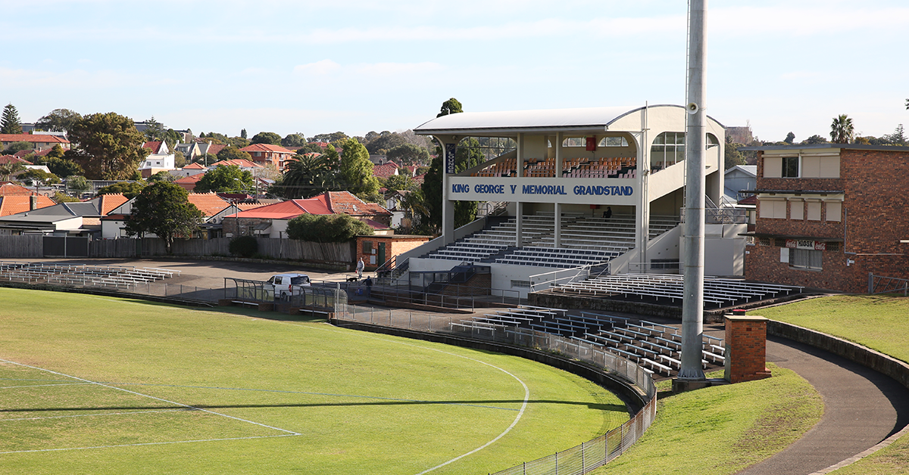

Have your say on the draft Henson Park Plan of Management and Master Plan
Inner West Council developed a Henson Park Plan of Management (PoM) and Master Plan with community input. Now, the community has a last chance to have their say on the key proposals before it goes to Council for adoption.
Key proposals:
- Upgrades to the grandstand and scoreboard
- Improved pedestrian access
- Upgrades to park entrances and parking
- New recreational spaces
- Additional planting and new trees
The Henson Park Plan of Management will guide the Park’s use, facilities, and improvements over the next 10 years.
The draft Plan of Management documents are available to read online at yoursay.innerwest.nsw.gov.au
Enquiries: Contact Mandy Smith on 9392 5635 for any enquiries and if you would like to see hardcopy of the draft PoM documents.
Comments open on Monday 22 March and close Monday 3 May 2021

Also happening at Henson Park
Council continues to maintain the grounds and carry out planned works.
Recent works include:
- Upgrading the oval turf and underlay soil to elite sport standards
- Installing a storm water harvesting and treatment system
- Installing a new field drainage system including water recycling
- Upgrading the irrigation system
- Fixing the sinkhole in the centre of the field
- Renewing sports light pole wiring

