Simpson Park Upgrade

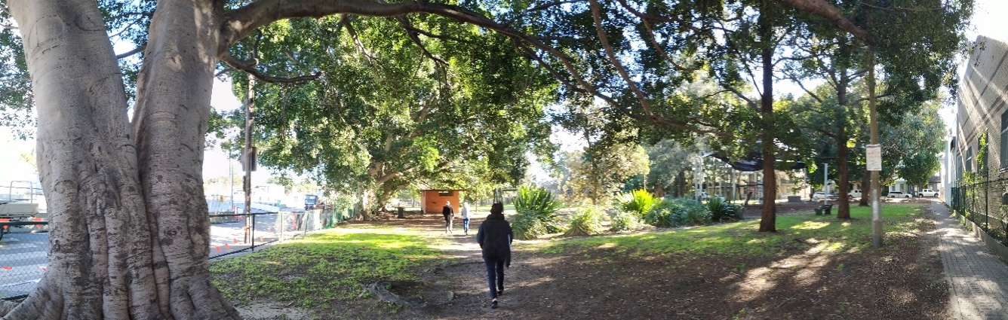

I’m writing to invite you to have your say on the upgrade of Simpson Park in St Peters.
Work on the upgrade includes the picnic facilities, cricket nets and playground paths.
At the same time, artist Mike Hewson is designing a playground – the St Peters Fences Playground.
We are inviting you to have your say on both of these projects.

Our commitment to your future
Council has committed $186,000 in funding to bring this project to you.
This is part of our $65 million investment in parks, sports grounds and aquatic facilities over 2018-2021, the largest and most comprehensive funding commitment to support community sport and recreation in the history of our community.
We are working to create a healthier community and aim to deliver first class sport and recreation facilities for everyone in in the Inner West.

For more information
For further information on the Simpson Park Upgrade, please contact Council’s Parks Project Manager, Sandra Chin on 9392 5007 or Sandra.chin@innerwest.nsw.gov.au.

Yours sincerely
Cr Darcy Byrne
Mayor
Inner West Council

Get involved in the Simpson Park upgrade

Council is upgrading Simpson Park, St Peters alongside WestConnex commissioned artist Mike Hewson. Council is funding and managing upgrades to the picnic facilities, cricket nets and playground paths.

Have your say and get involved
This is an exciting opportunity to have input on both Council’s upgrade and the artwork playground designed by Mike Hewson.

Picnic facilities and paths
We would love to know how you think the picnic facilities could be improved. We would also appreciate your input as we upgrade the playground paths to be more accessible. To have your say on these elements, please go to yoursay.innerwest.nsw.gov.au.
Comments close on Sunday 3 November 2019.

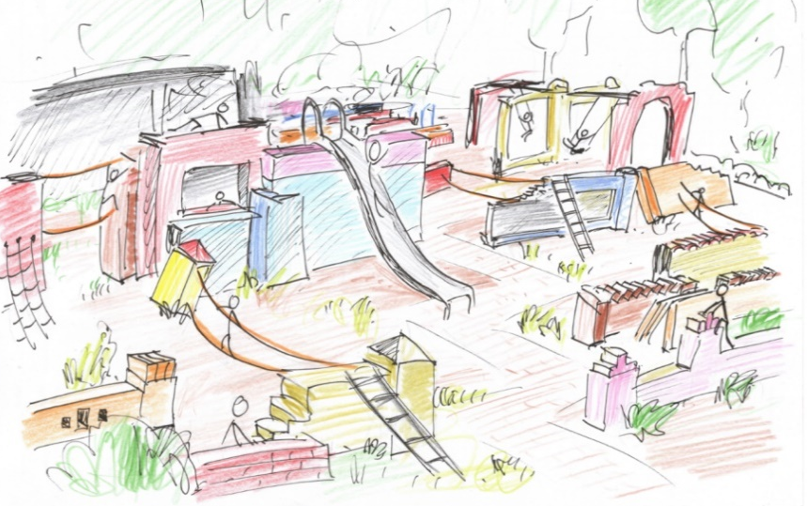
St Peters Fences Playground
Artist Mike Hewson is seeking your memories of the area to inspire the design. Additionally, he’s collecting salvaged materials from St Peters to enhance the work. He invites you to supply any recycled or salvaged material you wish to see incorporated (brick, blocks, stone etc).
To find out more and contribute your stories and/or materials to the artist designed playground, please visit
Artistic impression of the ‘fences’ themed artwork playground
mikehewson.co.nz/simpsonpark.
What happens next?
Council will collate the feedback on the park upgrade and incorporate it where possible into the final design. We’ll continue to liaise with Mike Hewson on the development of the artwork playground. Construction is expected in 2020. Everyone who provides input will be kept informed about the projects and updates will be posted at yoursay.innerwest.nsw.gov.au

