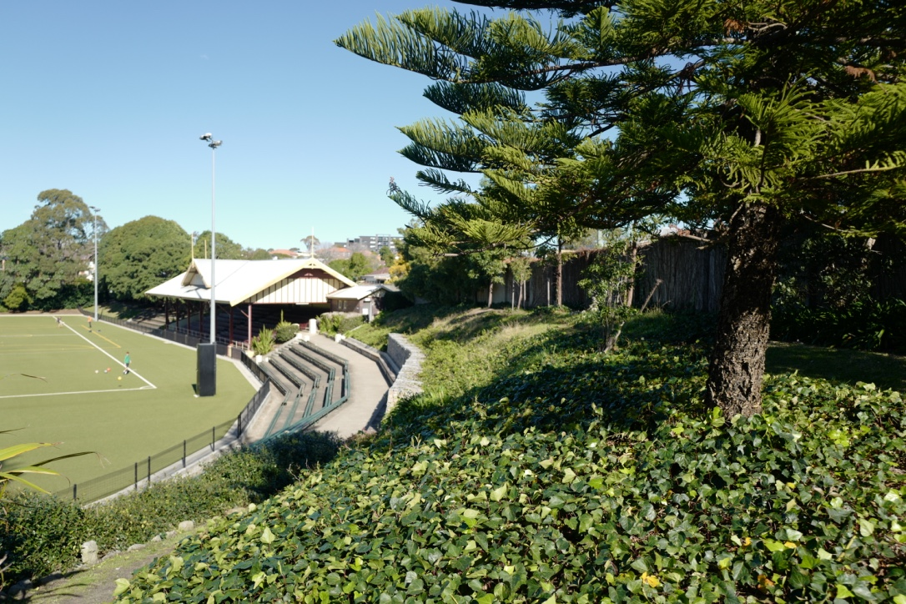

Engagement outcomes report

Dulwich Hill Parklands Park Plan of Management and Master Plan

Contents
Summary 4
Background 4
Engagement Methods and Promotion 4
Engagement outcomes 5
Who did we hear from? 5
What did they say? 6
Officer comments in response to public exhibition 7

Summary

Council engaged the Inner West community for input in the preparation of a 10-year plan for the Dulwich Hill Parklands which include Johnson Park, Hoskins Park, JF Laxton Reserve and Arlington Reserve. The plan includes a Plan of Management and Master Plan. Community engagement was carried out via the engagement platform Your Say Inner West (YSIW).
Online engagement was carried out from the 8 November – 5 December 2019. The project page received 202 visits. Of those visitors, 38 visitors provided feedback. The questions prompted visitors to read the draft Plan of Management and Master Plan and indicate if they agree, agree with changes, or disagree with the draft Plan of Management. Respondents were also asked to leave a comment with their opinion on the documents.

Background

Plans of management must be prepared for all types of parks on community land.
Part of the Dulwich Hill Parklands is owned by the NSW Government and requires a land categorisation. This land is managed by Council for community benefit, however we require the NSW Government to approve our categories before the Plan of Management can be adopted. This impacts Johnson Park. Once the categorisation has been approved, the draft Plan of Management and draft Master Plan for Johnson Park will be exhibited for 28 days.

Engagement Methods and Promotion

The public exhibition period was promoted by Inner West Council using a number of means, including:
- Your Say Inner West project page
- Social media
- Council website
All promotion collateral directed people to the online submission form on YSIW.

Engagement outcomes
Who did we hear from?

What did they say?
Report on the data from the method/s you used such as:
- Online via yoursay.innerwest.nsw.gov.au

Listed below are the common themes the community raised in relation to each of the parks:
J.F Laxton Reserve
- Respondents strongly opposed reinstating the trial off-leash dog area in Laxton Reserve.
- Respondents requested improved lighting along pathway that runs adjacent to Arlington Oval
Arlington Recreation Reserve
- Request for signage to encourage and remind users to be mindful of noise and language and to be respectful of neighbouring residents
- There were requests manage parking in the area to 2hr parking to manage conflicting uses between residents and sporting users
Johnson Park
- There was strong support for the upgrade of the amenities building with many also noting poor maintenance and cleaning regimes.
- There was a request for separation of the children’s playground and dog off leash area
- Conflicting responses for additional and expanded sporting facilities including extension of cricket nets and inclusion of multipurpose courts
- There were conflicting responses in favour and against the dog off leash facility within Johnson Park
Hoskins Park
- Request for shade sails to be installed over the playground
- Requests for the provision of toilets

Officer comments in response to public exhibition
Following community engagement, the following changes to the document have been amended.
- Reinstating the dog off leash area at J.F Laxton Reserve will not be reintroduced.
- No dog off leash area is proposed for J.F Laxton
- Upgraded and improved lighting along pedestrian routes in JF Laxton given high priority.
- Use of Arlington Recreation Reserve Operations Plan to be implemented and adopted.
- Review of parking arrangements on Williams Parade to minimise congestion during pick-up/drop-off times for sporting events and training given a high priority.
- Upgrade of the amenities block at Johnson Park given Medium to High priority
- Provision of toilets included at Hoskins Park.
- Provision of additional shade

